Functional Specification Documentation

Submitted to

Gulf International Bank Saudi Arabia (GIB)



December 2024

Version Control Log

Release | Date | Author(s) | Description Update
V 1.0 | 05.06.2024 | Ashish Luthra | Initial Document
V 1.1 | 02.09.2024 | Ashish Luthra | Added more information on platform usage or features.
V 1.2 | 05.09.2024 | Ashish Luthra | Added more information on Use Cases, Data Migration.
V 1.3 | 18.09.2024 | Ashish Luthra | Added more information on In-App campaigns, RTM.
V 1.4 | 20.10.2024 | Saru Wadehra  Ashish Luthra | Replied to comments from GIB.  Added additional information for those points.
V 1.5 | 05.11.2024 | Saru Wadehra | Replied to comments from GIB.  Added additional information for those points.
V 1.6 | 22.11.2024 | Saru Wadehra | - Replied to comments from GIB.  - Added additional information for those points.  - Attached MMP document  - v0.76 document.  - Updated Role Management table  - Added more info in Data Ingestion  - Added Audit Logs section  - Updated Reports section
V 1.7 | 23. 12.2024 | Ashish Luthra | Added more Info
V 1.8 | 24.12.2024 | Ashish Luthra  Dhanush Jain | Email Configuration:

Table of Contents
1. Glossary & Abbreviations 6
2. Introduction 6
- 2.1 Platform Overview 7
3. Functional Requirements 7
- 3.1 Functional Requirements raised by GIB 8
4. Journeys to be covered 10
5. Customer Data Led Engagement 11
i. Behaviour based personalization 11
ii. Transactional data-based personalization 11
- 6. Data Ingestion 12
- 7. Data Archival 13
- 8. Data Taxonomy 14
- 9. SDK Integration 15
- 10. Journey Events 15
- 11. Campaign Workflow 18
- 11.1 Select Channel 19
- 11.2 Creative or Content Sizes: Basis Channel 19
- 11.3 Use Prebuilt Templates or Make a New Template 20
- 11.4 Select Segment 26
1. Events 26
2. User Traits 26
3. Computed Traits 26
- 11.5 Scheduling 27
- 11.6 View Campaign Reports & Analytics: Basis Channel 33
- 12. App-Inbox behaviour 35
- 13. APIs 36
- 14. Use Cases 37
- 15. Segmentation & Traits 37
- 15.1 Segmentation 38
- 15.2 Traits 39
- 15.3 Computed Traits 39
- 15.4 Language Selection 42
- 15.5 Timezone & Geotagging 42
- 15.6 Multivariate Testing 43
- 15.7 Digital Asset Manager (DAM) 44
- 16. Behavioral Data Analytics 44
- 16.1 Aggregate Dashboards 44
i. User Analytics 45
New Users 45
Retained Users 45
Engagement 46
ii. User Trends 46
Active Users Trends 46
Daily Active Users Trends 46
iii. User Events 47
iv. Header 48
Platform 48
Period 48
Reports available in platform: 49
- 16.2 Funnels 51
- 16.3 Journeys 55
- 16.4 Visitor Engagement Overview 56
- 16.5 Traffic Sources 57
- 16.6 Top 10 Events 57
- 16.7 Retention Trends 58
- 16.8 Specific Reports 58
- 16.9 Acquisition 59
App Acquisition 59
■ Acquisition Sources 59
■ App Versions 60
■ Locations 60
■ Acquisition 60
■ OS 61
■ Day-Wise Acquisition 61
■ Time-Wise Acquisition 61
- 17. User Management 62
- 17.1 How to Register a New User 62
- 17.2 User Addition Process 63
- 17.3 User Modification Process 65
i. Change Role 65
ii. Revoke Role 67
iii. Status 67
v. Unblock 67
- 18. Role Management 68
- 19. Other Integrations 69
- 20. Event List 69
- 21. Requirement Traceability Matrix (RTM) 69
- 22. Appendix 71
- 22.1 Use Cases 71
- 22.2 Data Taxonomy 73
- 22.3 Events List 73
- 22.4 SMS Integration 73
- 22.5 Email Integration 73
- 22.6 LDAP Integration 74
- 22.7 Sample data 75
- 22.8 Final BRD 75
- 22.9 MMP Integration 75
- 23. Audit Logs 75

1. Glossary & Abbreviations

Acronym/Abbreviation | Description:
BRD | Business Requirement Document
RDC | Retail Delivery Channel
CC | Credit Card
API | Application Programming Interface
SAMA | Saudi Central Bank
CFF | Counter Fraud Framework
AppICE | Digital Engagement Platform
CDP | Customer Data Platform
CEX | Customer Engagement Platform
FCM | Firebase Cloud Messaging
APNS | Apple Push Notification Service
CCMS | Credit Card Management System
SFTP | Secure File Transfer Protocol
MMP | Mobile Measurement Partner
UTM | Urchin Tracking Module
ROAS | Return On Ad Spent
DND | Do-Not-Disturb
SCV | Single Customer View
DAM | Digital Asset Manager
CNS | Central Notification System
SDK | Software Development Kit
JSON | JavaScript Object Notation
DAU | Daily Active Users
WAU | Weekly Active Users
MAU | Monthly Active Users
OoB | Out of Box
UCs | Use Cases

2. Introduction
This document covers the requirement for Gulf International Bank (GIB) to integrate the Appice Customer Data Platform and Customer Engagement Platform.

Customer engagement lies at the heart of positioning meem brand in the market, building a sentiment with our existing customers, promoting the product proposition to our future customers, as well as ensuring we maintain the dialogue with both the customer and the market. Keeping the objectives in mind, meem plans to deploy a Digital customer engagement engine to enable:

- Channel Engagement and Personalization.
- Reporting and Analytics
- Campaign Planning and Management.
- Multichannel Campaign Execution
- Audience Targeting and Segmentation.

Please note - Required audit reports/source code certificate to be provided to the Bank as and when required for their security audits. Also, technical walkthroughs can be provided for their VAPT testing.

2.1 Platform Overview

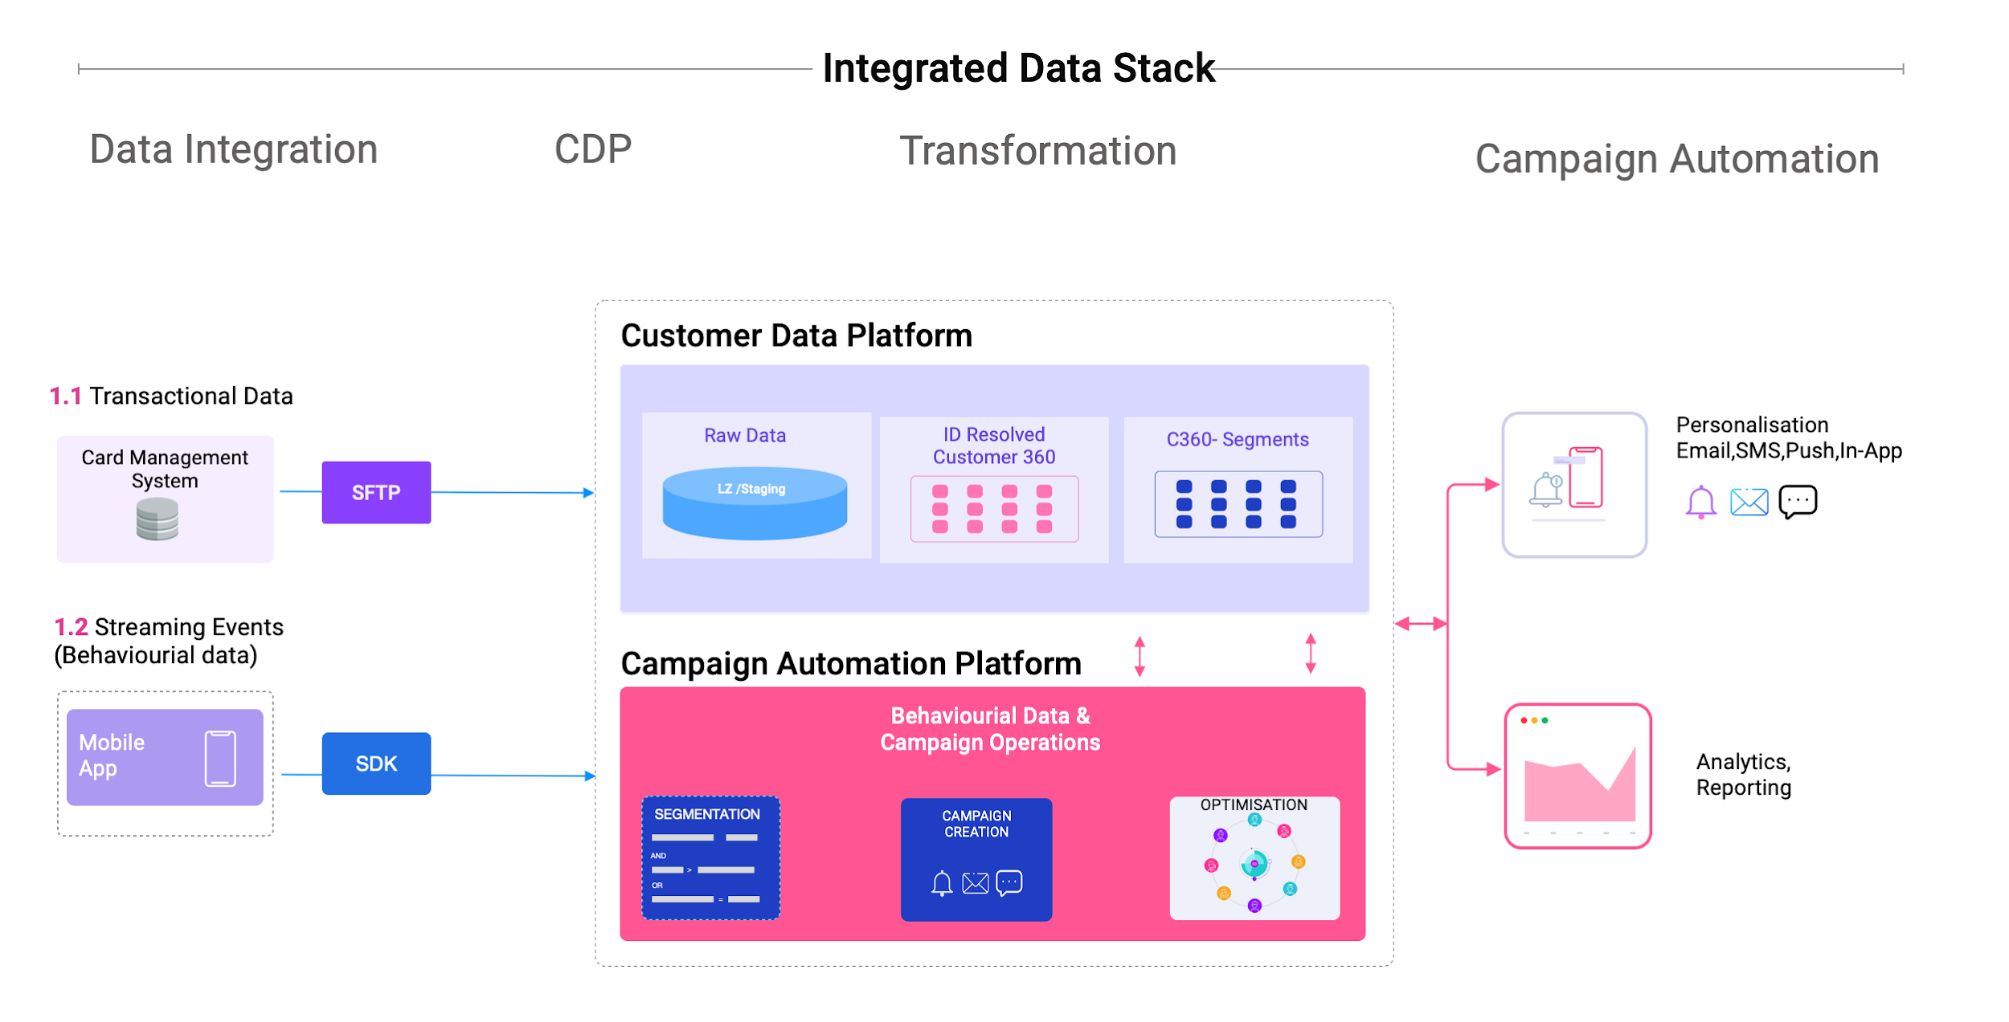

3. Functional Requirements

Sno | Functionality | GIB Role
1 | Customer Data Platform (CDP) -  1. Integration with Credit Card Management System: [GIB to provide CCMS data, along with profile data from UBS/CRM to staging environment via SFTP]  2. Data Unification  3. Identity Resolution  4. Customer 360  5. Segmentation  6. Personalisation API | Infrastructure Prerequisites to be enabled
2 | Customer Engagement Platform (CEX)  1. Omni Channel Campaign Management  2. Campaign Design  3. Omni Channel: Push, In-App, SMS, Email  4. Campaign Analytics  5. Events design for TEN Journeys  SDK for mobile App ‘meem’ only | GIB to integrate SDK and App Events in GIB App.  10 Journey events to be designed by Appice.
3 | Data Analytics & Reporting  1. Dimensions & Measures as per KPI's  2. Behavioural customer data reports and dashboards  3. Funnel view and users drop off  4. Journey effectiveness and bottleneck identification  5. Tracking customer behaviour in response to the received notifications.  6. MAU, DAU, WAU, Top 10 Events, Trends  7. Data export for custom reports
4 | MMP integrated Campaign Management & Attribution (for mobile campaigns)  Limited to tracking 25000 conversions/month | GIB to do SDK integration for attribution tracking of mobile campaigns.  A detailed document has been attached in section 22.9 of Appendix for the integration steps.

3.1 Functional Requirements raised by GIB

Sl no | Functionality | Scope Areas | Integration required
1 | The platform requirements should support meem KSA only. | Platform Scope
2 | The requirements should support on the following platforms:  - Mobile (iOS, Android, and Huawei) | Channel Scope
3 | The requirements should be supported in both English and Arabic languages. | Language Support
4 | Ability to have a campaign workflow involving multiple stakeholders like product, marketing, compliance, quality etc, for SMS, Email and Push Notification | User Management → Add User | Addition of user registration from AppICE Platform
5 | Ability to have a maker-checker workflow for broadcast messages | User Management → Add User | Addition of user registration from AppICE Platform
6 | Ability to add/edit/delete any conditions of the published workflows and also maintain the audit logs for change management. | Campaign Management → Edit a campaign  Server Logging | Logging to be enabled from the AppICE Platform.
7 | Ability to have out-of-the-box templates for various use cases such as Onboarding, Retention etc. | Audience Segment | Access to AppICE Platform.
8 | Ability to schedule SMs, Email and push notifications at a future pre-determined time | Campaign Management → Create a new campaign → Launch Campaign | Access to AppICE Platform.
9 | Ability to send SMS messages to the entire user base to a selected segment or to a selected set of customers based on business-level events or manual broadcast. | Audience Segment | SDK Integration with app.  Event configuration & integration.
10 | Personalization of SMS based on the customer’s preferred language. | Campaign Management →SMS → Launch Campaign
11 | Ability to send Email messages to the entire user base or to a selected segment or to a selected set of customers based on business-level events or manual broadcasts. | Campaign Management → Email → Select Audience | SDK Integration with app.  Event configuration & integration.
12 | Personalization of Email based on customer’s preferred language. | Campaign Management →Email → Select Engagement Tool
13 | Ability to send Push Notification to the entire user base or to a selected segment or to a selected set of customers based on business-level events or manual broadcast. | Campaign Management → Push Notification → Select Audience | SDK Integration with app.  Event configuration & integration.
14 | Personalization of Push Notification based on the customer’s preferred language. | Campaign Management →Push Notification → Select Engagement Tool
15 | Manage and optimize SMS & Email communication process with recipients via DND (Do-Not-Disturb) and frequency capping | Campaign Management →Email/SMS/Push → Launch Campaign
16 | Set up an Email delivery gateway, Dedicated IPs, Un-subscription and Bounces Management. | Campaign Management →Create a new campaign → Email | Email delivery gateway to be provided by GIB. Unsubscribe & bounce management is Email SMTP server functionality- Not done by us
17 | Ability to visualiza email across devices and email clients. | Campaign Management →Create a new campaign → Email → Preview | Mobile & Web view only in Phase 1
18 | Send time-sensitive updates and promotions via Email. | Campaign Management →Create a new campaign → Email → Launch Campaign
19 | Personalization of Email based on business-level events via broadcast. | Campaign Management →Create a new campaign → Email → Select Audience
20 | Ability to manage subscription categories for email. | Campaign Management →Create a new campaign → Email → Select Audience | Not Covered in Phase 1
21 | Auto-triggered/Customised notifications based on the Customer actions on meem channels | Campaign Management →Create a new campaign → Email → Select Audience → Events List | SDK Integration with app.  Event configuration & integration.
22 | Customized notifications/ offers based on the customer profile, balance…etc. | Campaign Management →Create a new campaign → Email → Select Audience → Events List | SDK Integration with app.  Event configuration & integration.
23 | Dynamic content delivery based on user preferences and behaviour | Campaign Management →Create a new campaign → Email → Select Audience → Events List | SDK Integration with app.  Event configuration & integration.
24 | Notifications & Alerts: Push notifications for real-time updates and customizable alerts for app activities or promotions | Campaign Management →Create a new campaign → Email → Select Audience → Events List
25 | Personalization of push notifications based on the customer’s preferred language | Campaign Management →Create a new campaign → Email → Select Audience
26 | Ability to send push notifications with images, videos, GIFs and Emojis | Campaign Management →Create a new campaign → Push Notification → Select Engagement Tool
27 | Ability to perform A/B testing for SMS, Email and Push notification | Campaign Management →Create a new campaign → Push Notification → Select Engagement Tool
28 | The ability for all stakeholders to track the performance of A/B testing on a real-time basis | Campaign Management | Access to AppICE Platform.
29 | Ability to schedule a campaign and edit it (Text, replace image, add or remove audience and change publish date and time if needed before selected publish date & time ) | Campaign Management

4. Journeys to be covered
There are 25 journeys to be configured by the AppICE.

Here is the list of journeys:

S.No. | Journey Names
1 | Credit Card Onboarding
2 | One Pack Onboarding
3 | Apply Credit Card
4 | Credit Card Activation
5 | Apply Personal Finance
6 | Personal Finance Top-Up
7 | Open Banking Connected Service
8 | Profile Management KYC
9 | Transfer / Investment
10 | Transfer / International
11 | Own Account
12 | WithinMeem
13 | IPS / Transfer
14 | IPS Mobile
15 | IPS Email
16 | IPS IBAN
17 | IPS Above Limit
18 | IPS Limit Update
19 | i) App Rating-App Rating
20 | ii) App Rating-Certified Document Request
21 | iii) App Rating-MOI
22 | iv) App Rating-SADAD
23 | Payments
24 | ii) Profile Management- Promotions Settings
25 | User management

5. Customer Data Led Engagement

When it comes to personalization, especially from the standpoint of the data and technology that drive the customer experience, it is critical to distinguish between the two primary methodologies for personalization: behaviours and transactional data.

This distinction is important because the data sources and technologies behind each vary significantly.

Behaviour based personalization
In behaviour-based personalization, one step determines the next step in the customer journey. Each touch, swipe or click is recorded as an event to understand the experience and actions of customers.

Data Sources: meem APP
Data Ingestion: Appice SDK

Behaviour-based models will ingest data pertaining to customer usage of the meem App through the Appice SDK, in near real-time—data that represents the granular actions taken by each user. Events are collected using streaming pipelines; such as App usage time & frequency, Journey start, Journey drop-off, actions taken inside a journey etc.

These events and associated attributes will be used for:

- Behavioural Segments ( first see, last seen, app usage, journey completion etc)
- Customer engagement analytics
- Journey usage funnels
- Engagement campaigns targeted to specific segments
- Real-time personalisation based on past events or live events

Transactional data-based personalization
Customer traits and segments are constructed using the demographic characteristics of the user (i.e., age, gender, job title, products availed, credit score etc.) combined with their transactional data for personalised engagement actions.

Data Sources: CCMS & [UBS, CRM for building customer profile]
Data is to be ingested via SFTP into the staging zone. Details of data fields may be referred to in the data taxonomy section. C360 & Segments will be built using a combination of profile data and transactional data through

- CCMS data
- Offers data
- Profile data from UBS, CRM

Please note - backend system notification will not be real time.

6. Data Ingestion
- Data Ingestion will take place via Bank’s SFTP.
- Bank to provide SFTP server credentials.
- It will be Linux ingestion, there should be no windows markers.
- Bank to share sample data & folder structure along with filenames to test the data ingestion process. Refer to section 21.8 of Appendix.
- Each data set will have a separate file to be put on SFTP.
- Data ingestion will happen sequentially one after the other.
- Bank to give updated or new data daily.
- Data ingestion will happen daily post midnight via cron jobs (even if file is placed during the day)
- Initial data ingestion will be of all the GIB customers.
- The maximum size of 1 file should be 500 MB.
- The filename structure will be Source_DATE.csv.
- In case of any kind of failure/non-ingestion of files, the AppICE team verifies the file/failure and the Bank’s concerned team will get a notification with failure details via email.
- In case of failure, data is to be fixed by GIB and a new updated file should be added in SFTP for ingestion. Data ingestion will start post midnight only.
- If any issue in any single record (format issue), data ingestion will happen. During transformation of data, we find data format issues and the same is reported to the concerned Bank’s team.
- Date input should be in YYYY-MM-DD format.
- If any issue is there in file format/encoding, the entire file will be skipped.
- New records create a new row and updated records update the existing record in AppICE database.
- If no new files have been added in SFTP on any day, there will be no activity happening on data ingestion. System notification will be sent saying there is no new data for ingestion.
- Bank’s SFTP server archival will be taken care of by the Bank.
NOTE:
- SIT/UAT environment limit data limit is 100K users and for Prod, data limit is 275K Users. If additional users are there then additional capacity will have to be configured.
- For Testing purposes, data of Closed User Group should be set up to test positive and negative cases.

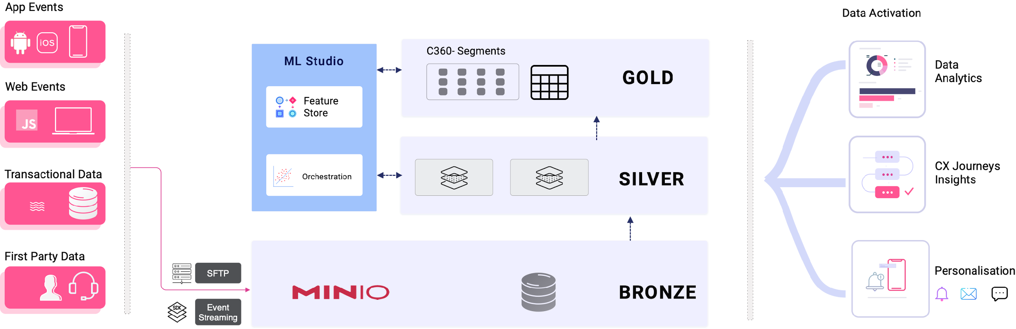

Data File Format | Data Ingestion Method
CSV Format | Appice to ingest from SFTP
Parquet Format | Appice to ingest from SFTP

Source Data | Ingestion | Frequency | Data Type | Filename
CRM - Customer | SFTP | Daily | Demographics | Customer_<date>.csv
CRM - Applications | SFTP | Daily | Offer, loan data | Applications_<date>.csv
UBS – CASA Accounts | SFTP | Daily | Account status | CASA_Accounts_<date>.csv
CORTEX - Cards | SFTP | Daily | Card Financials | Cards_<date>.csv
CORTEX- Card Transactions | SFTP | Daily | MCC based transactions | Card_Transactions_<date>.csv
CORTEX- Card.Transaction.PaymentPlan | SFTP | Daily | Card payments | Card_PaymentPlan_<date>.csv
CRM - Offers | SFTP | Daily | Personalised Offers | Offers_<date>.csv
UBS - Term Deposits | SFTP | Daily | Term deposit details | TermDeposit_Accounts_<date>.csv
UBS – Account Transactions | SFTP | Daily | Average of customer spends | Account_Transactions_<date>.csv

NOTE:
Loan-related/Personal finance data will not be included in the ingestion and downstream use cases. Refer conversation dated 24.11.2024.

7. Data Archival

S.No. | DATA TYPES | Brief Description of Data Type | Applicable? (Yes/No) | Retention Period of the data | Reference/comments
1 | Application Data | Application Binaries, Database, Configuration files, Parameter files and other related data pertaining to the applications | Yes | Application binary- Until Release of the next version/6 months whichever is more.  Configuration files and Parameter files w.r.t. the application: Until Release of the next version/6 months whichever is more | The data in the form of logs, application, database etc. are stored. Backup of the operating system itself is not retained. This will be a manual process.
2 | Logs/Audit Trails/behavioural data | Chronological record of events and activities at the application level. | Yes | 3 months | 3 months from the date of creation. This will be a manual process.
3 | Transactional Data | Financial and Nonfinancial (includes timestamp) | Yes | 6 months | 6 months from the date of creation. This will be a manual process.  [only Card transaction, account transaction will be archived after 6 months. Customer data will remain there]
4 | Reports/Dash  Board/MIS | Reports prepared by the department (Regulatory, MIS etc.) | Yes | 3 months | Data will be retained for the last 3 months’ campaign data in "Live Storage".  This will also be "archived" from prior to last 3 months' through last 12 months' campaign data in "Cold Storage" for different strategic activities.  This will be a manual process.
5 | Miscellaneous Data | Data not mapped to any of the above. | No | NA | NA
6 | Files from AppICE SFTP server | Data sets copied from Bank’s SFTP to AppICE OnPrem server. | Yes | 3 days | Files will be archived & removed after 3 days. This will be a manual process.

NOTE:
Data is removed & archived (as per the above schedule) in the form of a backup file in a different App Server to maintain security.

8. Data Taxonomy

Different data fields have been provided from different systems for mapping within Appice CDP. Refer to section 22.2 of Appendix section.

9. SDK Integration
AppICE SDK will be integrated with Meem KSA only. It will support the following platforms: Mobile (iOS, Android, and Huawei).
End-to-End integration testing & performance testing to be performed jointly with the GIB team.

10. Journey Events
The process of understanding customer behaviour starts by defining the ‘events’ and their corresponding ‘attributes’. These events are captured by the AppICE SDK which is integrated in the App. Once implemented, the platform automatically identifies where your customers are in the journey helping you deploy acquisition, conversion and retention strategies. Data captured via events is used to understand customer behaviour and drive personalisation.
Example:

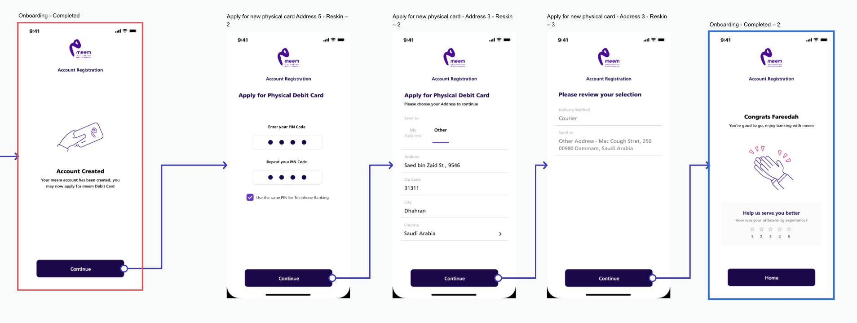

Events: Events are actions or occurrences that a user initiates or experiences while interacting with the Meem App. Events are constructed for a ‘Journey’ and are always analysed in the context of a ‘Journey’.

- Login
- AccountCreation
- ApplyForCard
- UpdateAddress

Attributes: Attributes are data points that provide context or details about the events. They help in segmenting, personalizing, and analyzing user behaviour. Common attributes include:

- TimeStamp
- DeviceType
- AccountType
- CardCategory
- ContentType

By combining events and attributes:
- User Journey: Tracking the sequence of events that lead to conversions or specific outcomes.
- Conversion Path: Identifying the steps and touchpoints that lead to a purchase or other key actions.
- Funnel Analysis: Analyzing how users move through various stages of a marketing or sales funnel.

By capturing and analyzing these events and attributes, Appice provides valuable insights into user behaviour, enabling marketers to make data-driven decisions, personalize experiences, and improve overall marketing effectiveness.
Sample Credit Card Onboarding Process:

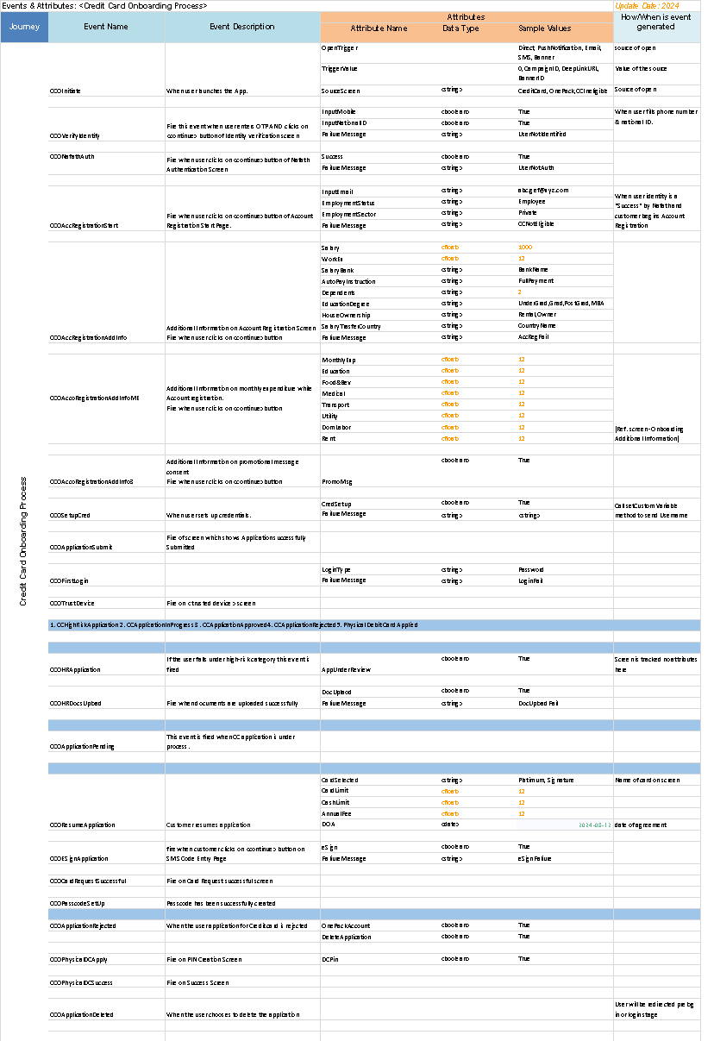

11. Campaign Workflow
The platform offers various engagement channels such as Push, In-App, Web Push, Web Pop-up, Email, SMS, and WhatsApp. Once the channel is selected, one can start building a campaign with multiple variables:
Steps | Methodology
1. Define user journeys and use cases for engagement | Events & Attributes for each user- journey.  App & Web Dev teams integrate SDK which captures interactions with UI.
2. Transactional Data | Use Custom traits for transactional data
3. Events Data | All actions performed by users are captured in real-time e.g. App open, page browsing, select product, add to cart, buy product, exit.
4. Build Segments | As per engagement use cases e.g. [customers who did not login in the past 30 days and have made a deposit in the last 30 days and …]
5. Select Campaign Type | App Push, In-App, SMS, Email, Webpush, WhatsApp
6. Build Campaign | Edit the previous campaign or build a new one – Headline, Image, body, CTA, Button colour, Deep Link, Language, Special parameters etc.
8. Define Campaign Schedule | Date of the campaign, Time, frequency, budget etc. to make life
9. Taking campaigns live | Move campaign from Draft to live stage
10. Campaign Analytics | See analytics in real time to iterate

We have an ability to have a campaign workflow involving multiple stakeholders like product, marketing, compliance, quality etc. for SMS, Push, In-App, Email.
This can be managed through Maker (i.e. Marketer), Reviewer, Infosec & Checker (i.e. Manager) functionality in the User Management section of the portal.
You can follow multi-level reviews/approvals by following this process, say:
- Marketing - Maker (create/edit)
- Quality - Maker (create/review/edit if required)
- Compliance - Reviewer (review and leave comments if required)
- Product Team - Checker (review/edit/activate)

11.1 Select Channel
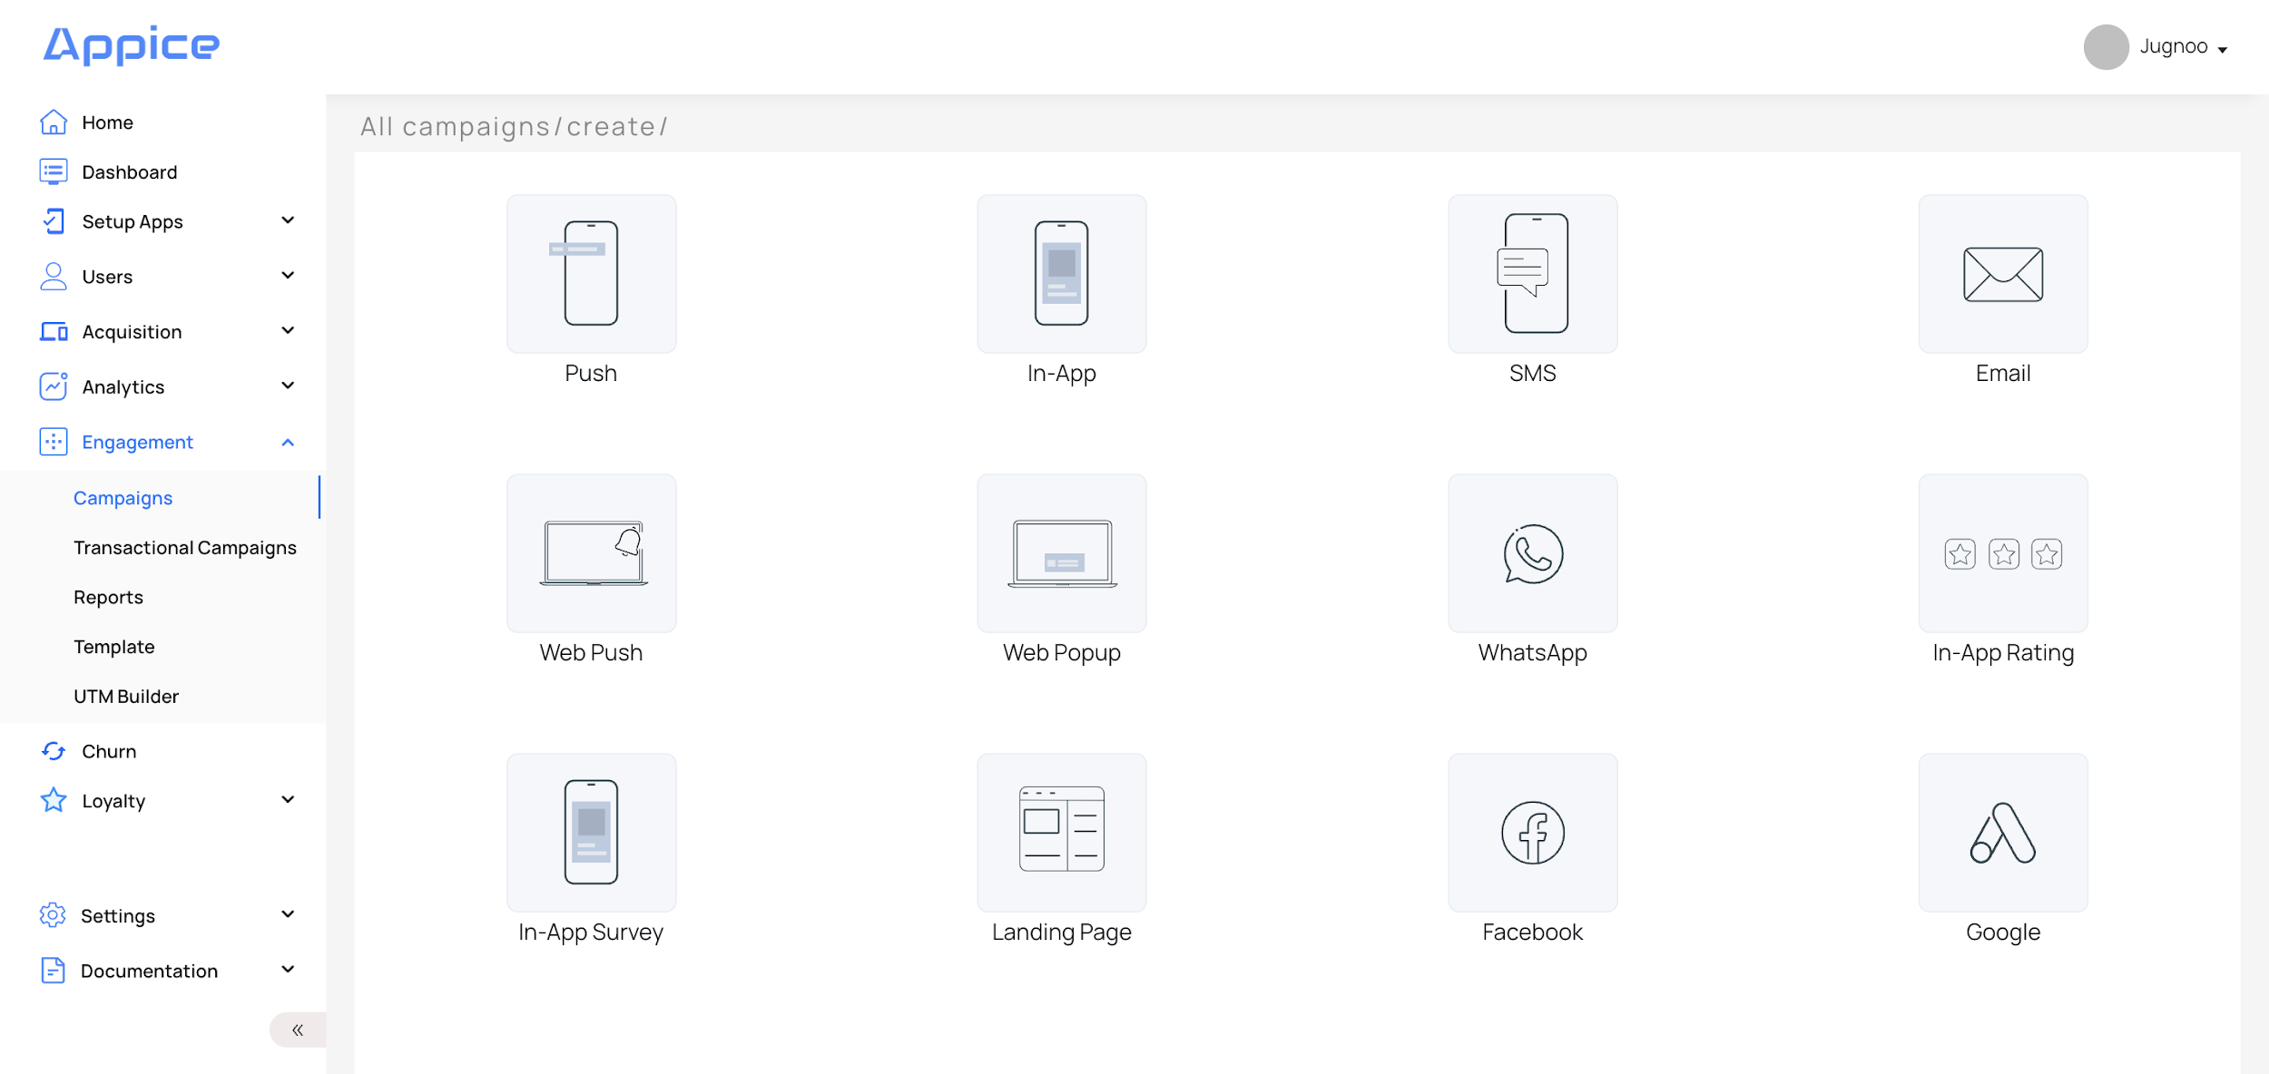

11.2 Creative or Content Sizes: Basis Channel

S.No. | Channel | Type | Image Size | File Size (Max)
1 | Push Notification | Icon | Between (w)60 x 60(h) and (w)96 x 96(h) | 100 KB
 |  | Expanded Image | (w)600 x 300(h) | 500 KB
2 | In-App Notification | Interstitial (image, gif) | (w)480 x 800(h) | 500 KB
 |  | Mini | (w)400 x 400(h) | 500 KB
 |  | Header | Between (w)60 x 60(h) and (w)96 x 96(h) | 100 KB
 |  | Footer | Between (w)60 x 60(h) and (w)96 x 96(h) | 100 KB

S.No. | Channel | Header | Description | Expanded Description
1 | Push Notification | 50 chars | 160 chars | 160 chars
2 | In-App Notification | NA | 80 chars  [only applicable for Header & Footer] | NA
3 | SMS | NA | 160 chars | NA
4 | Email | NA | NA | NA

11.3 Use Prebuilt Templates or Make a New Template
Please note - templates (header content, description content, images, email content, SMS content etc) are to be provided by Bank for AppICE to be uploaded/created into the system.
Example: Email Campaign
- Engage segments such as sleeping users, update new offer etc
- Select pre-built template stored in system or make a new one
- Creatives/Content to create template to be provided by Bank
- Select language and variant
- Add expanded text, image options
- Add redirection URL (if required) - This is not applicable due to security reasons.
- Check IOS/ Android rendering
- Email gateway to be provided by the Bank. Refer to section 22.5 of Appendix for integration steps. Refer to section 11.6 for Email reports.
Email Configuration:
Emailer creative is a mix of text, icons and images. While there is no limitation on number of elements, certain assets need to be optimised. The following recommendations can be followed for key elements:
- Header: horizontal image, max 300 kb
- Hero Image : square or rectangle, max 500 kb
- Footer: horizontal image, max 300 kb
- Product images : square or rectangle, max 200 kb
- Text description: no limit
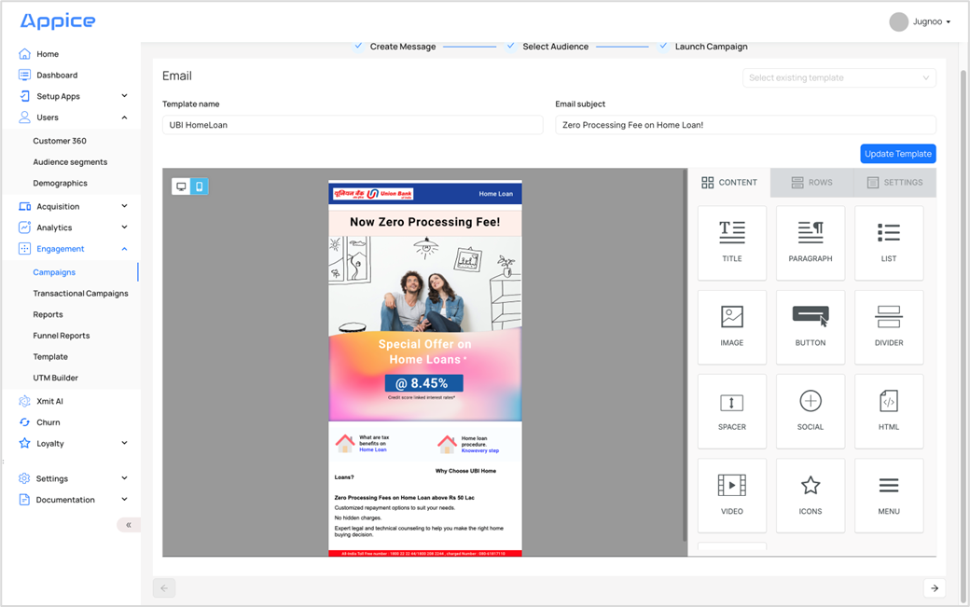
Example: SMS Campaign
- Engage segments such as entire customer base, sleeping users, update new offer etc
- Select pre-built template stored in system or make a new one
- Creatives/Content to create template to be provided by Bank
- Select language and variant
- Add sender details, message text, template id.
- Add redirection URL (if required) in message text - This is not applicable due to security reasons.
- Check IOS/ Android messages
- SMS gateway to be provided by the Bank. Refer to section 22.4 of Appendix for integration steps.
- Refer to section 11.6 for SMS reports.
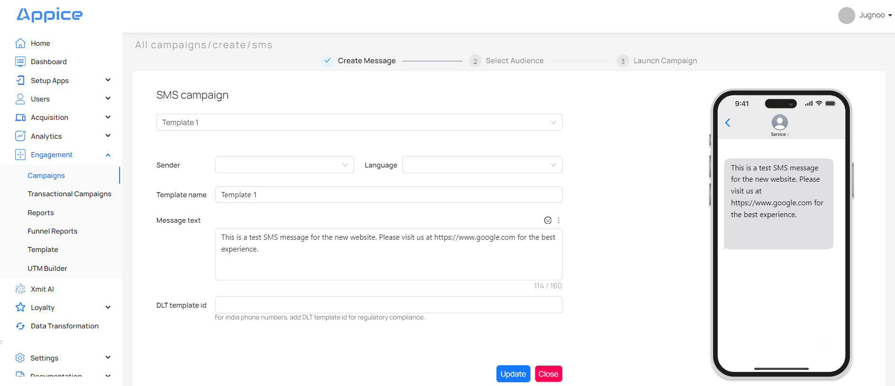

Example: InApp Campaign
In-app notifications are pop-up messages that are shown to the user while they are inside your application. These notifications are useful where we want to show contextual messages, such as discount offers while the user is within the application, OR where users have turned off push notifications.
The In-App Notification module on the appICE dashboard under Campaigns makes it easy to set up In-App campaigns for all your users or specific user segments. These segments can be created on the basis of past or live user behavior, user properties, or a combination of user behavior and properties.
You can trigger a message based on an action. Users receive messages when they perform an action in the app instead of waiting for the next app launch. It makes the messages more contextual and increases conversion.
- Use full-screen In-App for impact
- Select a pre-built template stored in the system or make a new one
- Add call to action button
- Add redirection URL (if required) - This is not applicable due to security reasons.
- Check IOS/ Android rendering
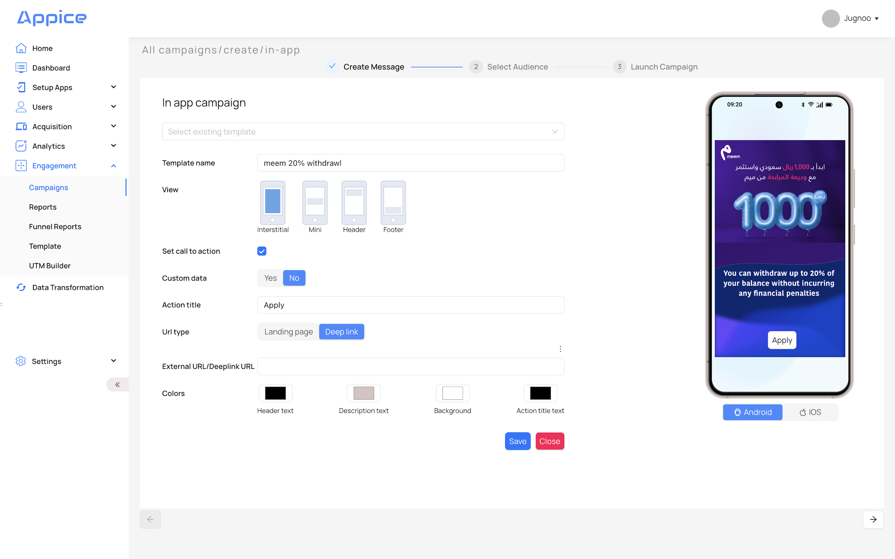
Select Existing Template - You can type and search for an existing template from the dropdown or you can create a new template.
Template Name - Name of the new template.
Set Call To Action - If this is selected, you will see the Action Title and Action URL, otherwise not.
- Action Title - Action to be performed/button to be placed on In-App notification. For example, the Close button has been put on the In-App screen, in the above case.
- URL Type - Landing page is an external URL where your user will land upon clicking the notification. Deep links allow you to land the user to a particular part of your app. If you want to use external URLs, then you have to whitelist the IPs or provide http/https before the URL so they can be handled properly by the SDK.
- External URL/Deeplink URL - On clicking the Action Title, what action should happen. For example, it should take to the respective screen within your app or it should to some external URL.
Tap Action URL - Put a URL where the user should land on clicking an In-App.
Custom Data - Put a deep link where the user should land on clicking an In-App.
Colors -
- Header Text - Color of header text. It should be in Hex Code like #RRGGBB.
- Description Text - Color of description text. It should be in Hex Code like #RRGGBB.
- Background - Color of background. It should be in Hex Code like #RRGGBB.
- Action Title Text - Color of action title text. It should be in Hex Code like #RRGGBB.

Refer to table below for more details:
S.No. | In-App Type | Header Text | Description Text | Background | Action Title Text
1 | Interstitial | NA | NA | Applicable  [for CTA] | Applicable  [for CTA]
2 | Mini | NA | NA | Applicable  [for CTA] | Applicable  [for CTA]
3 | Header | NA | Applicable | Applicable | NA
4 | Footer | NA | Applicable | Applicable | NA

In-App Description - Description to be shown along with the icon. This is applicable for Header & Footer views only.
View (Interstitial, Mini, Header, Footer) - How you want to see your In-App i.e. whether on full screen or in the header or in the footer or between the screen.
- Interstitial (Full Screen) - Uploaded image to be shown as Full Screen. It is shown with one CTA button and one ‘X’ button at the right top to dismiss the In-App.
- Mini - Uploaded image to be shown in the center of the Screen. It is shown with one CTA button and 1 ‘X’ button to dismiss the In-App.
- Header - Uploaded image is shown as an icon. It is shown with one ‘X’ button at the right top to dismiss the In-App. In-App itself works as a CTA. On clicking, it performs the action.
- Footer - Uploaded image is shown as an icon. It is shown with one ‘X’ button at the right top to dismiss the In-App. In-App itself works as a CTA. On clicking, it performs the action.
Example: Push Campaign
Push notifications provide the capability to communicate brief, yet important alerts to your mobile app users. appICE’s rich segmentation and powerful infrastructure let you send time-sensitive, relevant, and personalized push messages on a large scale.
The Push Notification module on the appICE dashboard under Campaigns makes it easy to set up push campaigns for all your users or specific user segments. These segments can be created on the basis of past or live user behavior, user properties, or a combination of user behavior and properties.
Once a campaign has been sent, you can view detailed reports on how many messages were sent, how many users clicked on them, and how many users converted as a result.
- Engage segments such as sleeping users, update new offer etc
- Select pre-built template stored in system or make a new one
- Select language and variant
- Add up to 3 CTA buttons - For example: Apply Now, Cancel & Remind me later
- Add expanded text, image options
- Add redirection URL (if required) - This is not applicable due to security reasons.
- Check IOS/ Android rendering

NOTE: 2 CTA buttons are already supported. 1 more CTA button is in the release pipeline and will be available in the future release. This requires SDK change.

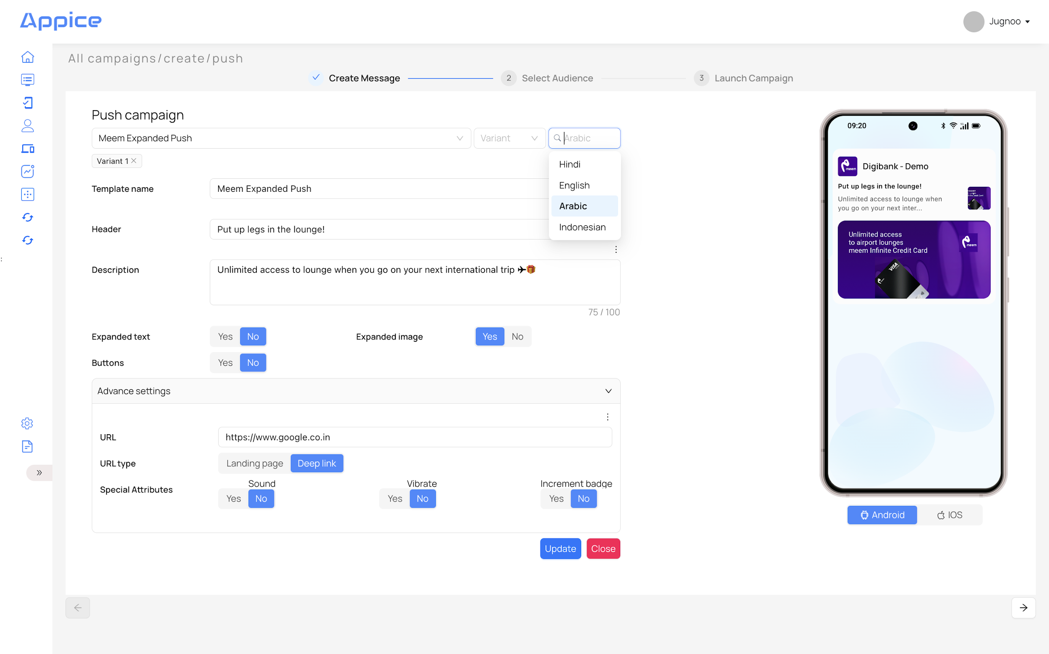
Select Existing Template - You can type and search for an existing template from the dropdown or you can create a new template.
Template Name - Name of the new template.
Header - Title of the push notification.
Description - Description of the push notification.
Expanded Image -
Yes - The expanded image should be shown, in addition to the icon, headline & description in Push received on the device.
No - Expanded images should not be shown.
Expanded Text -
Yes - Expanded text should be shown, in addition to icon, headline & description in Push received on the device. Description to be put in the Expanded text description textbox.
No - Expanded images should not be shown.
NOTE: Push is received with headline & description on the device. On scrolling the ‘arrow’ icon, it should show an Expanded image or Expanded text.
Buttons -
Yes - There should be an option to assign button name & URL to it.
No - There should be no option to put a CTA button.
Maximum 2 buttons can be shown.
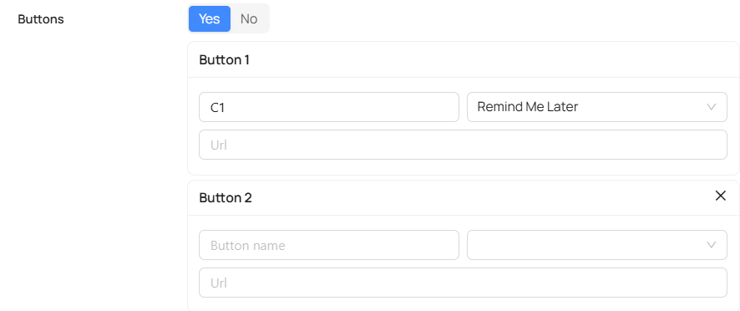
Advanced Settings -
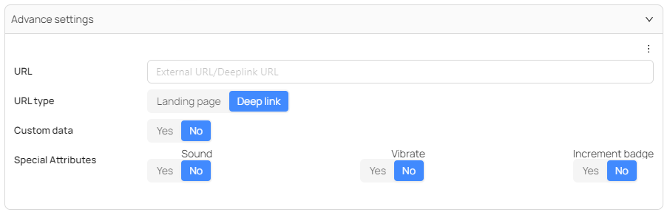
URL - Landing page is an external URL where your user will land upon clicking the notification. Deep links allow you to land the user to a particular part of your app. If you want to use external URLs, then you have to whitelist the IPs or provide http/https before the URL so they can be handled properly by the SDK.
URL type -
Landing Page - If selected, on clicking the notification, it should take to external URL, which is put in the option below.
Deep Link - If selected, on clicking the notification, it should redirect to a specific product screen within the app.
Custom Data -
Yes - This is valid only with the Deeplink option. It does not affect even if it is put with a Landing Page URL. On clicking notification, it should take you to a specific target screen.
No - No custom data to be put.
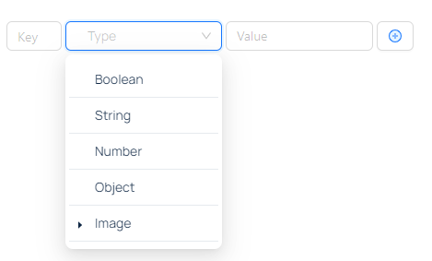
NOTE: This is applicable for the AppInbox feature.
Special Attributes -
Sound - Notification to be received with sound.
Vibrate - Notification to be received with vibration.
Increment Badge - Show badge count on App icon. Applicable for iOS only.

11.4 Select Segment
- Use existing segments or go back and create a new one.
- Target Audience Segment can be divided into 4 parts:

Events
can be created on the basis of Past or Live events performed by the users within the App.
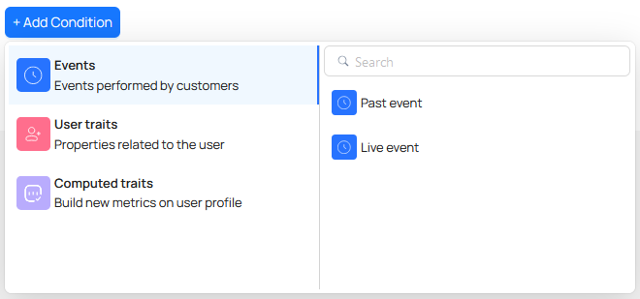

User Traits
can be created on the basis of User properties like Device, Profile etc. There is an option to upload a segment of users as well to create a segmented campaign, where customers' device IDs / Customer IDs can be uploaded to send messages.
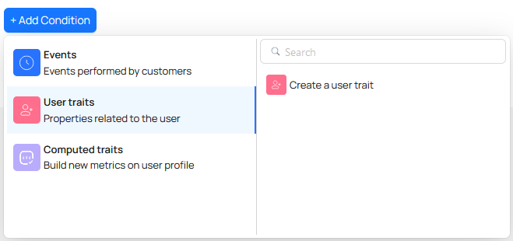

Computed Traits
can be created on the basis of computation done on transactional data of the users.
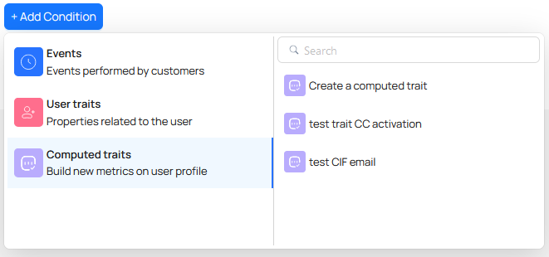
These criteria can be used together (by clicking on Add Condition) to create an audience segment. For example:
Users WHO have done Past event (VisitLoan)
+
Users WHO have Device (Android)
+
Users WHO have Average balance greater than 50,000
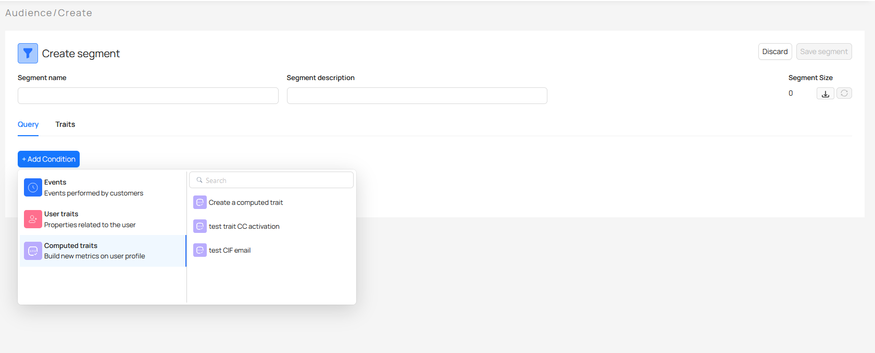
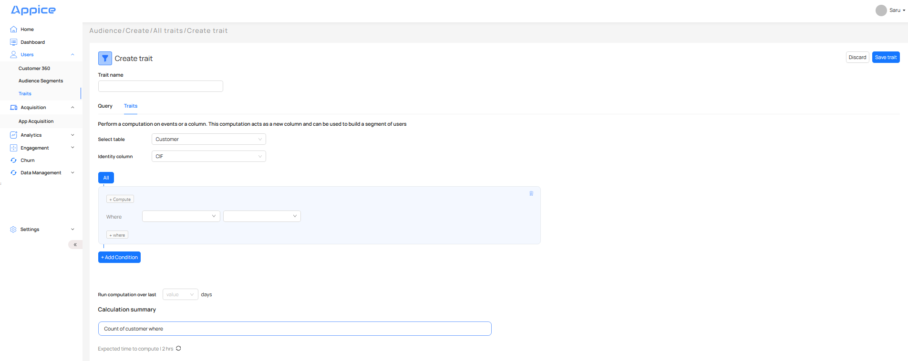
On saving the audience segment, it takes to this screen and it shows the newly created audience segment as selected.
There is an option to upload audience segments as well in a specific csv format. This can be uploaded with device IDs, Customer IDs, Phone numbers.

11.5 Scheduling
With date, time, frequency settings, batch send, day parting, delivery type etc.
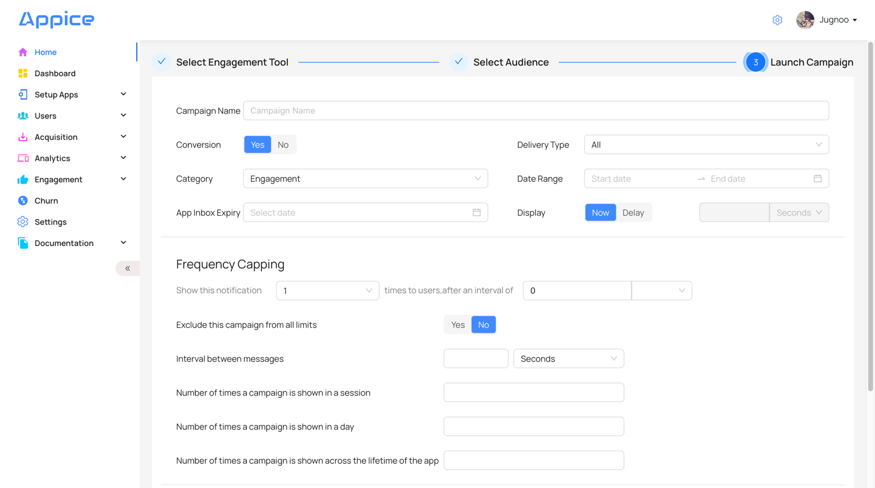
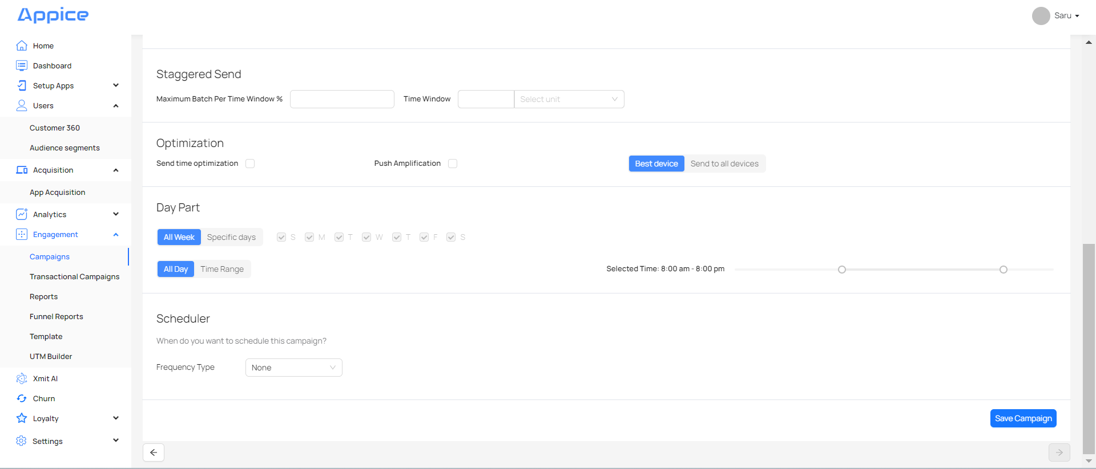
There are various settings on this screen:
Campaign Name - Name of the campaign
Delivery Type - There are various options to receive push notifications on device:
- All - Receive push notifications in notification tray as well as in App Inbox.
- DirectPush - Receive push notifications in notification tray only.
- InboxOnly - Receive push notifications in App Inbox only by clicking on the bell icon within the application.
Category - There are various categories:
- Engagement
- Uninstall
- Geofence
- Transactional
Date Range - You can choose the Start Date & Stop Date of this campaign.
App Inbox Expiry - Put date to remove notification from App Inbox
Display - You can send notification immediately (Now) or after some time (Delay).
Conversion - You can add conversion event to campaigns to determine the success rate.
Live Event - You can send campaigns as soon as any event is performed by the user.
Frequency Capping - You can limit the number of times the campaign can be sent to individual users.
NOTE: There is a way to set frequency globally for all the campaigns through App setting - Global Frequency Capping.

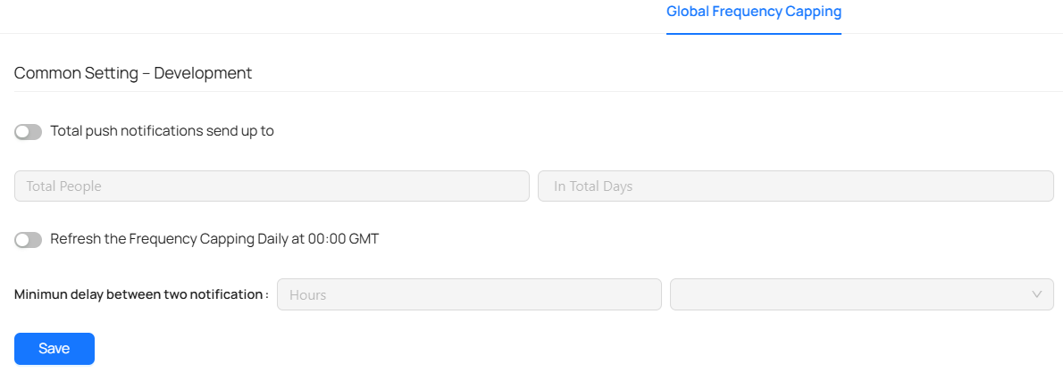
For example:
In case of campaign with a segment → WHO + WHAT
S.No. | Individual Frequency Capping | Global Frequency Capping | Priority | Output
1 | No change | No change | Individual Frequency Capping | Campaign should receive as when audience criteria is met
2 | No change | Changed (to 100, say) | Global Frequency Capping | Applicable to all the campaigns. Campaigns should be received max 100 times per user as when audience criteria is met
3 | Changed (to 100, say) | No change | Individual Frequency Capping | Applicable to this campaign only. Campaign should be received max 100 times per user as when audience criteria is met
4 | Changed (to 100, say) | Changed (to 120, say) | Global Frequency Capping | Applicable to all the campaigns. Campaign should be received max 120 times per user as when audience criteria is met

Staggered Send - You can send campaigns to users in batches instead of sending to all the users at one time.
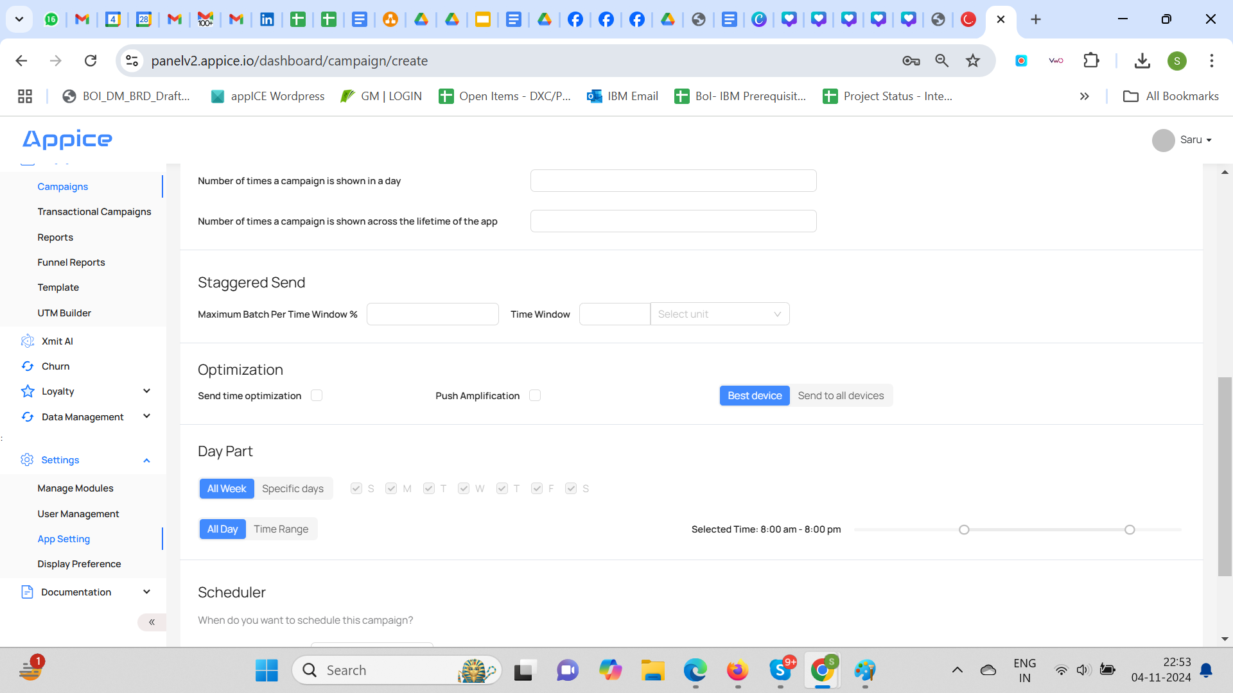
Optimization - You can optimize the campaign to be sent to the best users at the right time.
Day Part - You can send campaigns at specific times/day.
- All Week - By default this value is selected which means the campaign should run on all the days of the week.
- Specific Days - You can choose any specific day/days to run this campaign.
- All Day - By default this value is selected which means the campaign can be run anytime during the day.
- Time Range - You can choose any time range to run your campaign.
Scheduler - You can schedule the campaigns with frequency type - Recurring, Multiple Dates.
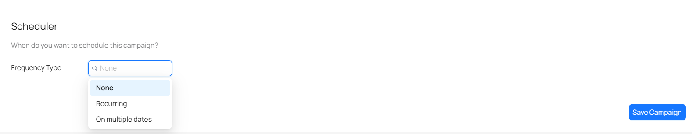
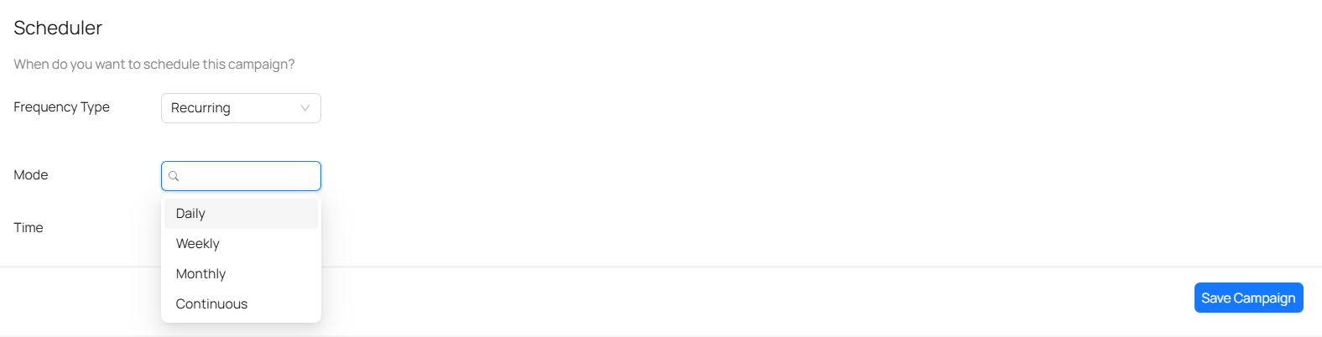
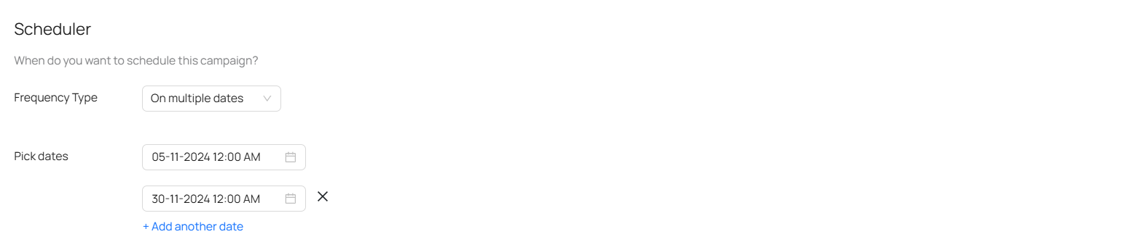
After putting the required settings, you can then click on Save Campaign to save the campaign.
On saving the campaign, it takes to the initial screen, which shows a list of all the campaigns, and you can see this campaign in the Draft Campaigns list.
Move campaign from Draft to Live:
- All new campaigns are by default sent to <draft> stage
- Maker, checker governance allows process adherence while making campaigns live
- Additional controls for campaign management
  - Set Active
  - Edit
  - Copy
  - Delete
  - View performance details

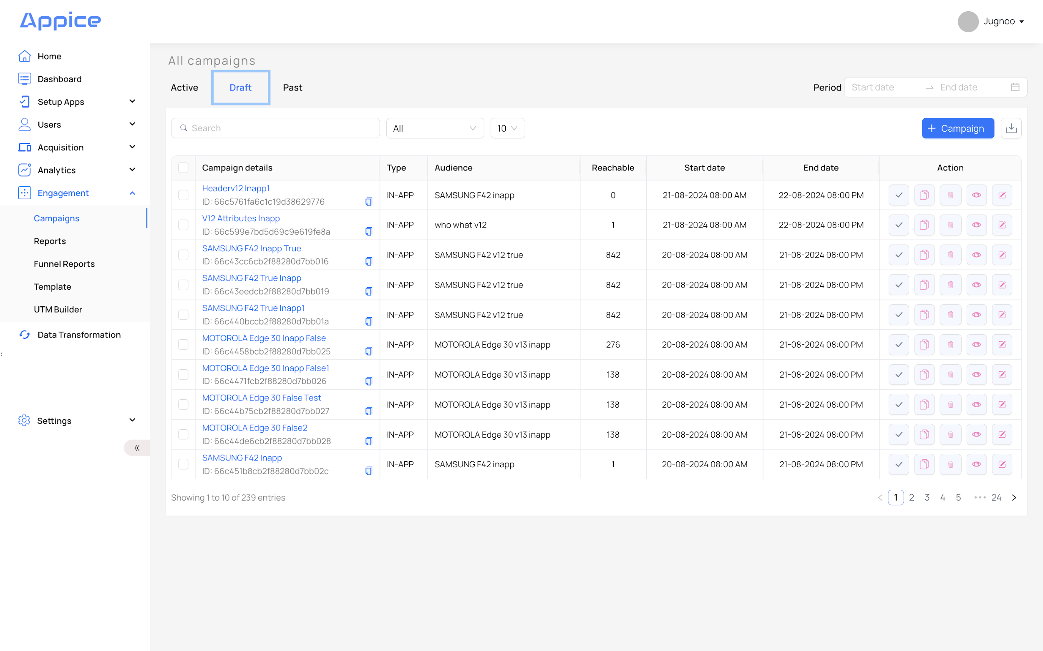
Campaign Details - Name of the campaign.
Type - Shows type of campaign i.e. PUSH, INAPP etc.
Audience - Name of the audience segment created/selected.
Reachable - Total possible base of the segment created.
Delivered - Total number of successful sends of the campaign.
Clicked - Total number of clicks on the campaign.
CTR - Click through rate. This is calculated as Clicked ÷ Sent.
Conversion - This is calculated as per the criteria put for Conversion i.e. if the selected
event has happened within the selected period, it will be counted as a conversion. This is not applicable as of now.
Start Date - Start date of the campaign
End Date - End date of the campaign
Action - This can be delete, edit, copy, active and preview.
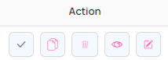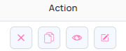
Edit - You can edit campaign settings.
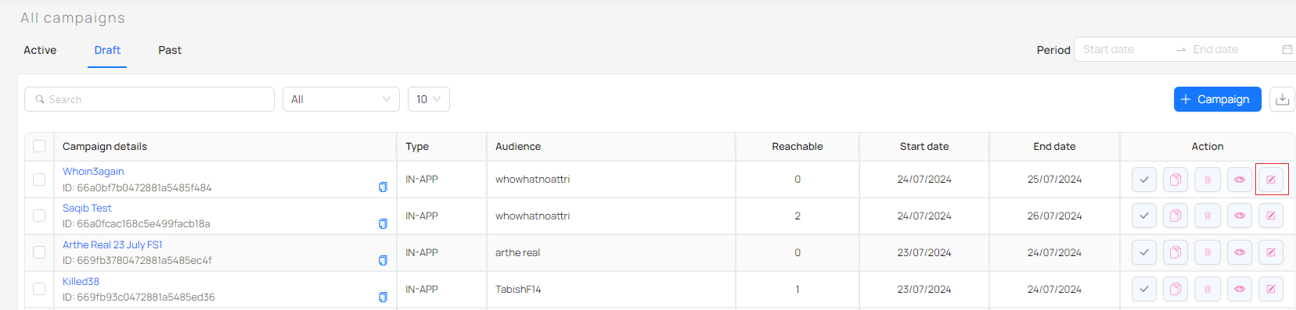
Active - You can make it active to run the campaign.
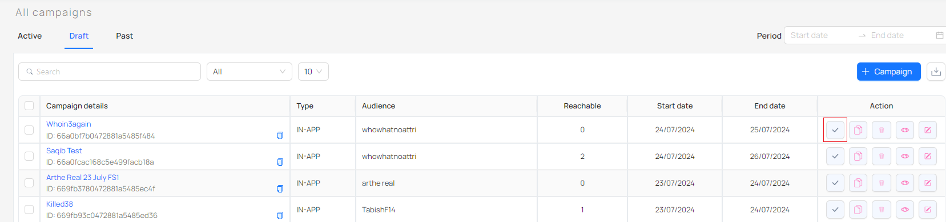
Copy - You can make a copy of the existing campaign instead of creating a new campaign every time.
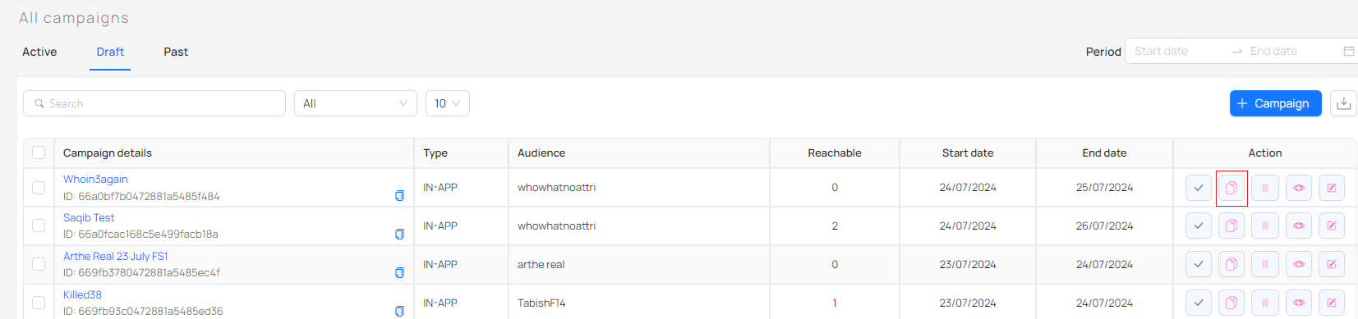
Preview - You can preview the campaign and its settings.
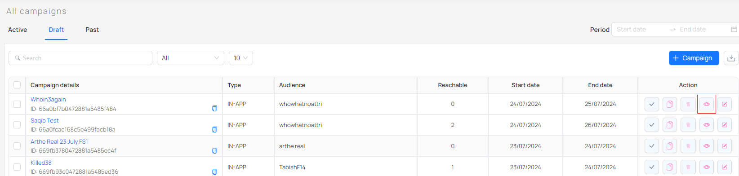
On clicking, it takes you to the next screen.
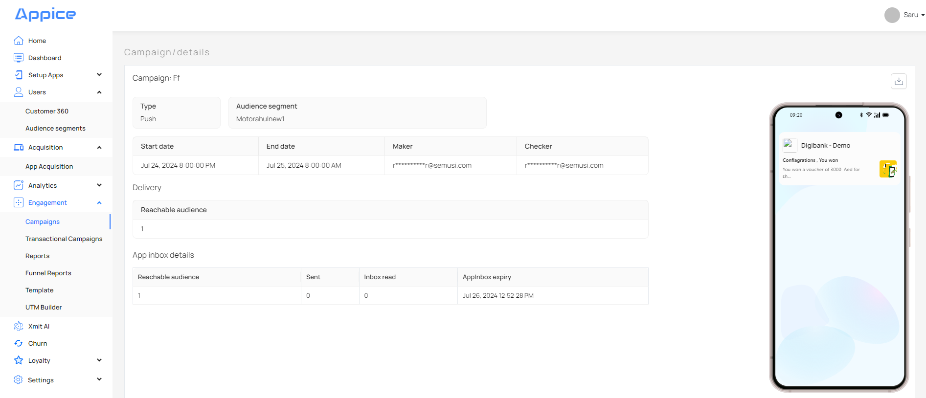

Once you mark this campaign as ‘Active’, it will send a push notification to your selected audience segment.

11.6 View Campaign Reports & Analytics: Basis Channel

Campaign Analytics
Push, InApp | Email | SMS
Reachable Audience | Sent | Sent
Sent
Clicked
CTR%

NOTE: It is not possible to track Open/Delivered/Bounced for Email/SMS as gateway does not send the same as a callback. Also, it is not possible to track Click/Click Rate as there is no click URL in Email/SMS due to security reasons.
All reports have additional information on:
- Campaign Type
- Segment sent to
- Maker email (Marketer role in our case)
- Checker email (Manager role in our case)
- Start date, End date
- AppInbox details
Push Campaign Report:
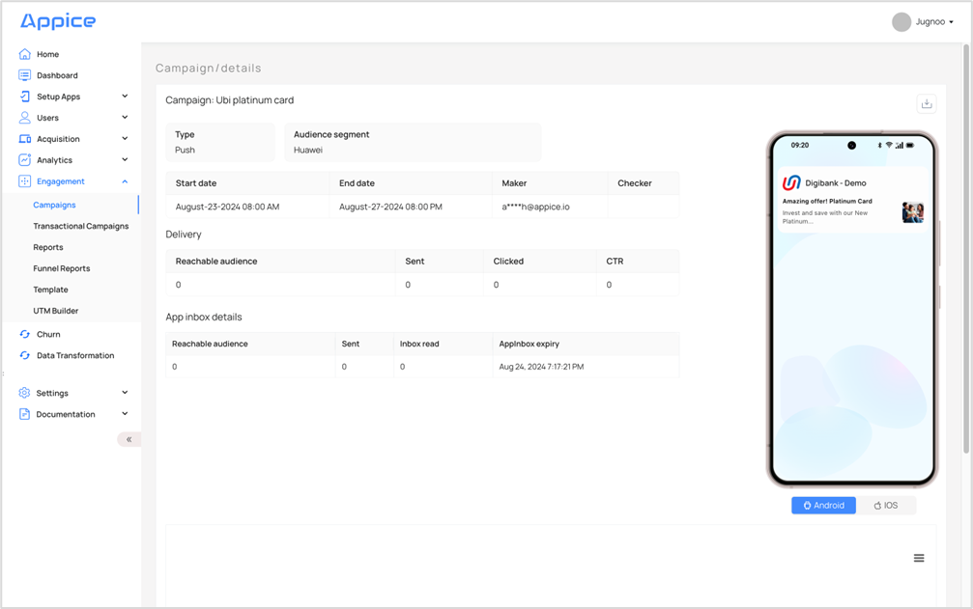
Email Report:
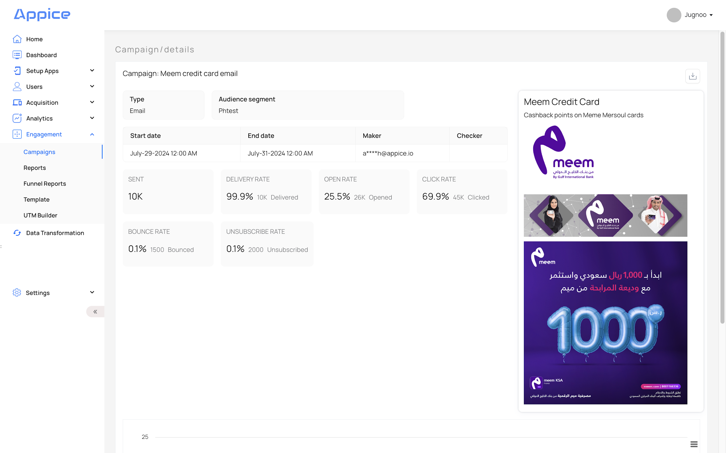
Campaign reports can be downloaded by selecting Period and then clicking on download icon.
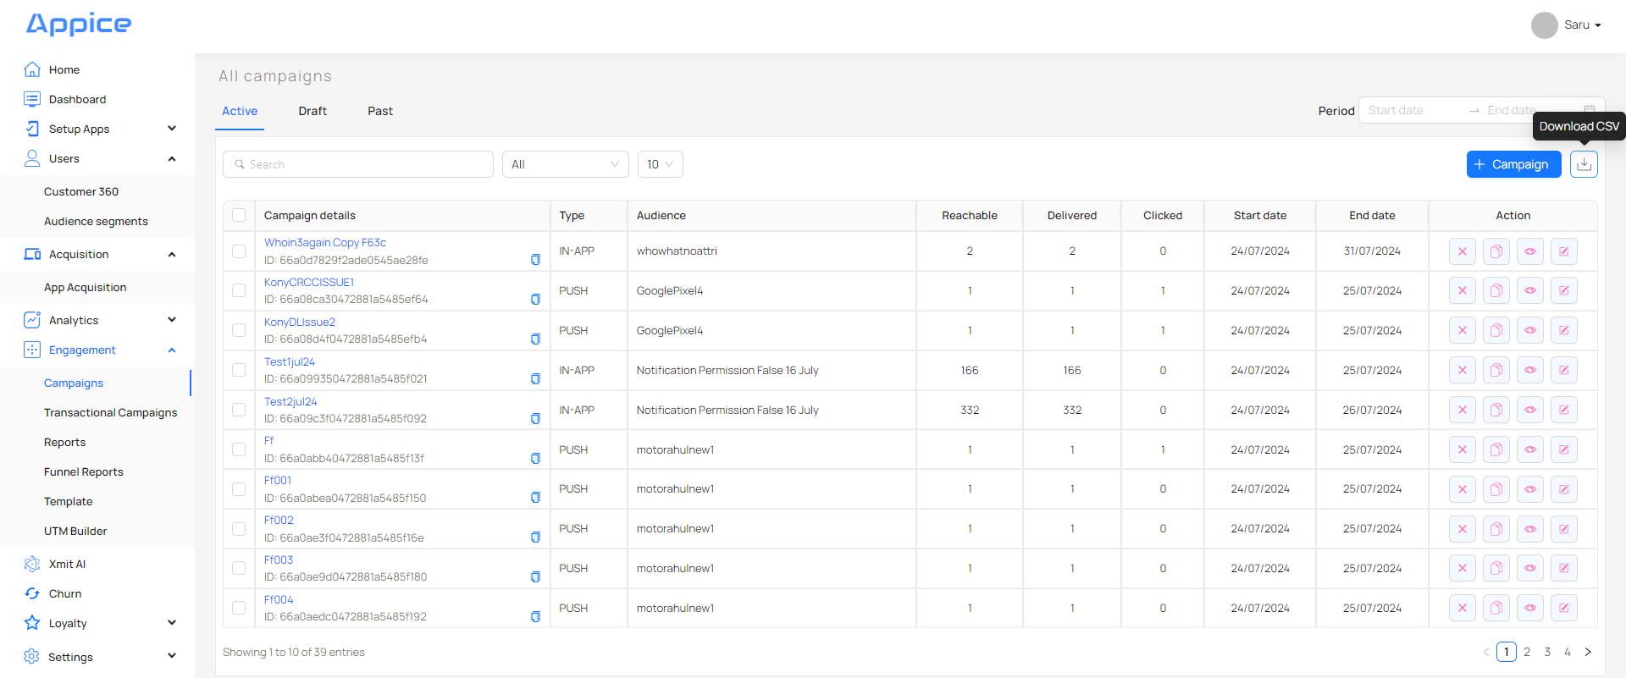

12. App-Inbox behaviour

Push campaigns made by Marketing/Internal systems are also seen inside App Inbox. Each Notification in App-Inbox has 3 sections:

- Header Text
- Image
- Description Text
- CTA buttons (3)

NOTE: 2 CTA buttons are already supported in Push but not in AppInbox yet. 1 more CTA button is in the release pipeline and will be available in the future release of Push. This requires SDK change and will be available in future release of AppInbox.

You can set App Inbox Expiry from the App Inbox Expiry field under the Launch Campaign tab.

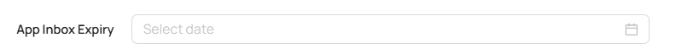

If not set, it takes the campaign end date as App Inbox expiry date.

To go to App-Inbox:
- Customer clicks on the ‘Bell’ icon on the homepage of the App.
- Campaigns are shown in List-View inside App Inbox.
- Campaigns remain in App-Inbox as per the ‘retirement’ days defined while creation.
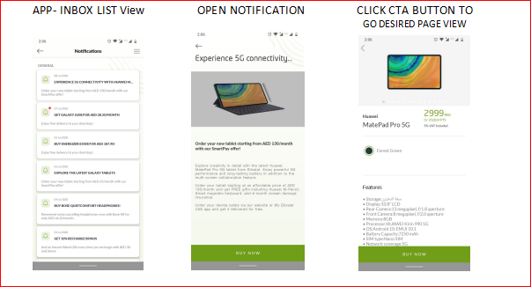

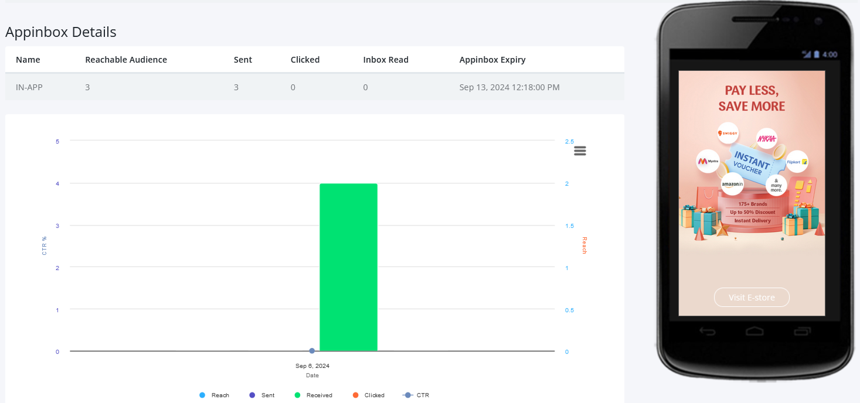

13. APIs
This section covers the AppICE SDK Server API endpoints used by the various SDKs to communicate with the AppICE backend server. These APIs cover the following scenarios:

- Initialization for a new device
- Capturing events for behaviour analytics
- Updating metadata and data about the device and user
- Retrieving metadata and data about the device and user

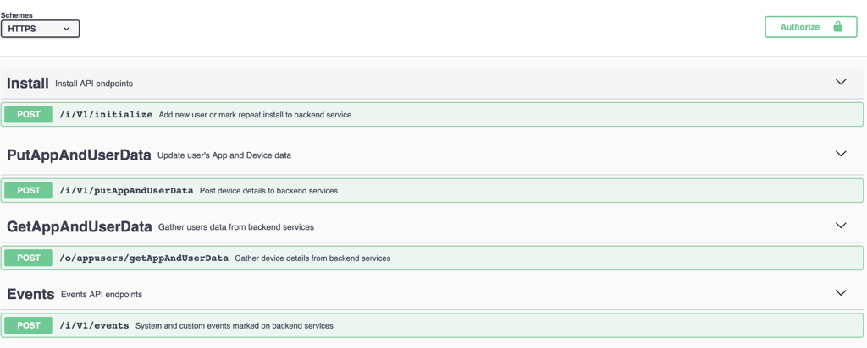

14. Use Cases
GIB has shared a list of Use Cases which are to be configured and tested in SIT.
The required information for configuring Use cases are mentioned in the Compliance Feedback excel.
Details like:
- Notification Content for each use cases
- Notification Target customers.
- Which data/Fields will be used while configuring campaign
- Events/Transactional data to be used
Refer to section 22.1 of Appendix to get detailed information on configured use cases.

15. Segmentation & Traits
Both transactional and behavioural data is used to generate segments for targeting:

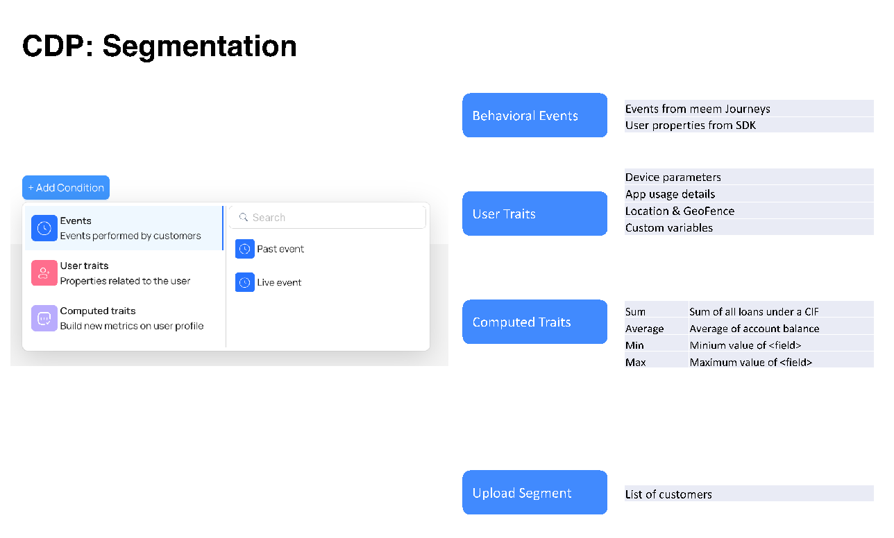

15.1 Segmentation
AppICE is built on the premise that the user journey is a combination of who they are, what they are doing, and when and where.

WHO: User Properties such as First Seen, Last Seen, Session Length, Android or IOS users etc.
WHAT: User behaviour on the app with all the events listed above.
WHERE: User location or based on Geo parameters
WHEN: Basis Time of usage

Using these parameters, an audience segment is created. Each audience segment has a ‘reach’ which is defined by the number of users who fulfil the ‘segment’ criteria. When the campaign segment is activated, various controls for sending the campaign are available such as

- Frequency: Number of times the campaign is shown in x time limit
- Date Range
- Send Now or Delay
- Days of Week
- The time Range for sending the campaign

Micro segments allow brands to run hundreds of experiments on what strategies are most likely to convert customers.

SEGMENTS: Can be a combination of

- Events Data: From DBP & DLP, ingested via Appice SDK
- User Traits: User parameter ingested via Appice SDK e.g Device, first seen, location etc
- Computed Traits: Transactional data ingested via SFTP

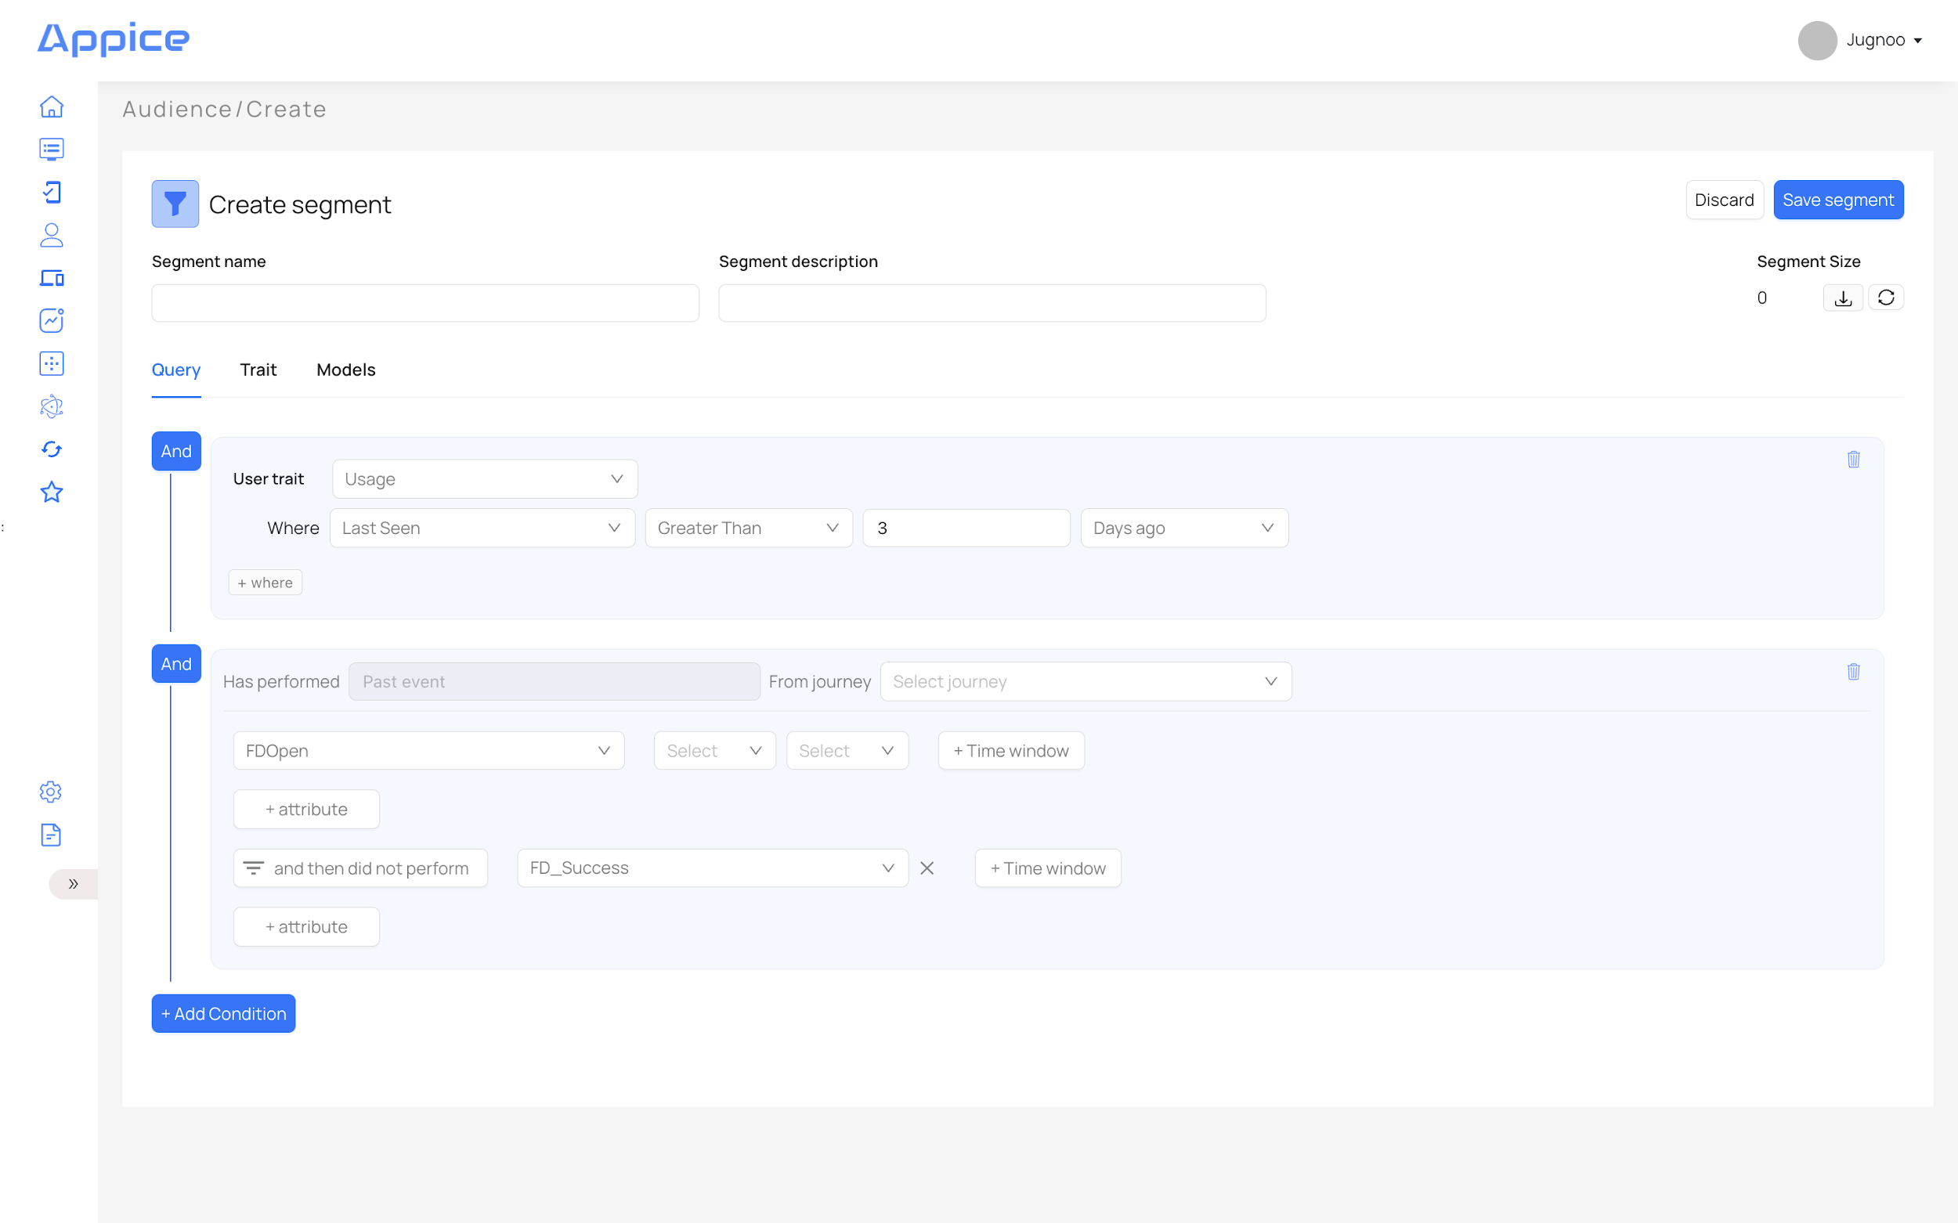

15.2 Traits
Traits are built using transactional data from C360, by performing functional computation on data fields.

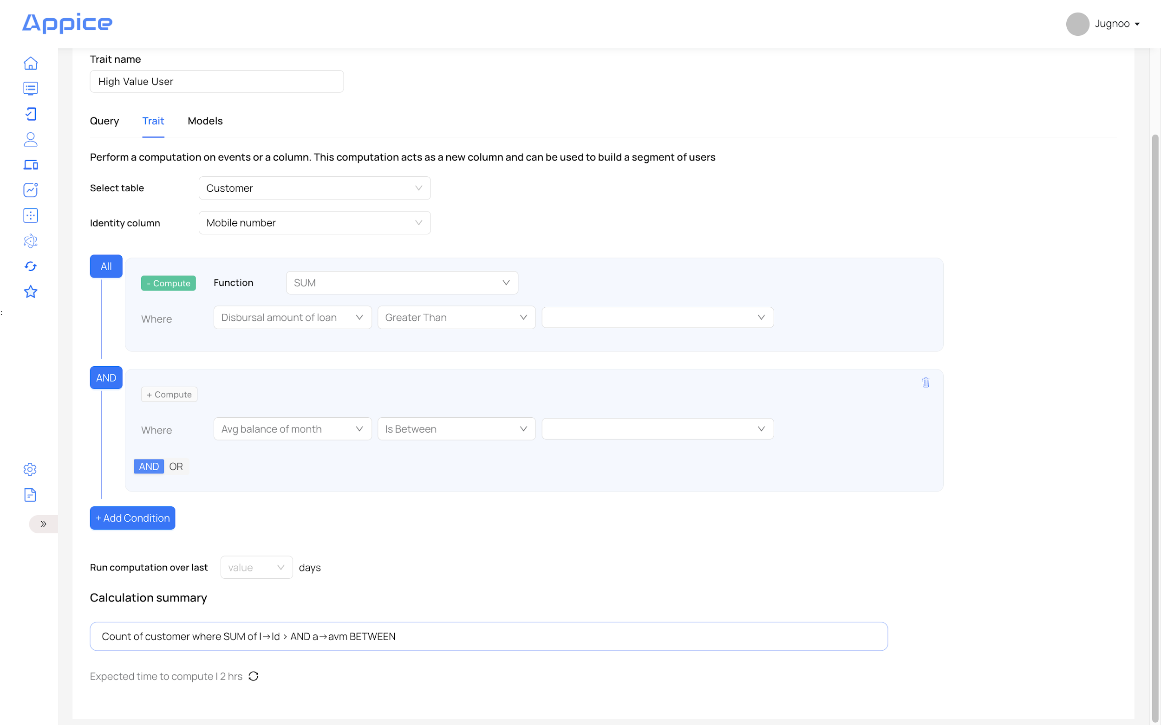

15.3 Computed Traits
You can use computation on the transactional data to build ‘computed traits’ and these sets of customers can be included in a ‘segment’.
Functions used in calculations: SUM, AVERAGE, MIN, MAX, COUNT
Let's understand the use of this functionality via the following requirements:
- Those customers who have loans > $ xx amount
Using compute function: To include all the customers who have loan amounts ( from multiple loans or single loan) greater than $ xx:
  - Use compute function <SUM>
  - Select col ‘Disbursal amount of loan’ is <greater than> $ xx

- Those customers whose average account balance is between $ xx – $ yy amount
Without compute function: Include all customers who may have multiple accounts, but a single CIF
  - Do not use the compute function
  - Select col ‘Avg balance of month’ <is between> $ xx to $ yy

Customer 360 Capabilities: Combining all data in the golden record to take engagement actions.
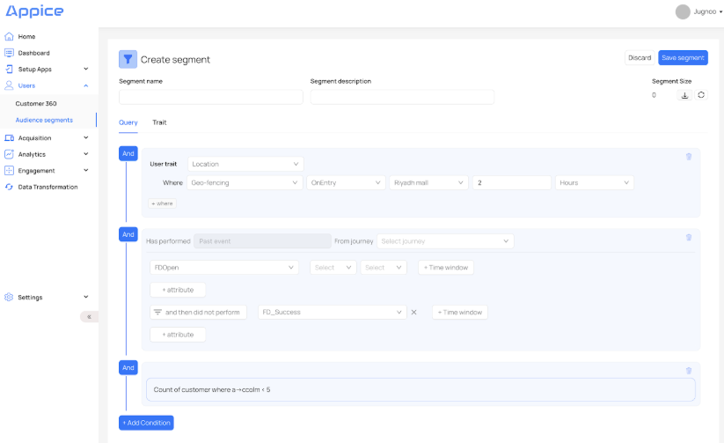

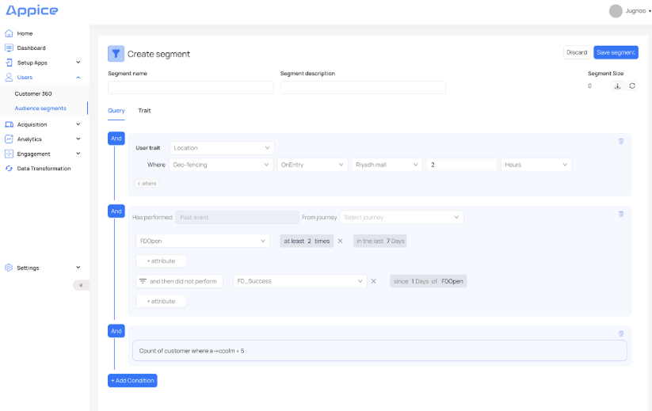

The following functional dimensions allow segment construction to enable various use cases:
Data Type | Example
Behavioural Events
Past Events, Live Events | Events & Attribute captured by SDK
Example: Events of a journey e.g FDOpen, FDSuccess | Customer who has started the ‘Deposit’ journey at least 2 times in the last 7 days And did not complete the ‘Deposit’ since 1 day of FDOpen
Frequency Functions for Events | At least, At most, exactly
Time Functions for the Event | In the last, in the next, before, since, after x Time unit in Seconds, Minutes, Hours, Days, Weeks, Months
Attribute Functions | Equals, Not equals, contains, In(set operator), Not in(set operator), Starts the string, Ends the string, Does not start the string, does not end the string
Did Perform, Did not Perform Function
User Traits
User Profile | Language, User ID etc
Device
Usage | First seen, Last seen, Session count, Total session, Notification permission
Location | City, District,State
Location - Geo Fencing | Entry, exit
Custom Segment | ClientID, DeviceID, Email, Mobile
Computed Traits
Compute Function | Sum, Min, Max, Count, Average
Data Fields | All Transactional / Demographic / Product usage fields in Customer 360

NOTE: For each Use Case, there will be one segment created on the basis of:
- Behavioural data only
- Transactional data only
- Behavioural & transactional data both
For 55 Use Cases, there will be 55+ segments created.

15.4 Language Selection
Language can be selected during campaign creation.
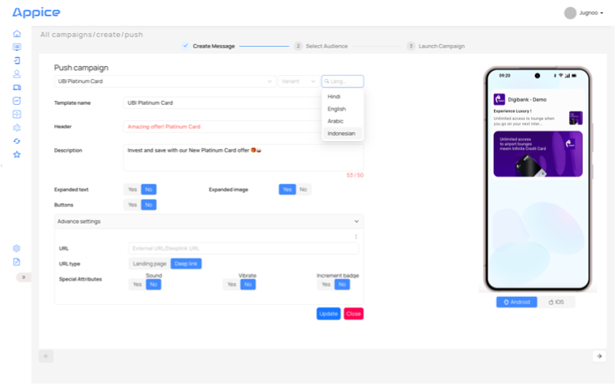

15.5 Timezone & Geotagging
Proximity based geo marketing solutions:
- Use Radial/Polygon based geofences that are best suited to real world environments
- Use Dwell Time and Real Time targeting

AppICE SDK captures location coordination (under OS allowed user privacy policies): IP address-based location to send geo-fenced campaigns.
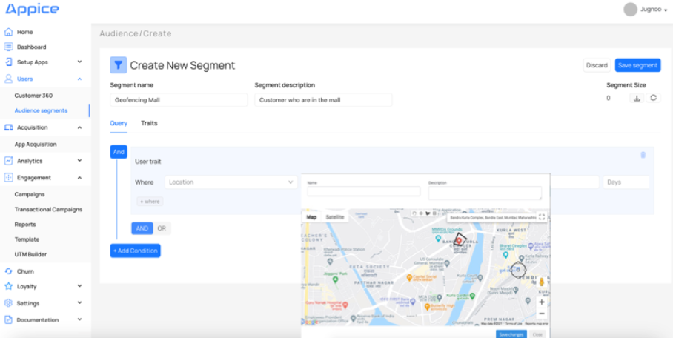
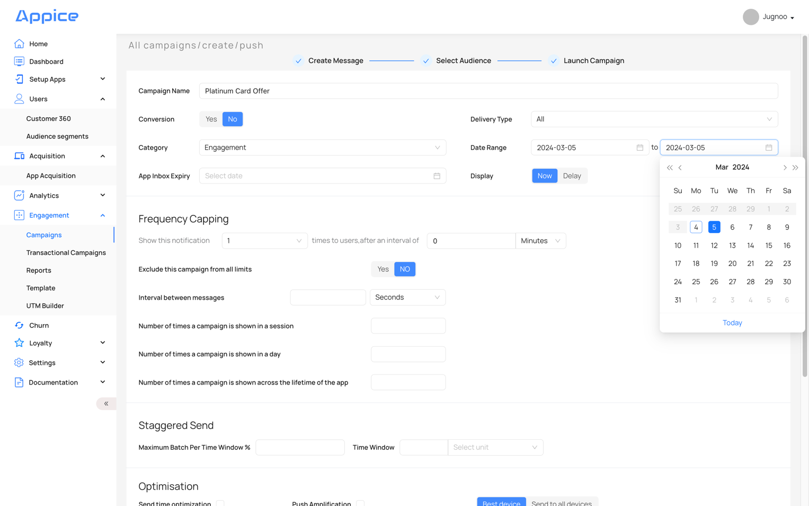

15.6 Multivariate Testing
The platform allows operating teams to perform multivariate tests, to figure out which campaign works better. You can build multiple options to target a segment such as – Headlines, Images, Click button colours. The platform then runs these campaigns on a small data-set and basis outcomes, activating the winning campaign on the target base.

15.7 Digital Asset Manager (DAM)
We store all images, icons, campaign details so that variations can quickly create campaigns – either new or for Multivariate tests. A simple UI allows anyone to build a campaign for any segment in a few minutes.
How AppICE manages campaigns components:
DAM Asset | Template ID | Ver No
Image 1: ID82022jw92 | TID9202 | Ver1.1
Image 2: IDwld93kw02j | TID8292 | Ver1.12
Deep Link URL https://gib.app/page | TID1192 | Ver2.39
CTA_loanapply | TID1139 | Ver2.1

16. Behavioral Data Analytics

Please note - following fields are to be shown as masked on portal/csv (if applicable):
- FirstName
- First Name Arabic
- Nationality
- Email
- Primary Mobile
- Dakhli AVG salary
- Salary Range
- Account Number
- AVAILABLE_BAL
- MonthlyAccountBalance AVG
- Amount AVG

Note that customer data will not be extracted as raw data. Reports show aggregate data.

16.1 Aggregate Dashboards
- New users trend – by OS
- Daily active users
- Weekly active users
- Monthly active users
- Active user trends
- DAU trend
- Campaign Engagement count, active campaigns, total campaigns

Overview of App & Web Performance Data
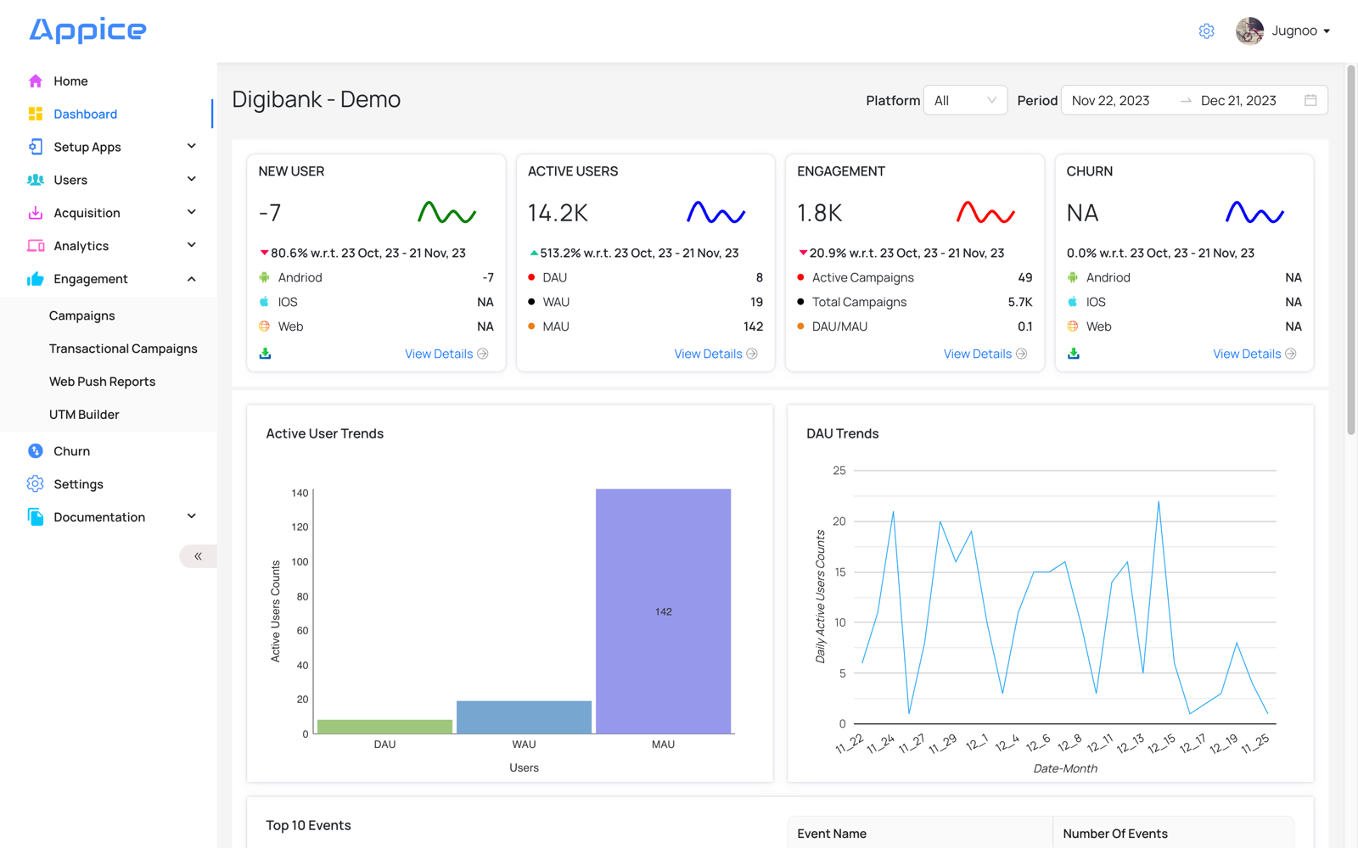

User Analytics
You can see the count of Users in different categories.
Refer screenshot below.
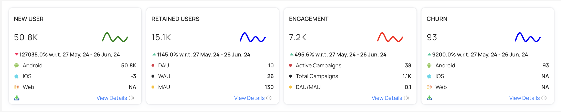

New Users
Acquisition is the selected period. You can see the count of users who have installed the application. This can be split based on Platform - Android, iOS , Web. Clicking on ‘View Details’, takes you to a new page to see this section in detail.

Retained Users
Active users are those users who have not uninstalled the app e.g 15.1K

Metrics under this tab:
- DAU (Daily Active User): Avg count of unique users per day who have opened the App or visited the website.
- WAU (Weekly Active User): Avg count of unique users per week who have opened the App or visited the website.
- MAU (Monthly Active User): Avg count of unique users per month who have opened the App or visited the website.

Clicking on ‘View Details’, takes you to a new page to see this section in detail.

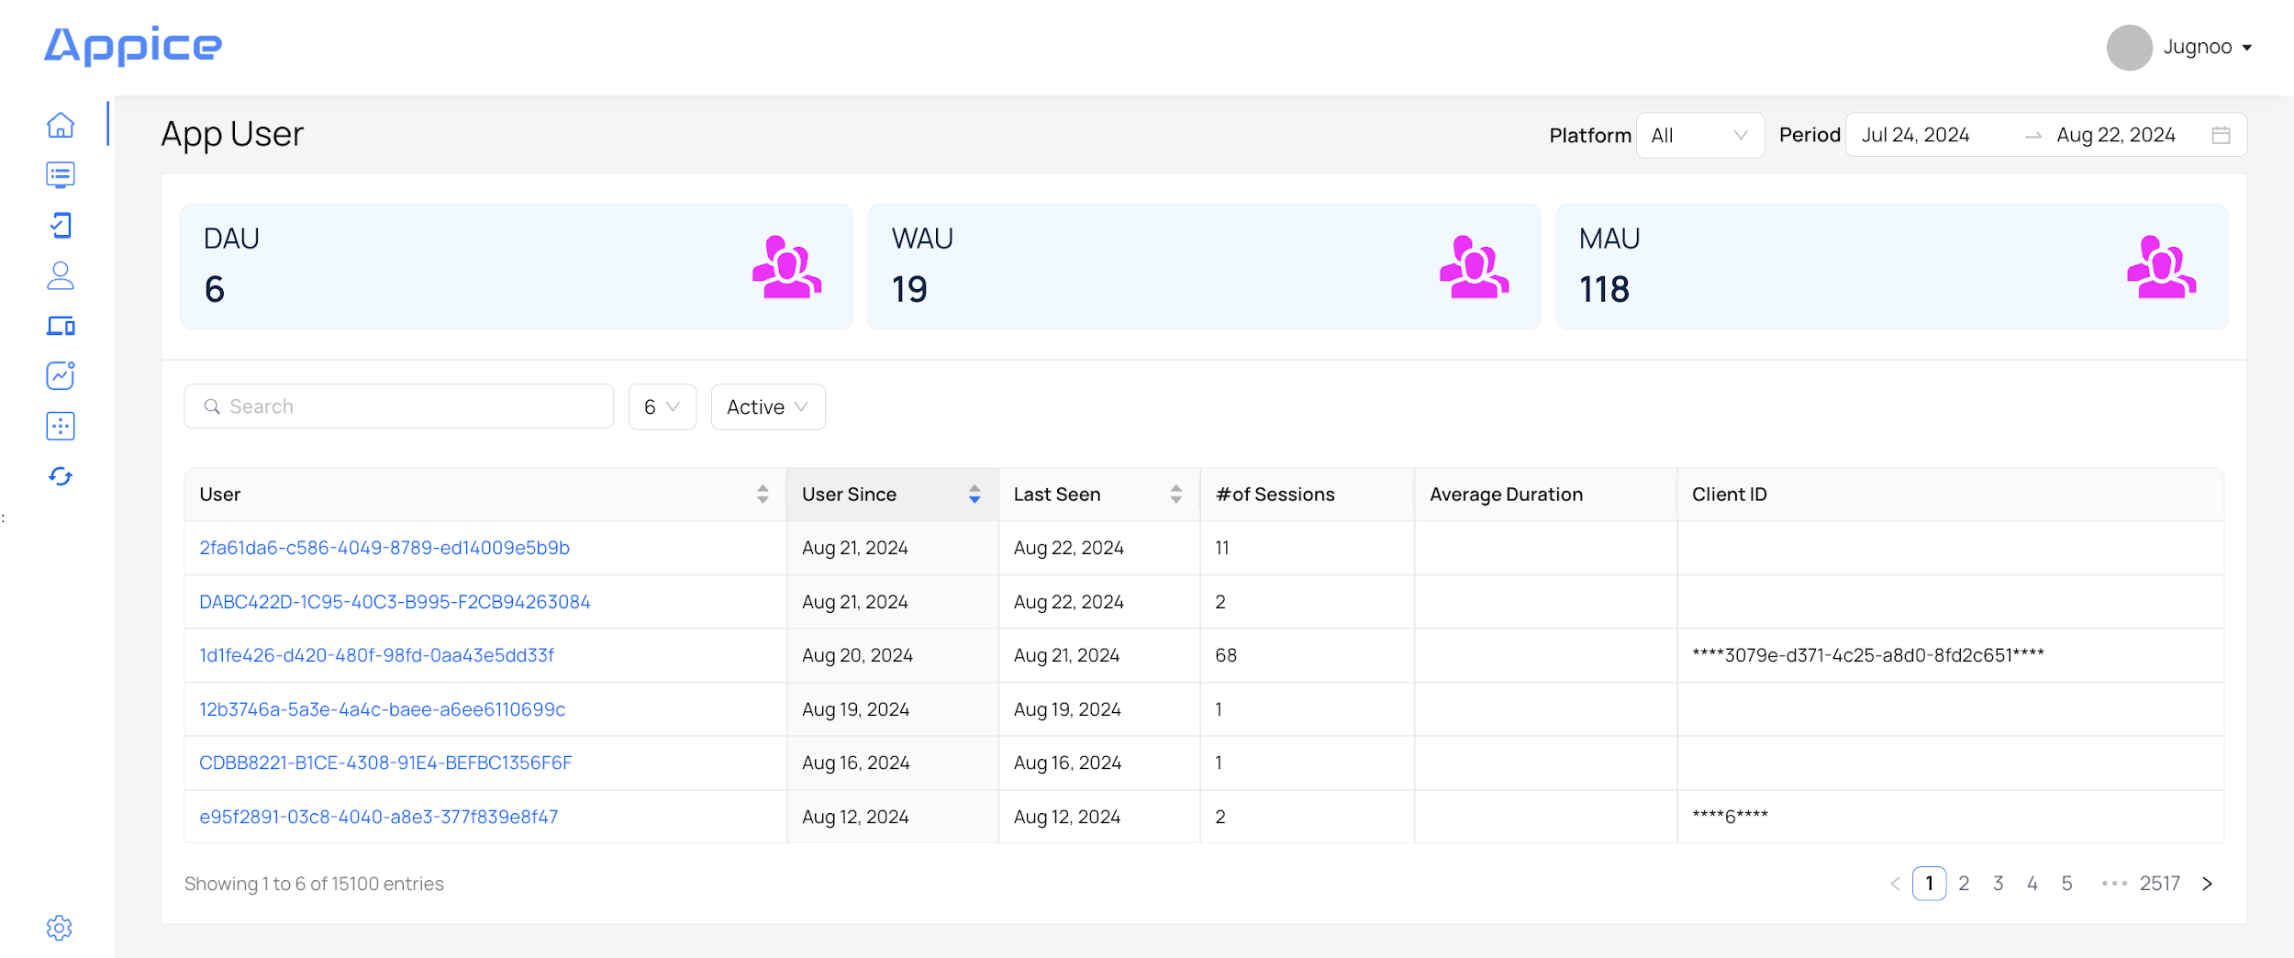

Engagement
Engagement is the number of sessions that have happened in the given time period. Remember, all of this is done in the context of a time period and platform that you select from the top.

You can see the count of campaigns being sent / to be sent to the users using the application, to engage those users.

User Trends

You can get an understanding of daily (DAU), weekly (WAU), monthly (MAU) trends of users, using the application, in the form of bar-chart & line-chart.

Active Users Trends
You can see the count of Active Users in the form of Bar-Chart. This shows values of DAU, WAU, MAU for the selected period.
Refer screenshot below.
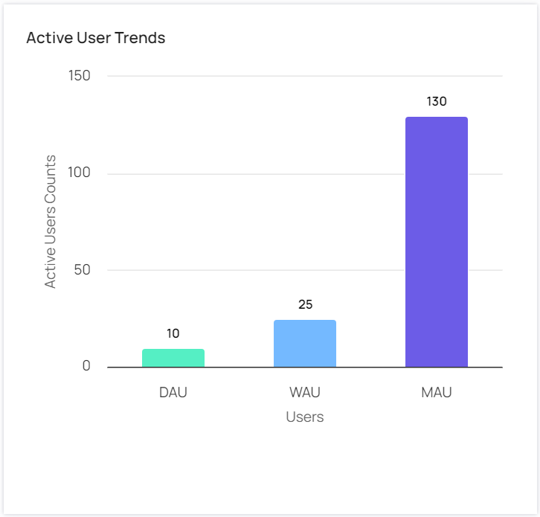

Daily Active Users Trends
You can see the count of active users on a daily basis. This is shown in the form of a line-chart.
Refer screenshot below.
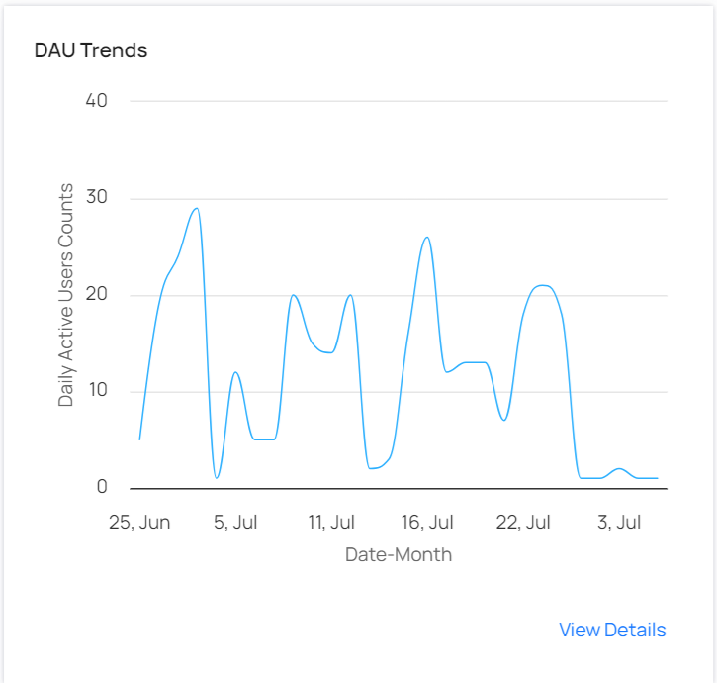

User Events
You can see a list of Top 10 events being performed in the application, along with its count.
This section can be shown in the form of Table & Pie-Chart for better visibility.

Refer screenshot below.
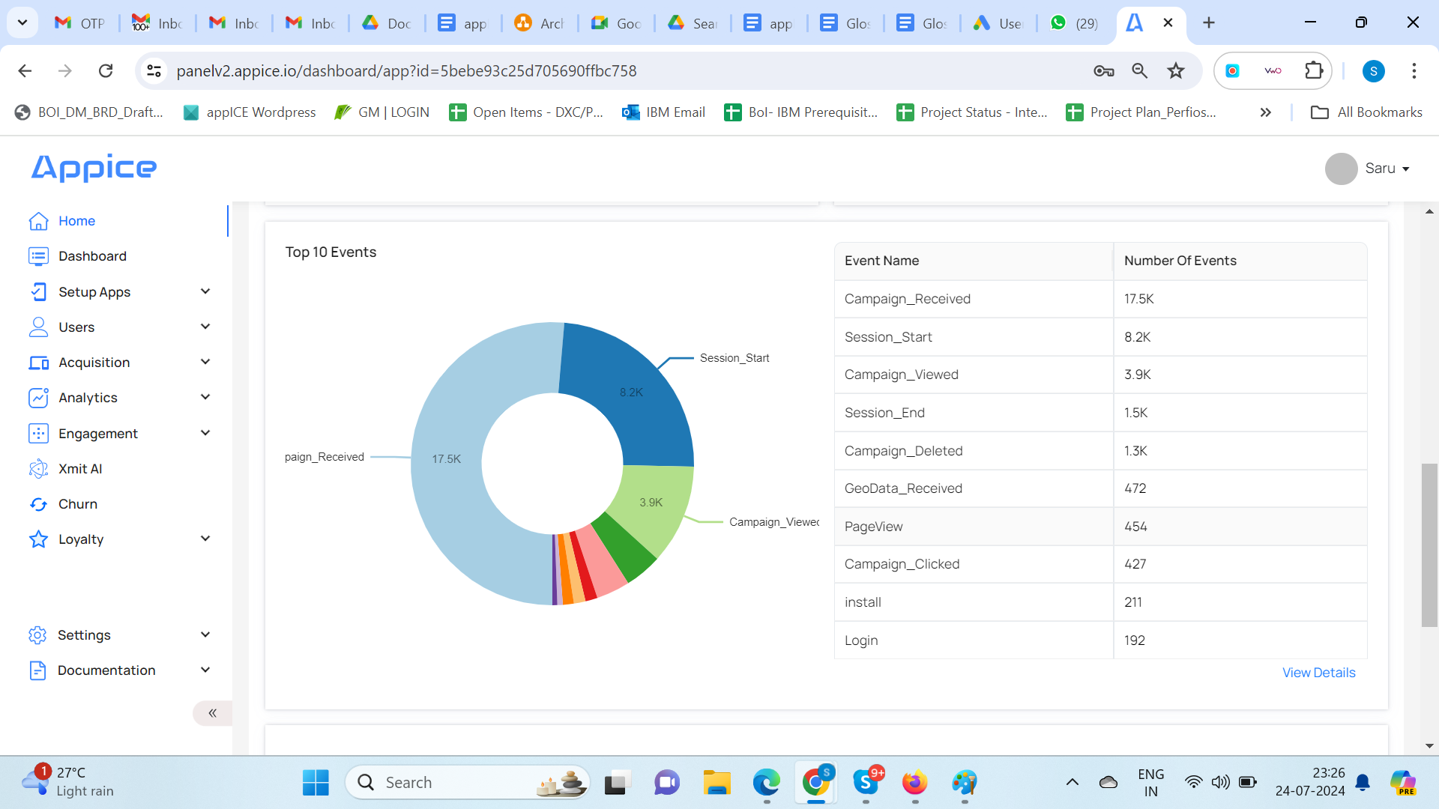
On clicking View Details, it takes you to a detailed page of Events.
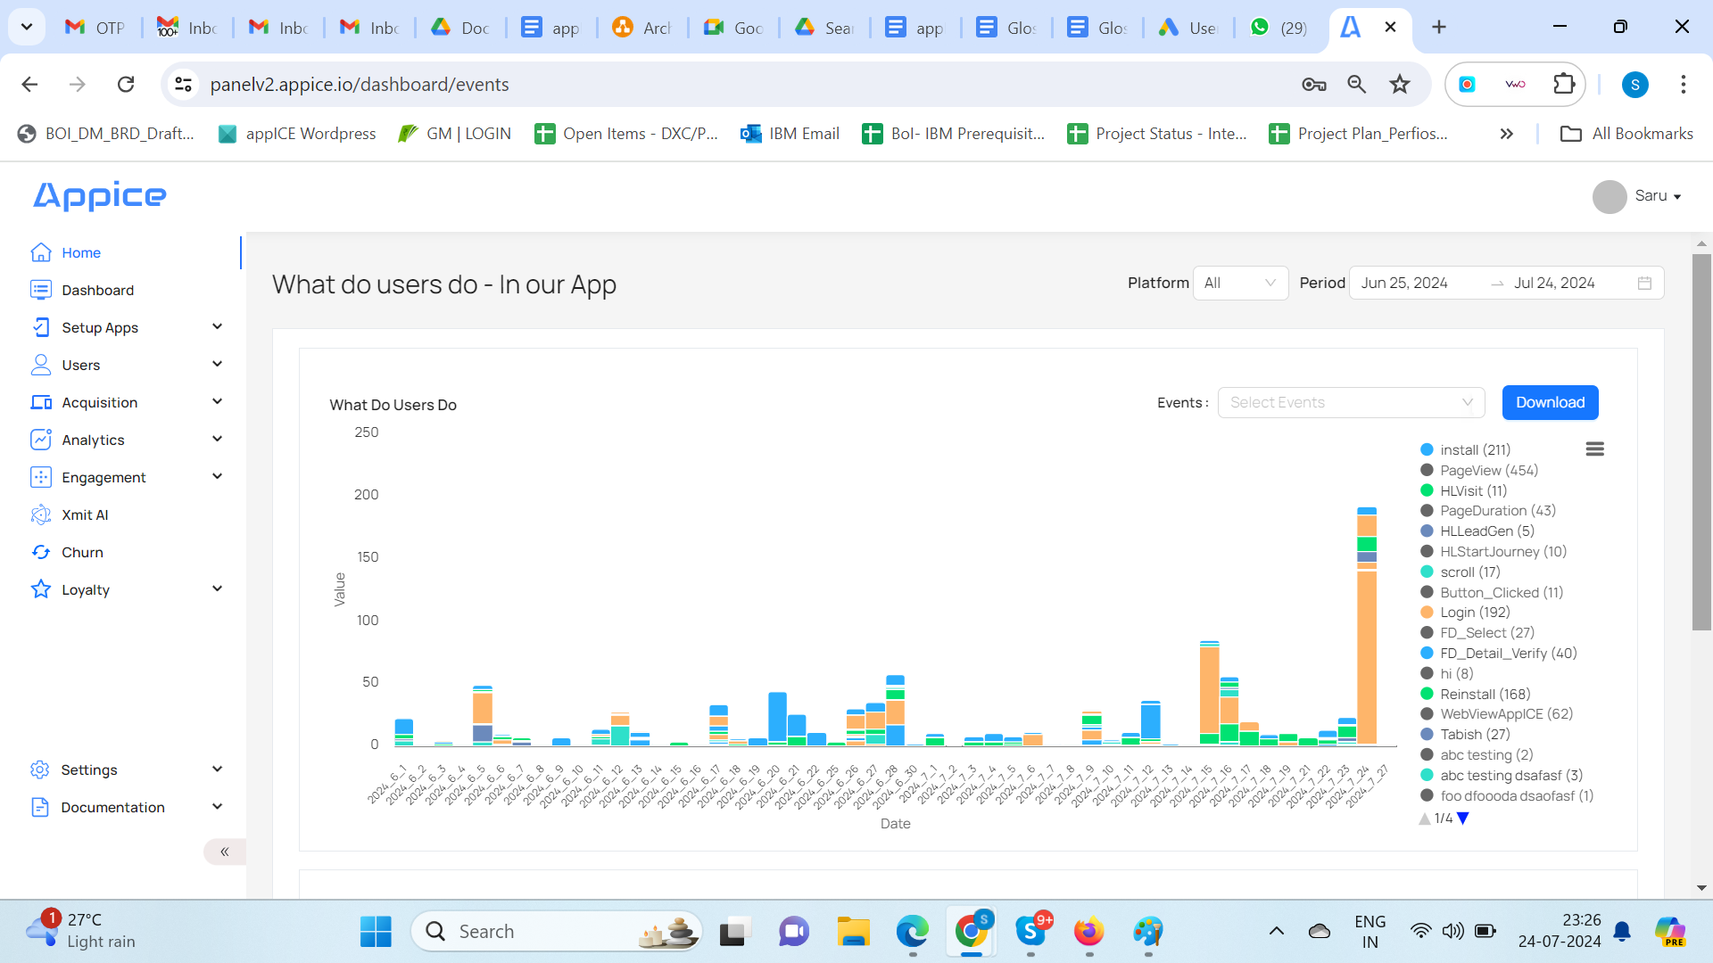
Drill-down into Event Attributes - count of all the attributes or events, along with their attributes, performed by users within your app. You can also download reports in csv format.

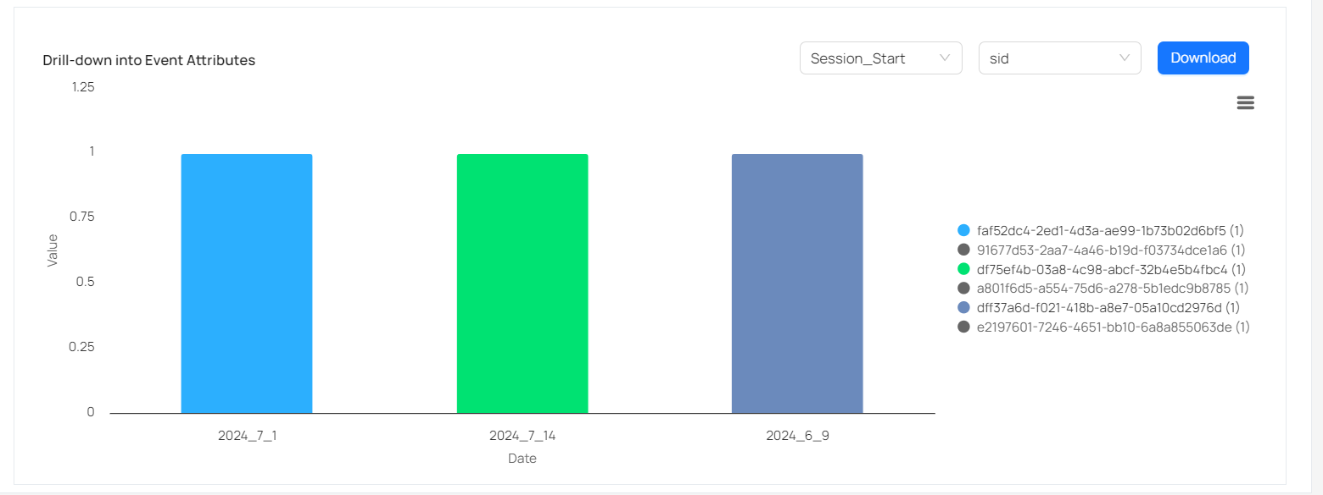

iv. Header
You can see 2 options to choose - Platform and Period. Refer screenshot below.
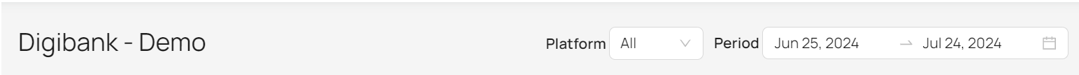

Platform
Allows you to see data on the basis of selection made in this dropdown. Values in the dropdown are Android, iOS, Web, All.

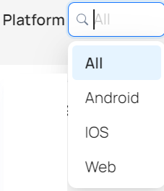

Period
Allows you to see data on the basis of period (date range) being selected.
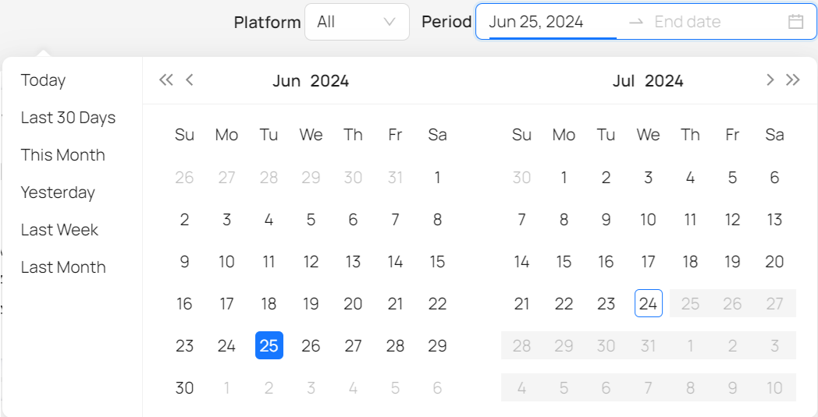

Reports available in platform:
Sno | REPORTS | STATUS - (SIT)
1 | New users trend – by OS | Yes
2 | New users trend – by Device | Yes
3 | New users trend – by App Version | Yes
4 | New users trend – by Country | Yes
5 | New users trend – by City | Yes
6 | New users trend – by Platform | Yes
7 | New users trend – by OS Version | Yes
10 | Inactive users trend – by OS | WIP - for SIT
11 | Inactive users trend – by Device | WIP - for SIT
12 | Inactive users trend – by App Version | WIP - for SIT
13 | Inactive users trend – by Country | WIP - for SIT
14 | Inactive users trend – by City | WIP - for SIT
15 | Inactive users trend – by Platform | WIP - for SIT
16 | Inactive users trend – by OS Version | WIP - for SIT
19 | Inactive users trend day-wise | WIP - for SIT
20 | Inactive users trend time-wise | WIP - for SIT
21 | Daily active users by time period | Yes
22 | Weekly active users by time period | Yes
23 | Monthly active users by time period | Yes
24 | Active user trends by time period | Yes
25 | DAU trends by time period | Yes
26 | Users by session count | Yes
27 | Average session length | To be implemented post UAT
28 | Users by usage period | To be implemented post UAT
29 | Average time spent | To be implemented post UAT
30 | System response time | Out of scope
31 | Error count | Out of scope
32 | Error type | Out of scope
35 | Understand Top 10 events on a daily basis | Yes
36 | Drill-down into events attributes | Defect - Data Issue
39 | Daily Logged in user report | Yes (From Funnels)
40 | New Installs – Aggregate level | Same as new users
41 | New Installs – OS, device, model | Same as new users
42 | New Registrations | Yes (From Funnels)
45 | Understand sleeping users | Build segment :  Last Seen = Greater than = 30 days
48 | Understand how many total conversions happen for a particular journey | Yes
49 | Understand where a drop-off happens for a particular journey | Yes
50 | Users by source | Will get from MMP integration
51 | Users by campaign id | Will get from MMP integration
53 | Journeys: Sunburst Chart
54 | Understand what users are doing on my app | Yes
57 | Campaign performance across channels (Email, SMS, Push, In-App) | Yes  Out of scope: Web Push, Web Popup
58 | Count by click rate | Yes
59 | Count by open rate | NA : Email callback not being received by Appice
61 | Active campaigns | Yes
62 | Draft campaigns | Yes
63 | Past campaigns | Yes
64 | Total campaign | Yes

Other reports include:
Leads generator
Case | Logic | Action | AppICE Comments
Abandan journeys | Customers who started any apply journey including account opening and didn't reach journey end point | Report to be shown per product per journey (Statistics)  Customer data to be provided as raw data (to be uploaded as leads on CRM)  (Daily job by GIB) | This can be extracted from the Funnel of event data.  NOTE: Data will be uploaded to CRM by GIB.
Engagement report
UseCase | Logic | Action | AppICE Comments
Mkt channels attribution | Based on marketing activities: Conversions per:  1- Campaign/post  2- Channel  3- Customer segment  4- Customer demographics (Gender- Age - Geolocation) | Real time and historical report  [Social Media posts not included] | From MMP: As per MMP Policies
Pre login & Registration | Customers who download the app and registration status | Realtime and historical report to show downloads/registration including avg time from download to registration | This can be extracted from the funnel of event data.
Post login - event tracking | Visits per:  1- product/Service  2- screens of each product/Service  and session source:  1- paid media platforms  2- push notifications  3- Email  4- SMS  5- Social media  6- organic login  7- exist customer or newly registered customer | Real time and historical report | Only 1 is available [From event drill down]  Source is a part of events data - OpenTrigger & custom variable [Only Push, Email, SMS can be tracked by App deeplink.] (paid media in not part of source)

Notification performance
Channel | Logic | AppICE Comments
Push | Delivery status, customer react (clicked - ignored) , Customer react date | Appice tracks: Sent, Clicked, CTR.  Ignored = Not Possible
SMS | Delivery attempt no. and delivery status | Sent is possible.  No callback from gateway for Read/Click.
In-App | Delivery status, customer react (Accepted, rejected or remind me later) Customer react date | App sends this information in callback:  - Accepted = CTA button clicked  - Rejected = X button clicked  - Remind Me Later = Not Possible
Email | Delivery status, customer react (clicked - ignored) , Customer react date | Sent is possible.  No callback from gateway for Read/Click.

16.2 Funnels

Understand where a drop-off happens in a user’s journey. Using this insight, one can communicate with the customer through various notifications. This is basically a sequence of Triggers/Events in your app which would help you better understand the customer’s journey while using your mobile app. This helps in better visualizing at which point in your transaction funnel, users drop off most or can be helped with in-app notifications or better messaging.

- How many users complete FD (or PPF) or
- Drop off at KYC validation stage

Event | Attribute | Attribute Value
FDStartDeposit
FDValidateKYC | KYCComplete | True
FDCreate | FDOpened | True

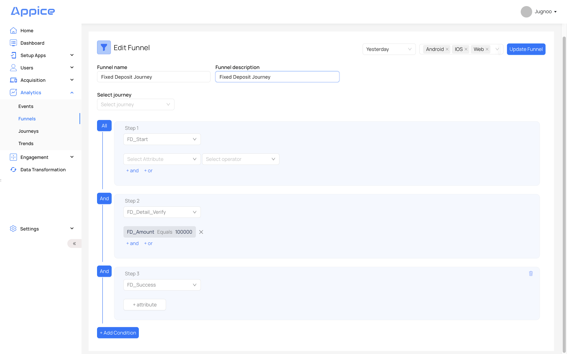

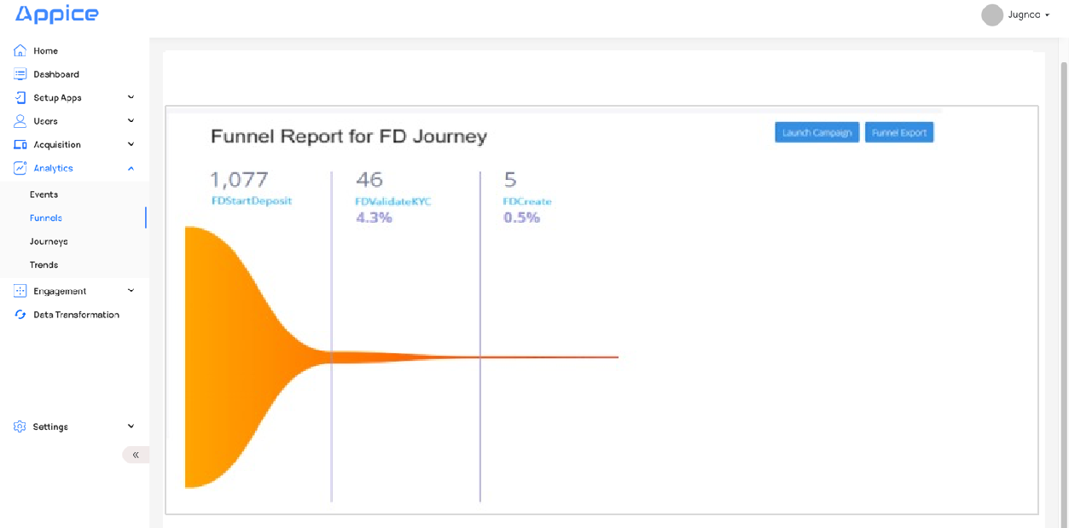

On Save, you can see a message at the top - Funnel Created Successfully.
You can see the newly created Funnel in the list.
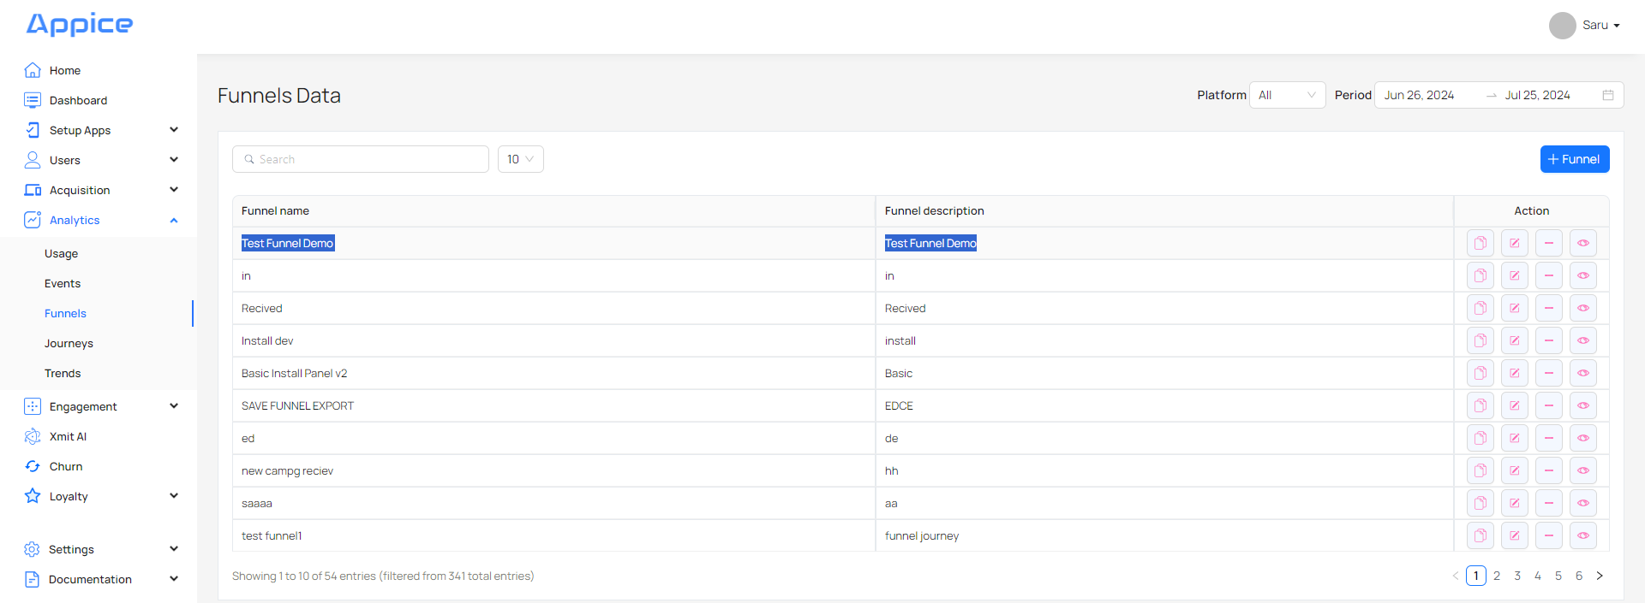
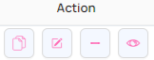
Copy button - To copy the funnel.
Edit button - To edit the funnel.
Delete button - To delete the funnel.
Preview button - To see analytics of users in the form of a widget, you can click the ‘Preview’ button.
Funnels can be exported as well to analyze the users’ data by clicking on the Funnel export option.

You can select users' data.

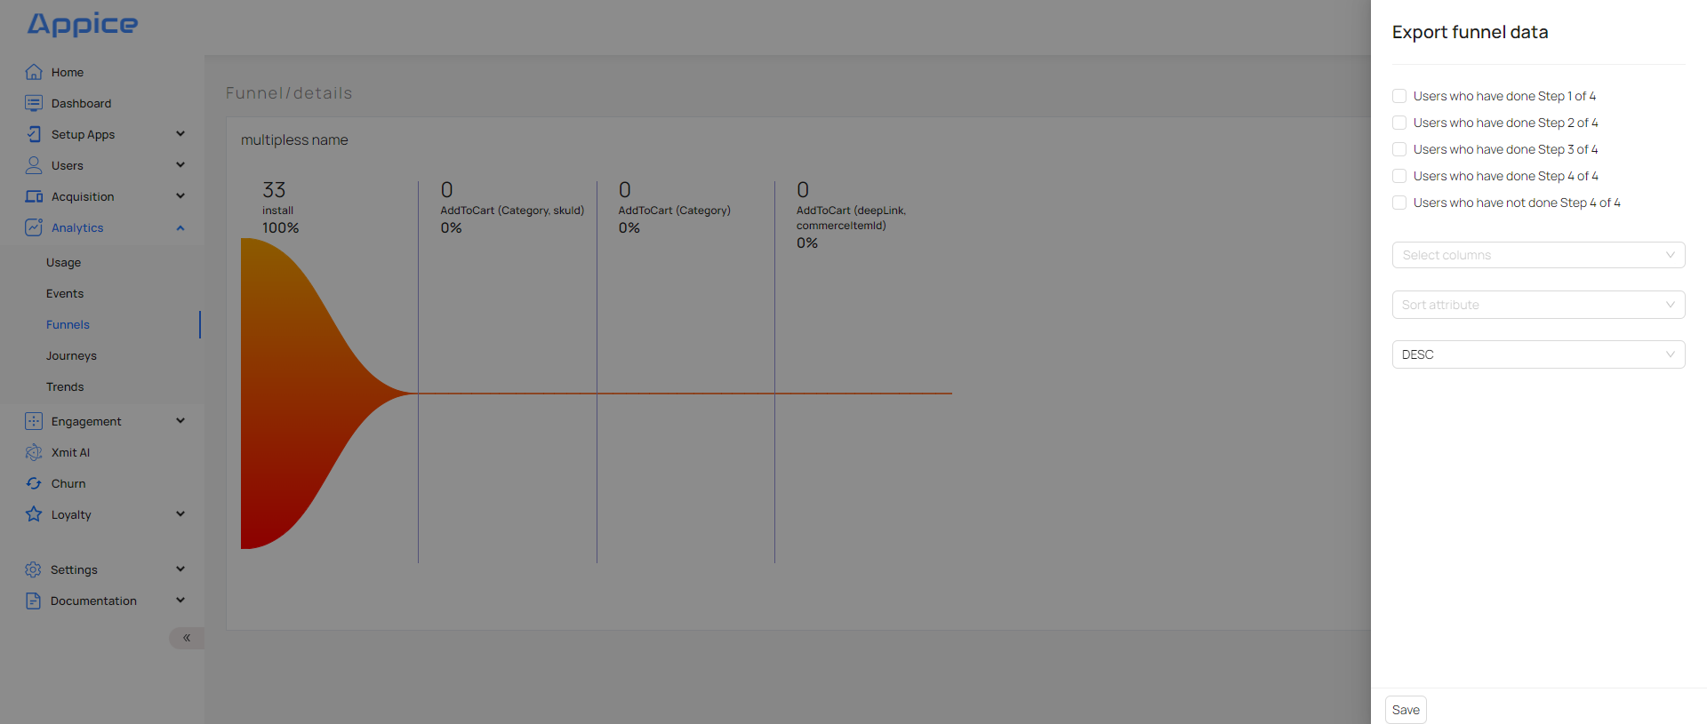
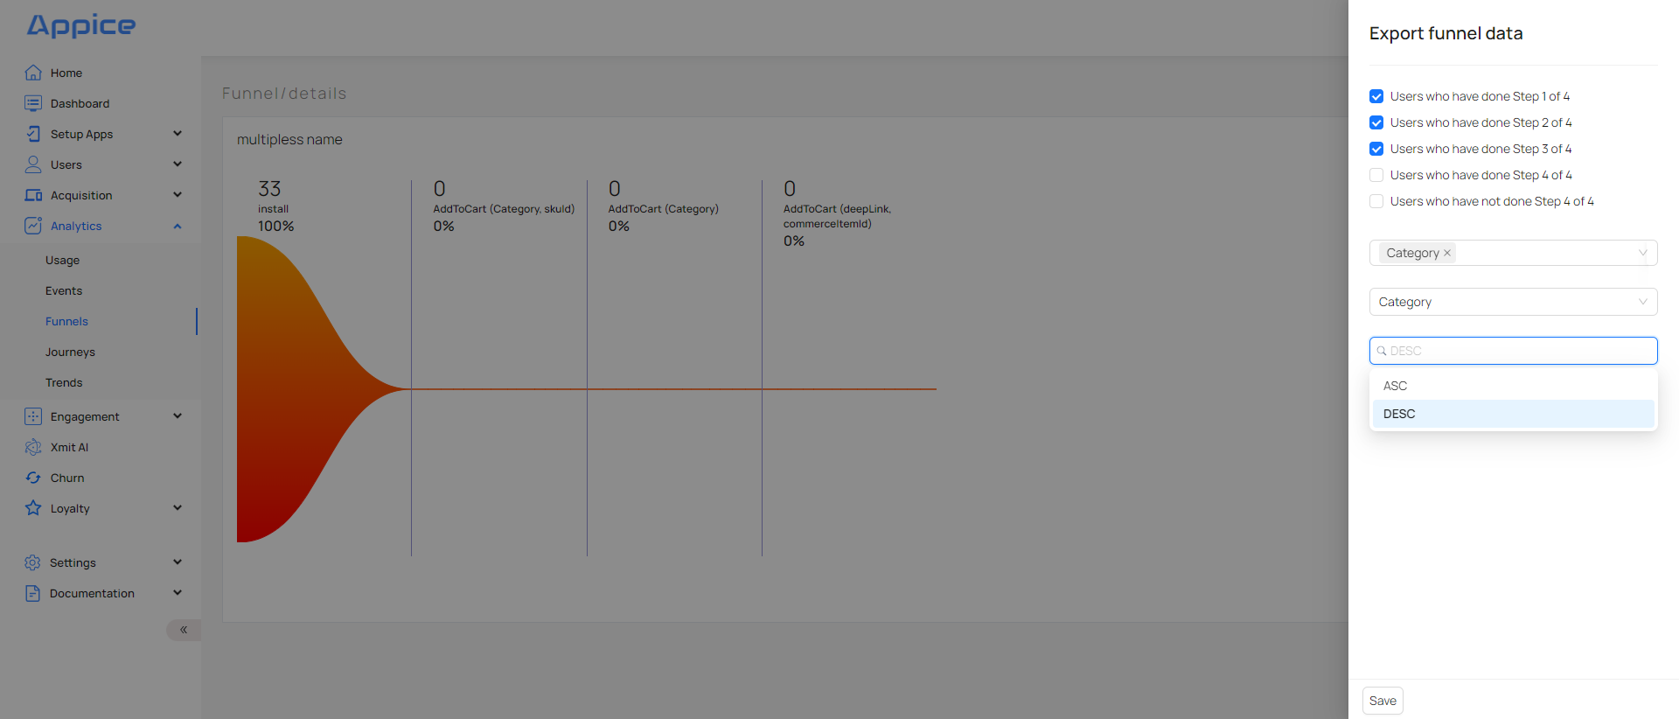
On clicking Save, it initiates the export.
Exported csv can be downloaded by clicking on Funnel Reports in the left panel.
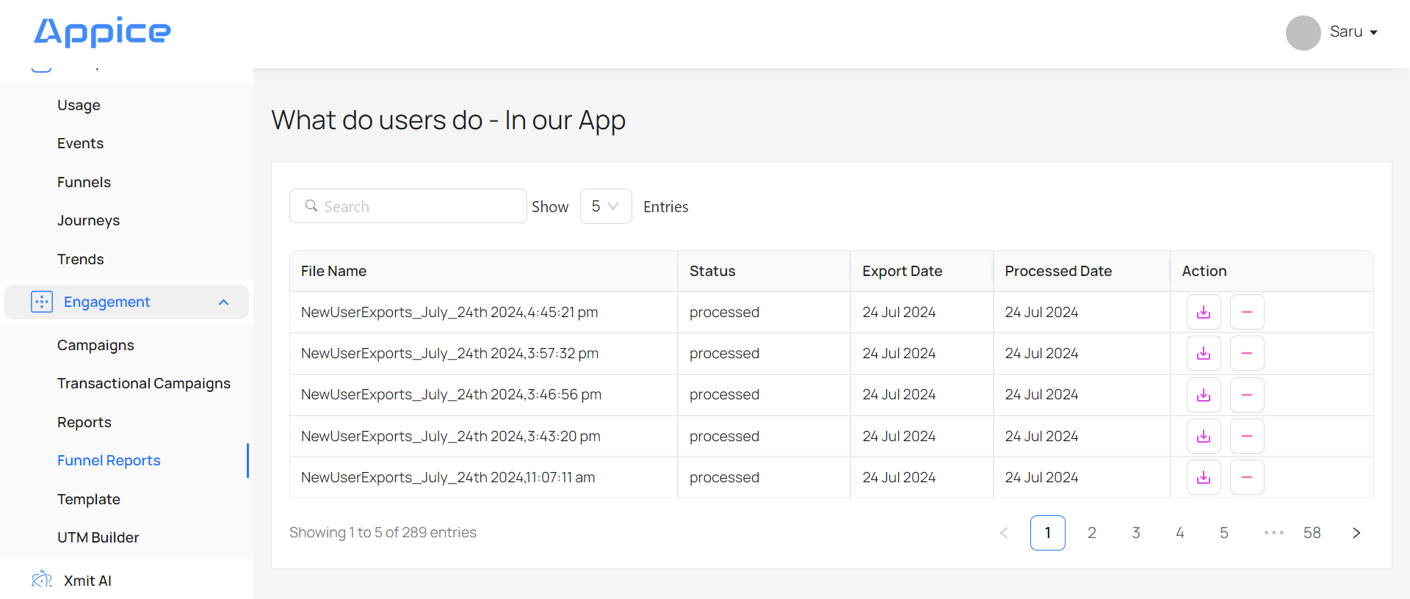
This shows the current status of the report which is ‘initiated’.
Once the exported report is ready, it shows status as ‘processed’ and a download button is also available.
On clicking the download button, csv can be downloaded.
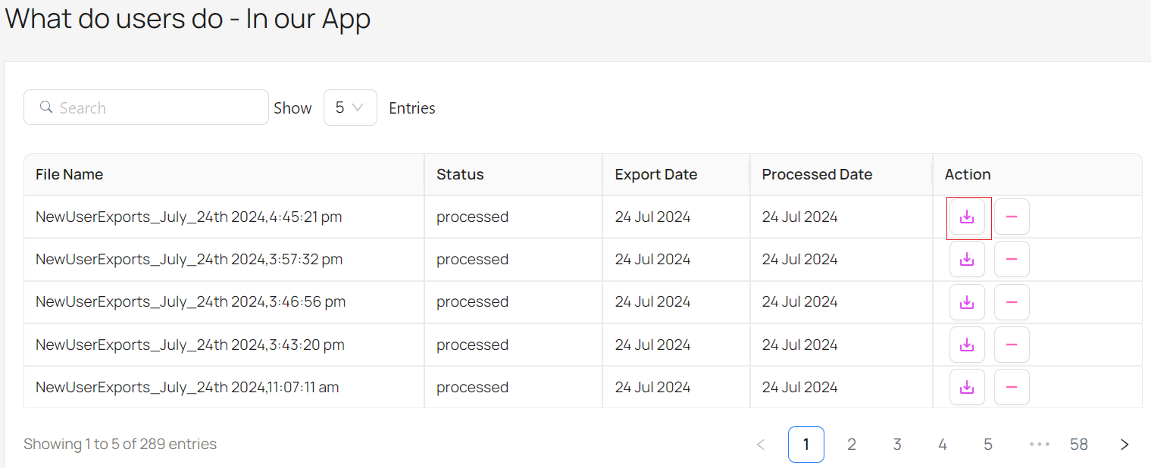

16.3 Journeys

One of the most intriguing questions that product managers and marketers face is, ‘What are users doing on my app?’

Let’s take the simplest form of user journey in a tabular data:
Step I | Step II | Step III | Step IV | Step V | Users
App Launched | App Launched | Category Viewed | Searched | App Launched | 4512
App Launched | UTM Visited | Searched | Product Viewed | Product Viewed | 3012
App Launched | Searched | Category Viewed | Product Viewed | Added To Cart | 422
UTM Visited | App Launched | Product Viewed | Added To Cart | Charged | 312
……… | ……… | ……… | ……… | ……… | ……

In order to understand how users navigate through the App or website - where do they start the journey and which pages do they end the journey, we represent this data with a Sunburst Chart.

This type of visualization shows hierarchy through a series of rings that are sliced for each category node. Each ring corresponds to a level in the hierarchy, with the central circle representing the root node and the hierarchy moving outwards from it. Rings are sliced up and divided based on their hierarchical relationship to the parent slice.

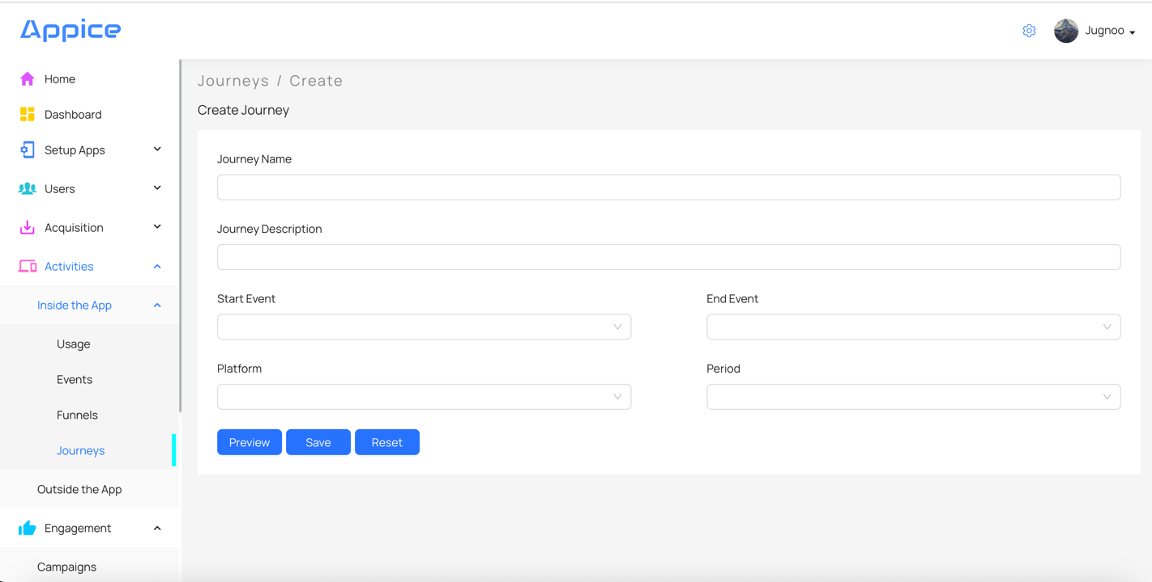

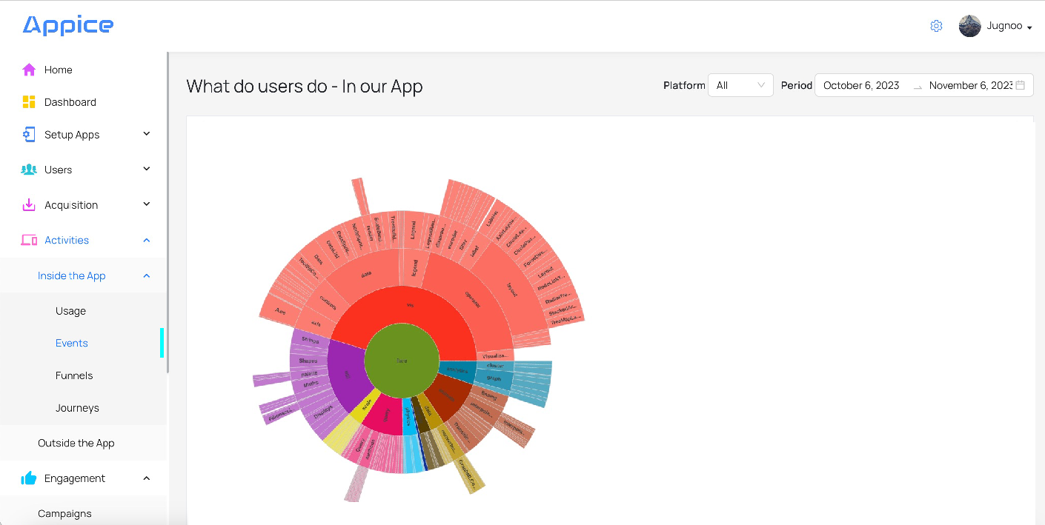

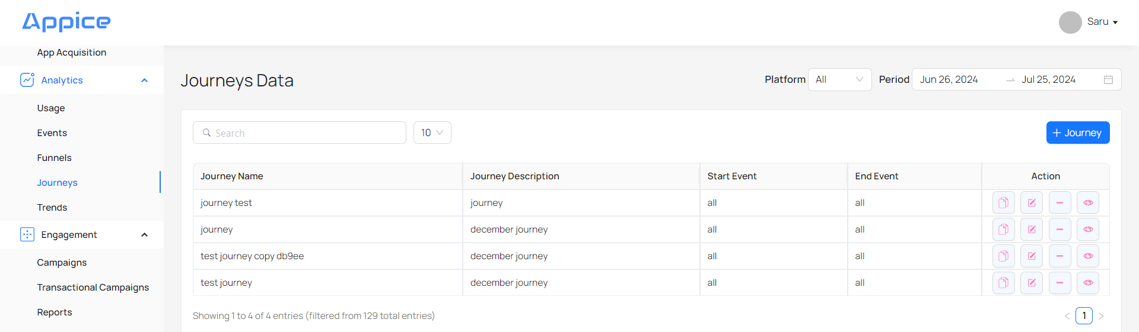

16.4 Visitor Engagement Overview
Visualize the sessions and user's time spent on the website across unique session counts, time per session and the day parting of the session traffic.
- Users - gives count of users vs session count
- Avg. Session Length - gives average duration of the overall sessions i.e. average time spent by users within your app
- Sessions - gives count of user sessions during morning, afternoon, evening, night and midnight
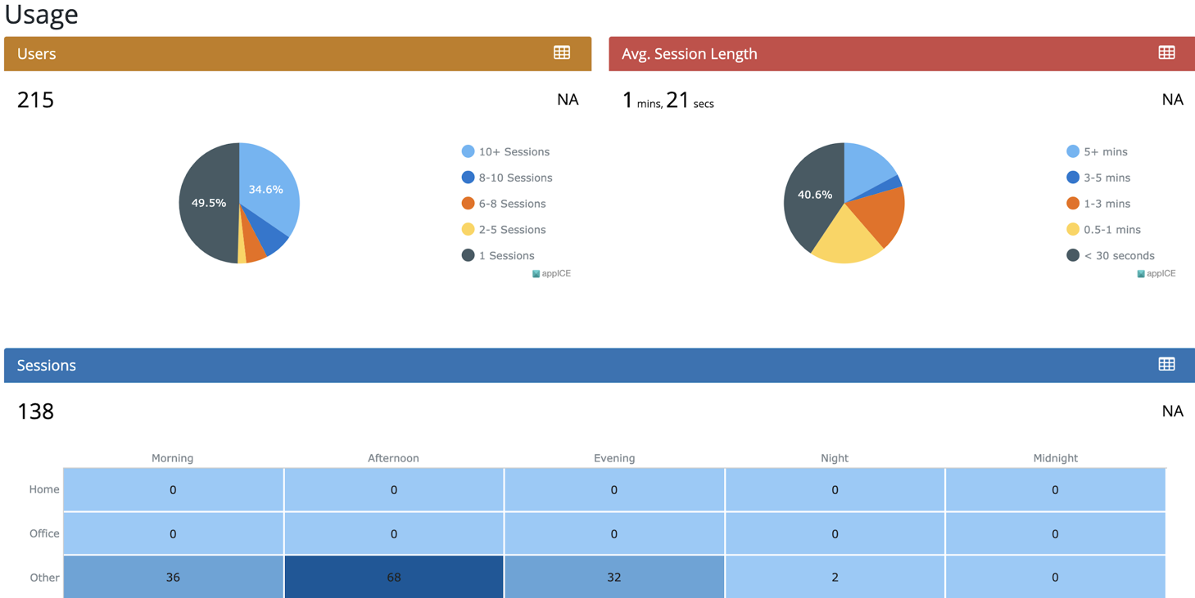

16.5 Traffic Sources
The traffic patterns can be split across various sources like Direct, Organic Search, Referral, Social, Email etc. This helps business teams allocate optimal resources on the channels that are yielding the maximum traffic or bring up under performing channels.
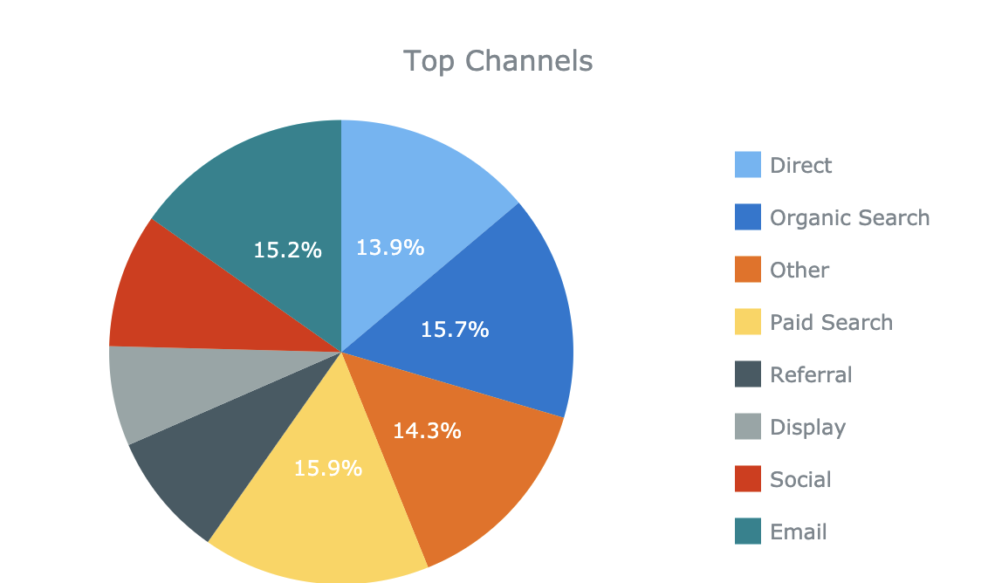

16.6 Top 10 Events

Understand Top 10 events on a daily basis. This data is used to derive insights on what are the most preferred features or functionalities of our App.

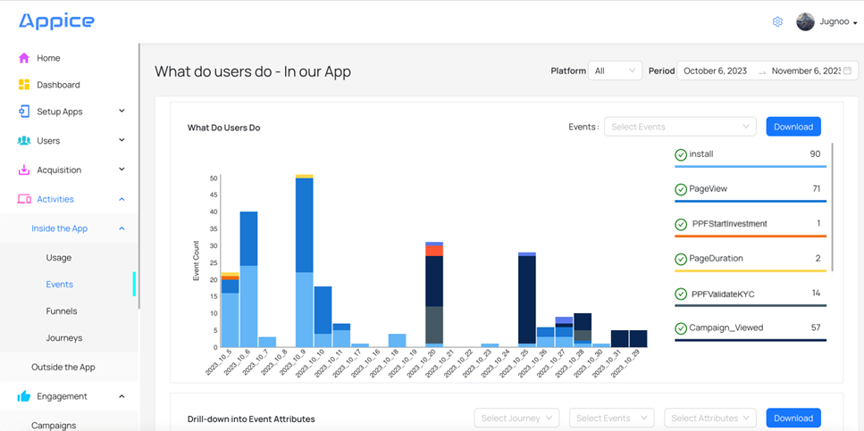

16.7 Retention Trends

When customers download or register on the App, many do not start active engagement or become regular users. These customers need to be identified in order to increase the retention rate, else they may slip in the category of ‘sleeping users’. Retention trends chart show progress of users on a monthly basis

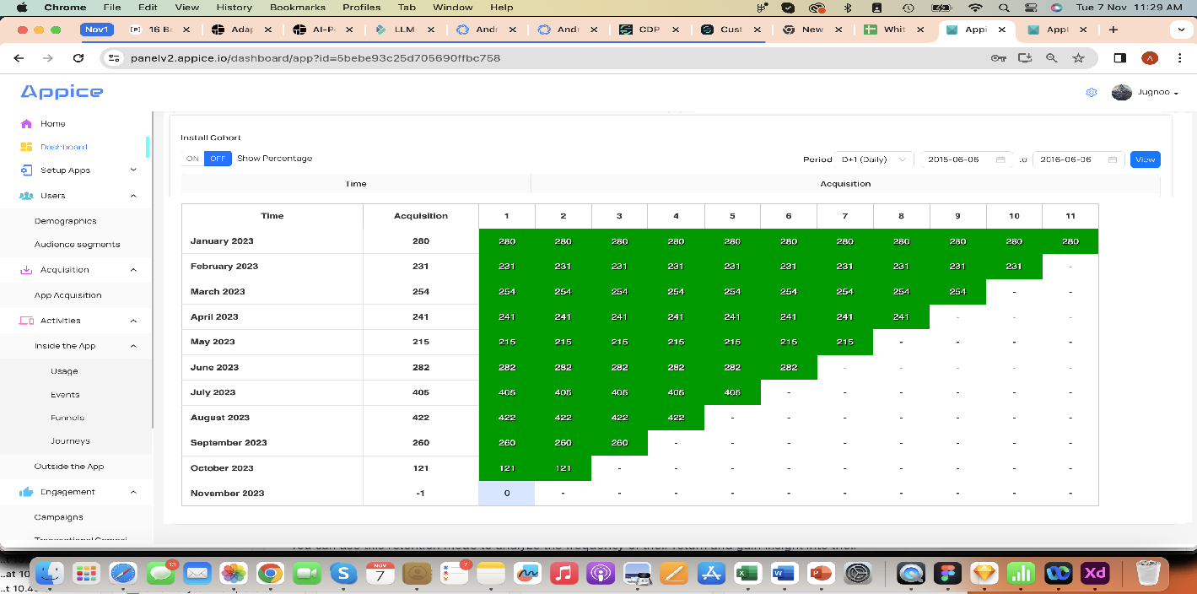

16.8 Specific Reports

In case specific reports have to be created by querying data, these are available in the reports section.
Example: Campaign report with details of which customers clicked on CTA can be made as a single step funnel with the following fields available in report:
-Campaign ID
-CIF
-Date
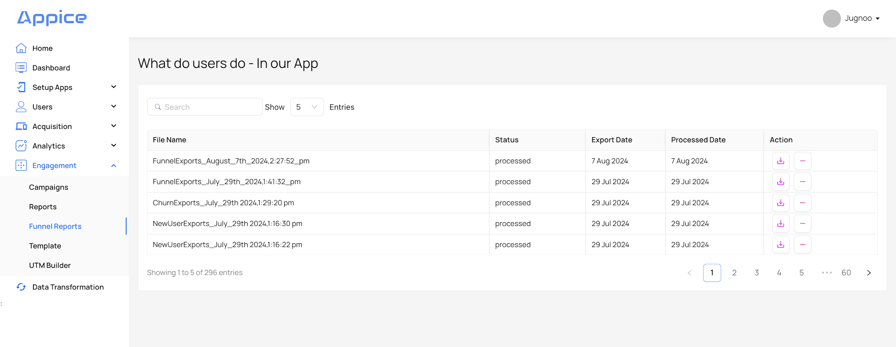
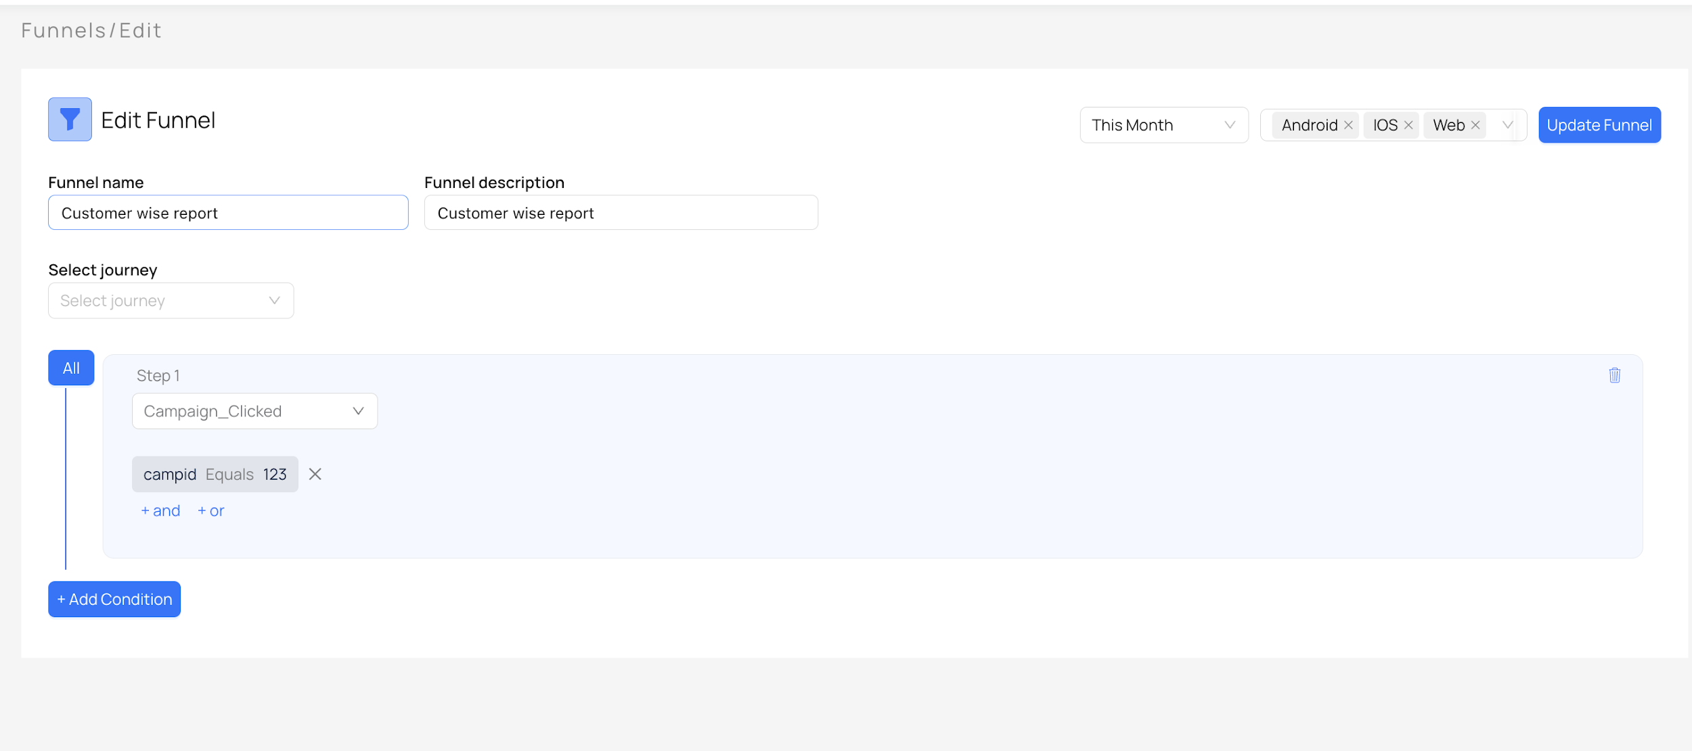

16.9 Acquisition
more details about the users who visited / installed your app.

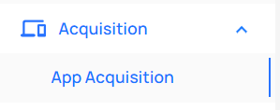

App Acquisition

Acquisition Sources
whether that user is a new user or repeat user.

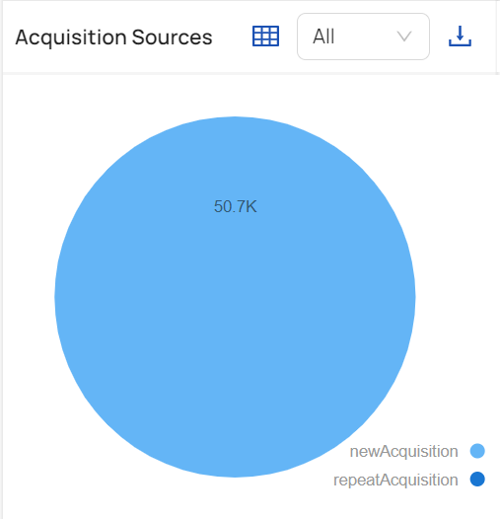

App Versions
from which app version users have installed your app.

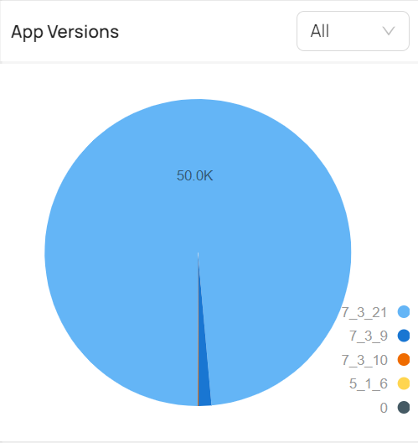

Locations
from which city users are from.
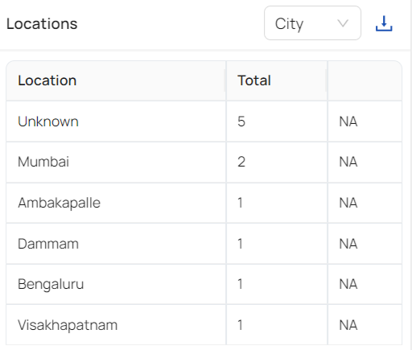

Acquisition
shows sources from where users have come with spend.

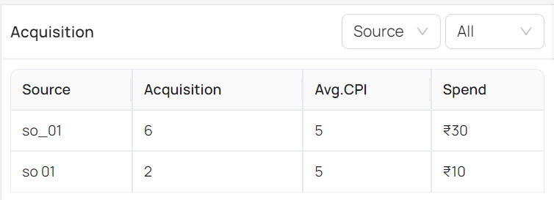

OS
from which OS users have installed the app.

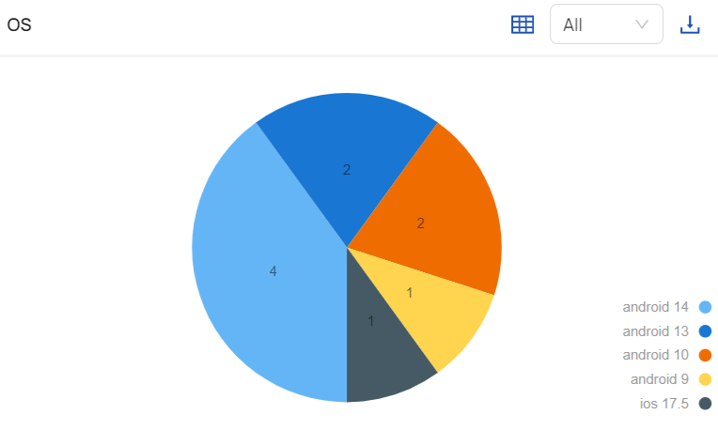

Day-Wise Acquisition
shows daily installs/visits.

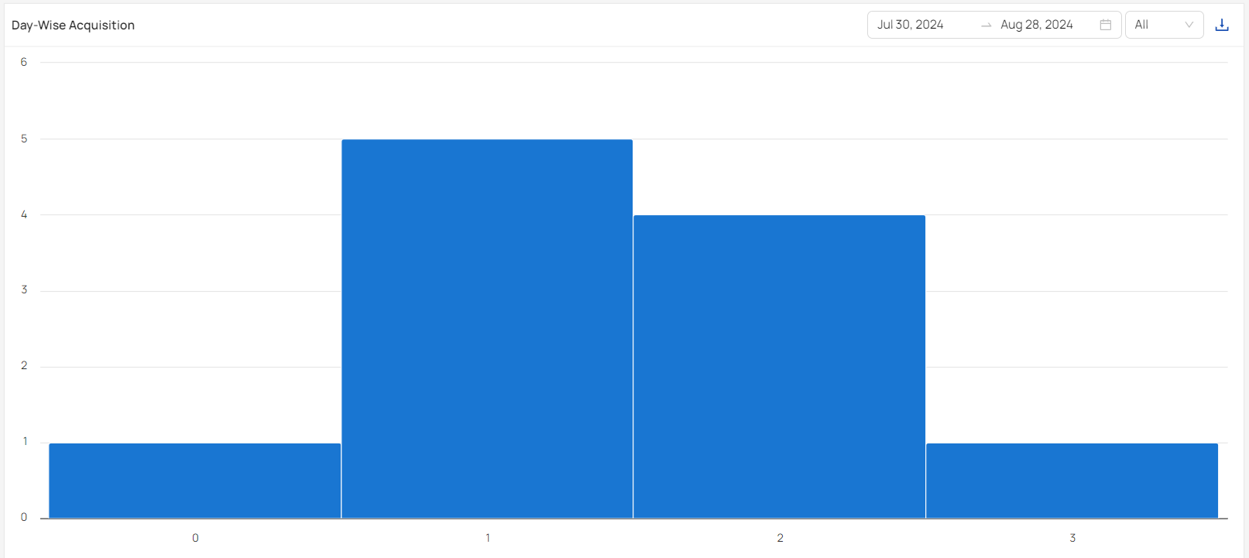

Time-Wise Acquisition
shows hour-wise installs/visits.

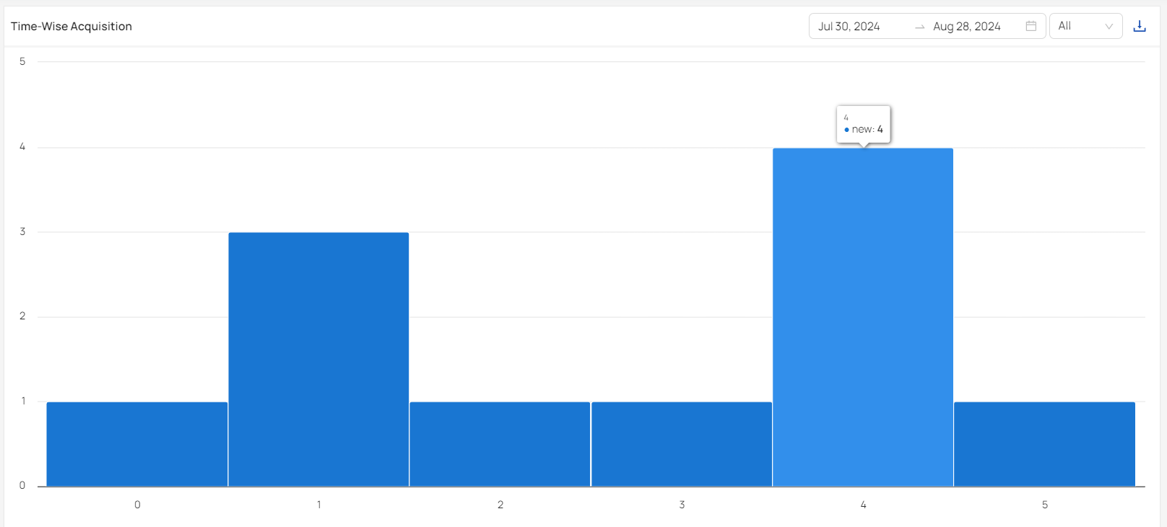

17. User Management
The AppICE system will be integrated with SSO to allow GIB users to login only with their ADID. Users can then be given access from the AppICE panel to login to it.

17.1 How to Register a New User

Here are the steps to register a user on Appice dashboard:
- Users can directly be registered from the dashboard.
- Users can access the Appice dashboard and click on the Sign Up link to register.
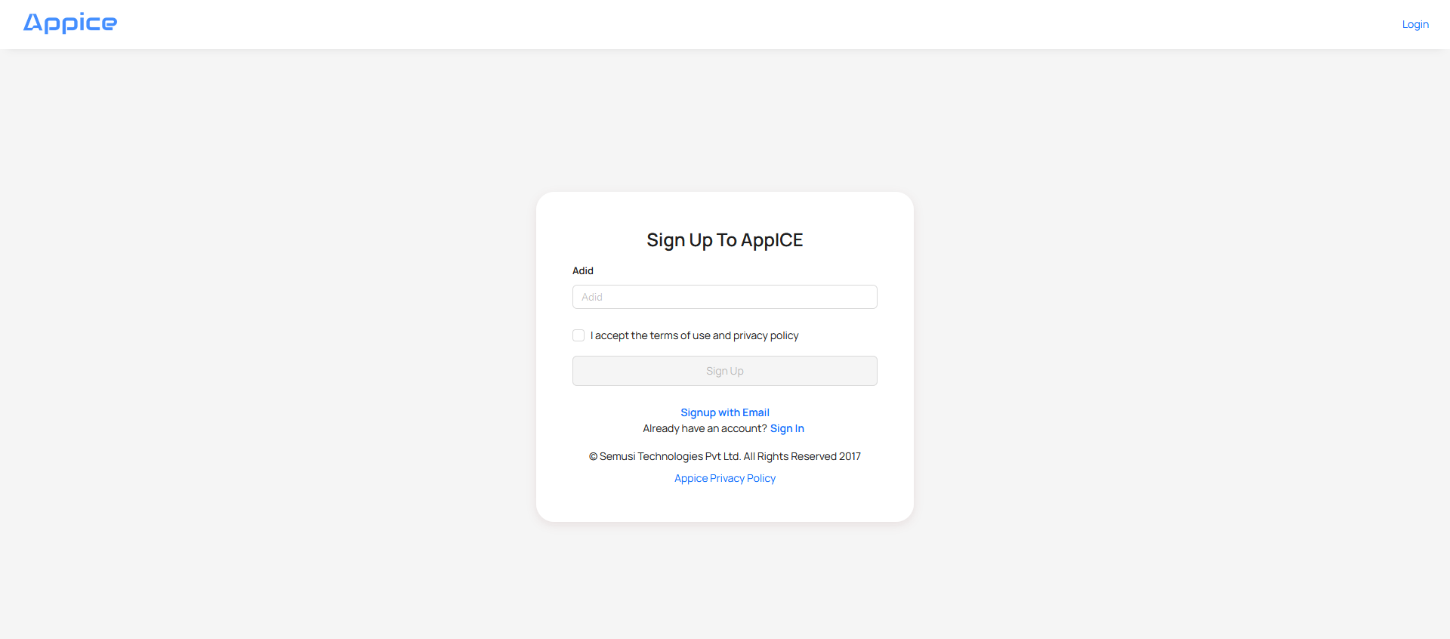
On clicking, it opens the below page. Users can fill their details and click on Sign up.
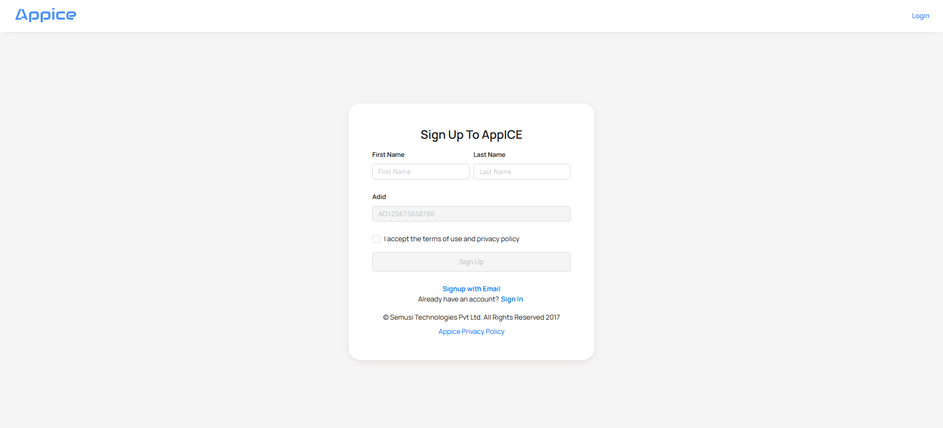
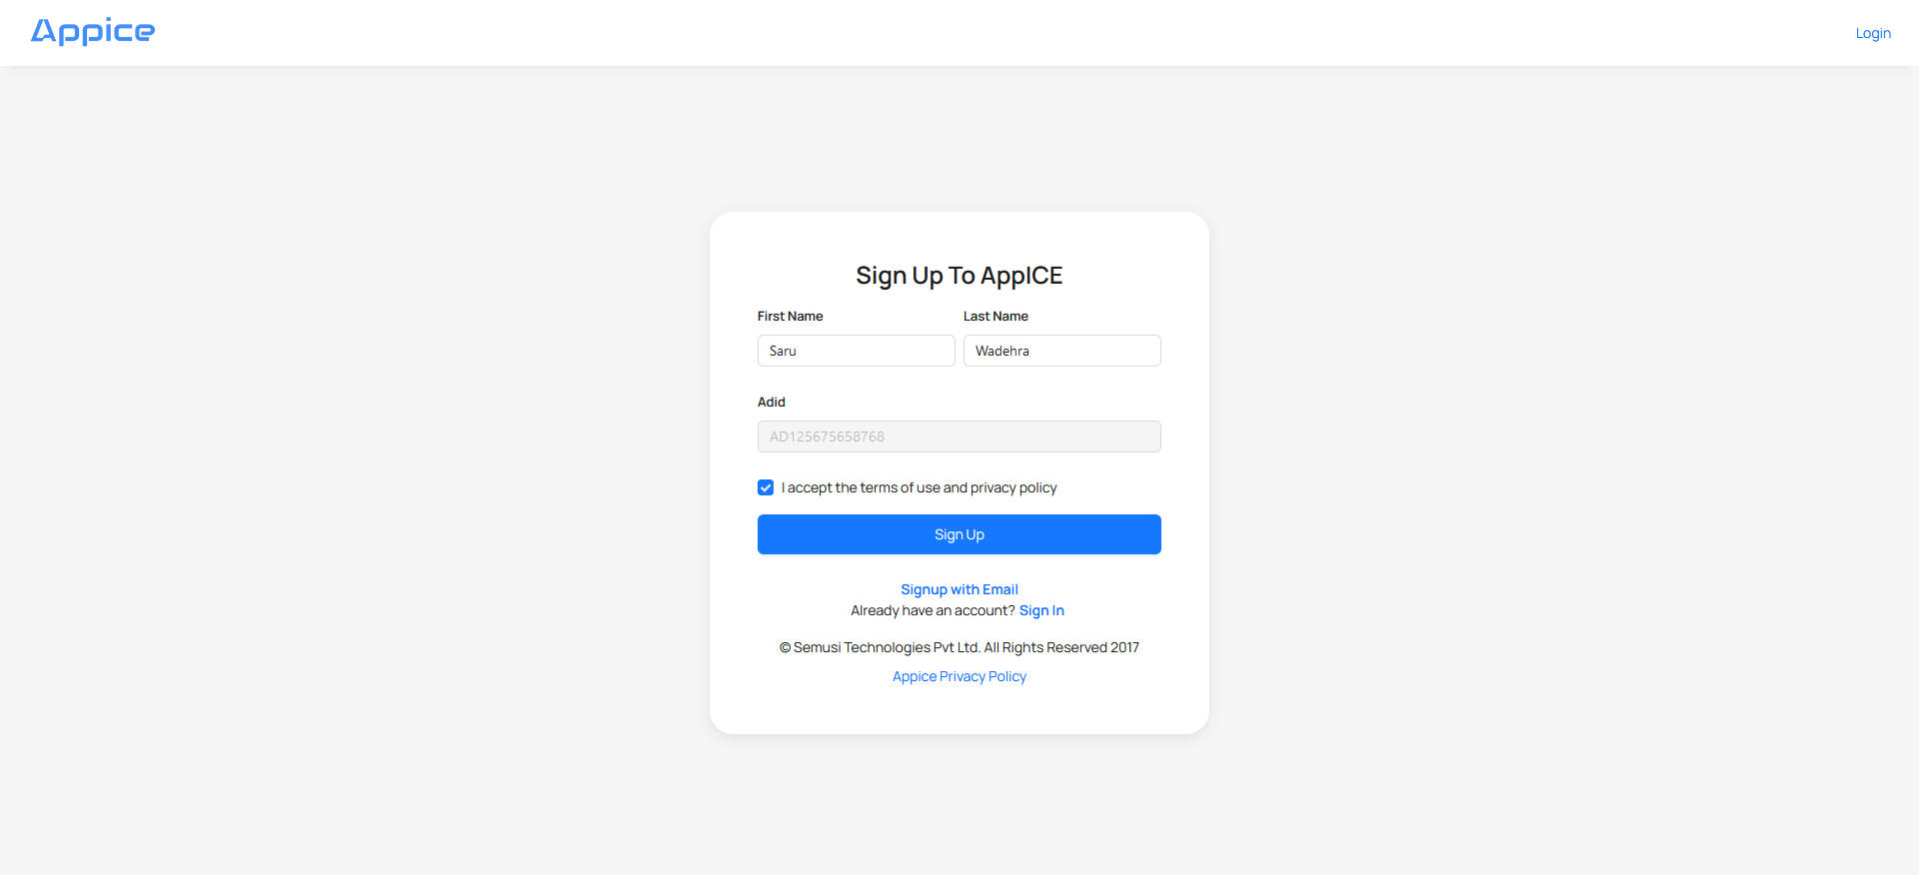
Once users click on Sign up, it takes them to the login page.
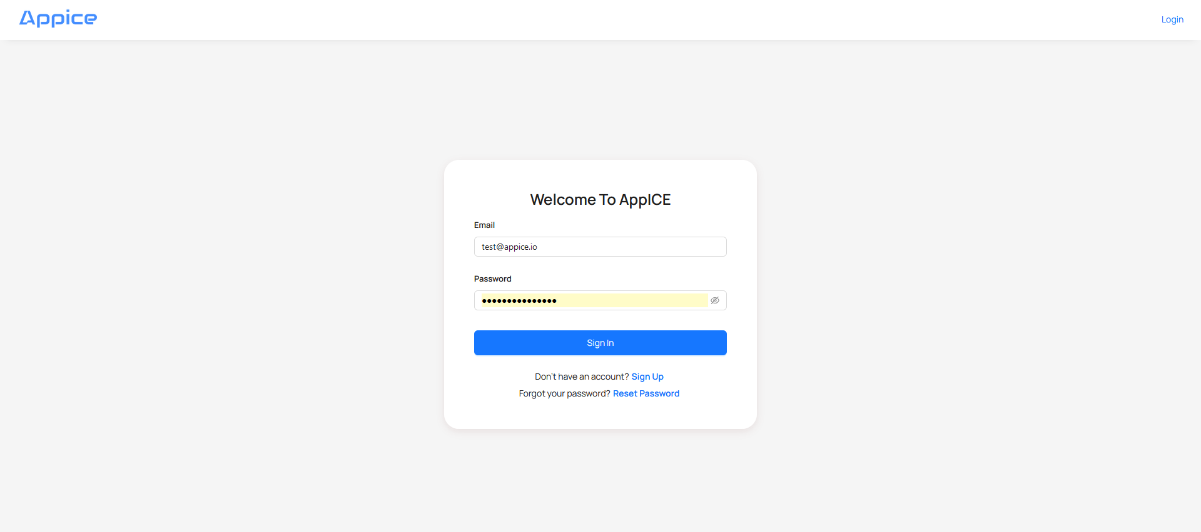

17.2 User Addition Process
Admin/Infosec Users can login into the Appice dashboard and go to Settings → User Management in the left panel.
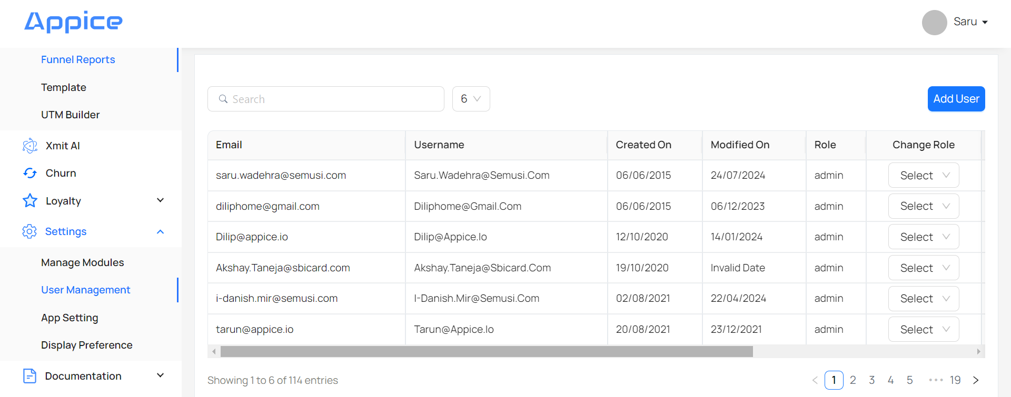
Click on Add User to add a new ADID along with its role.
By default, Users are in Not Approved state. These can be Approved by clicking on the Approved button.
Admin/Infosec users can also assign App and roles to these Approved Users by clicking on the Add User button.
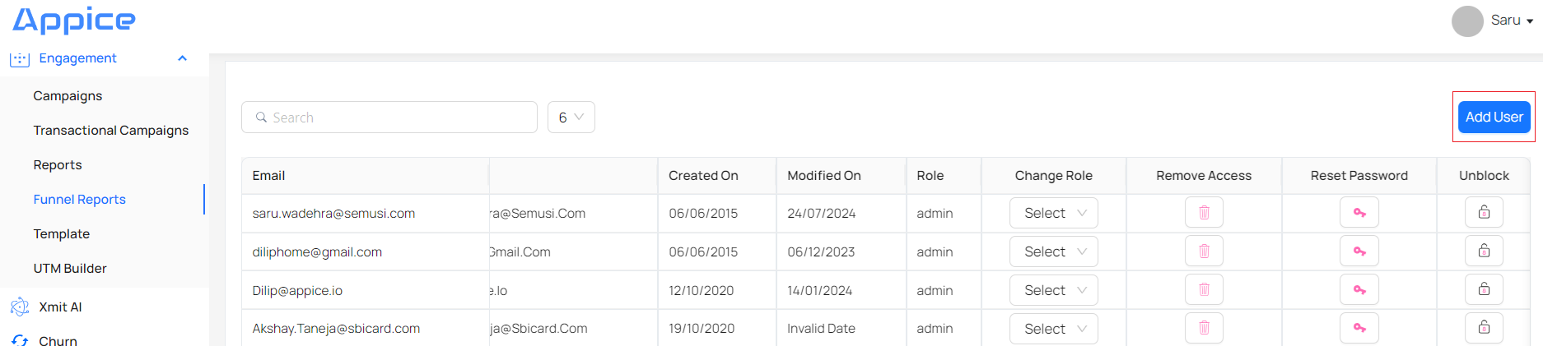
On clicking, it takes to this page where ADID has to be provided and Role has to be selected from the dropdown.
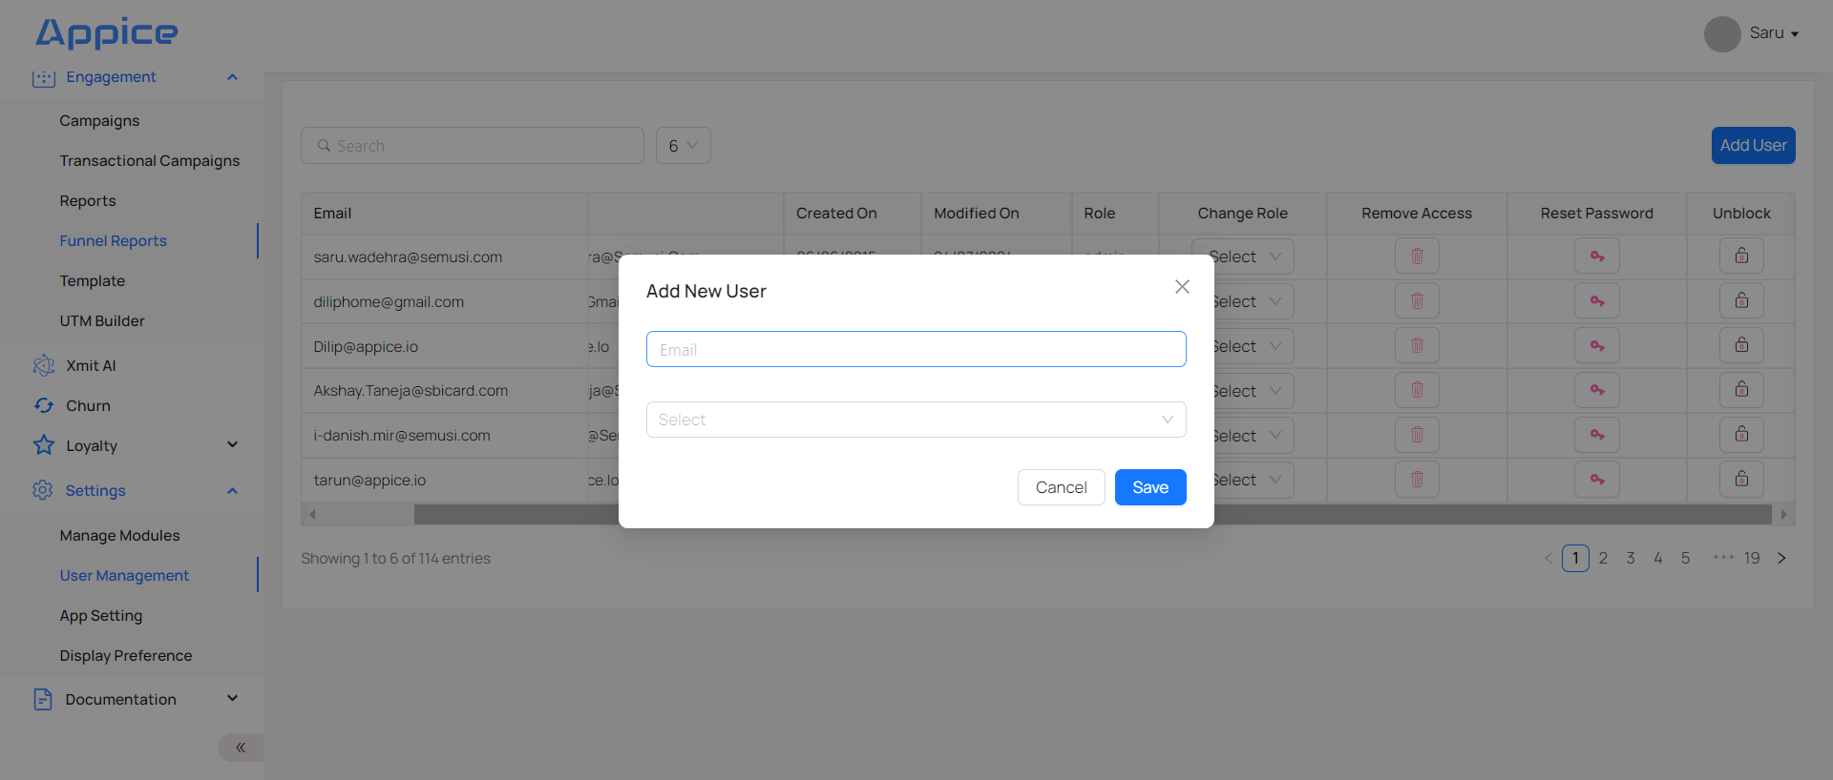
Click on Save button to save the users.
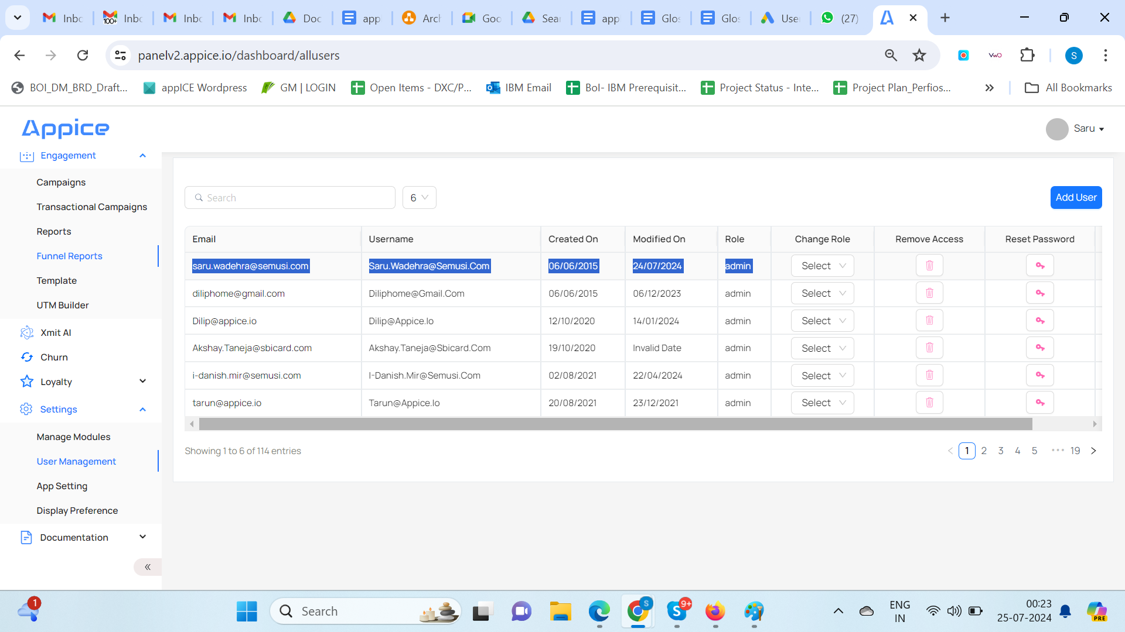
Newly added users can be seen in the Users List, as shown below.
NOTE: New users will not be assigned to any role, whereas existing users may/may not have roles assigned to them.

17.3 User Modification Process
There are three types of modifications possible in Dashboard:
- Change Role
- Revoke Role
- Status
- Unblock

Change Role
Users can only be modified by an Admin by logging into the account and going to Settings → User Management section.
Click the Change Role dropdown for the specific User, for which role is to be modified.
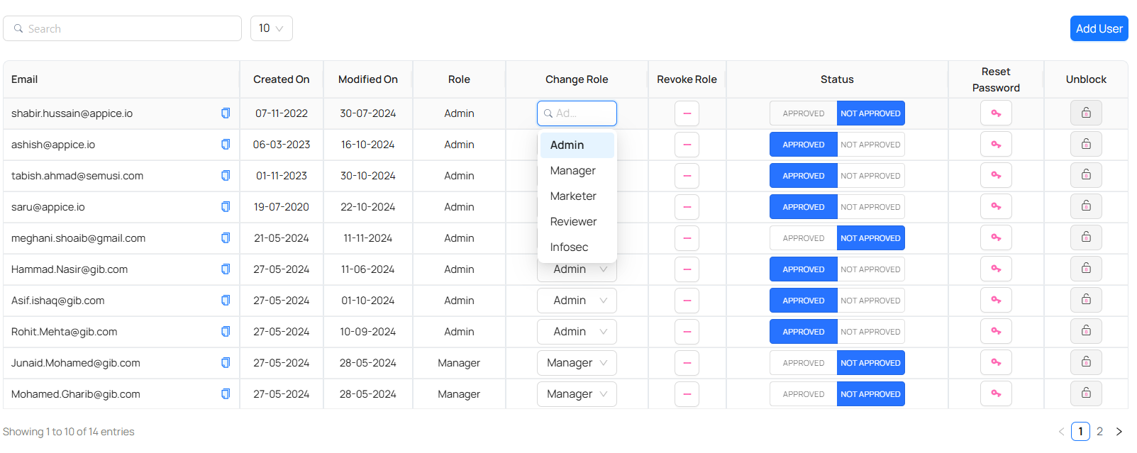
There are 5 roles in AppICE panel with following module access & update:
Roles | User Management | Campaign Creation | Campaign Updation | Campaign Deletion | Campaign Review/Give Comments | Campaign Activation | Audit Logs
Admin | Yes | Yes | Yes | Yes | Yes | Yes | Yes
Marketer | No | Yes | Yes | No | No | No | No
Reviewer | No | No | No | No | Yes | No | No
Manager | No | Yes | Yes | Yes | No | Yes | No
Infosec | Yes | No | No | No | No | No | Yes

Change the value.
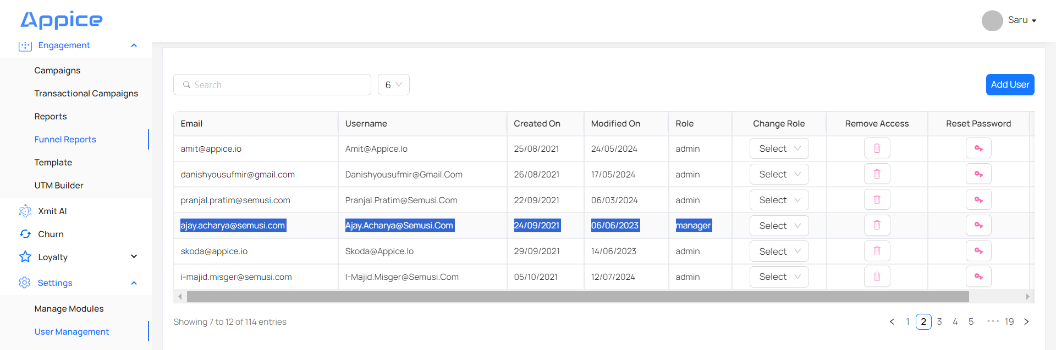
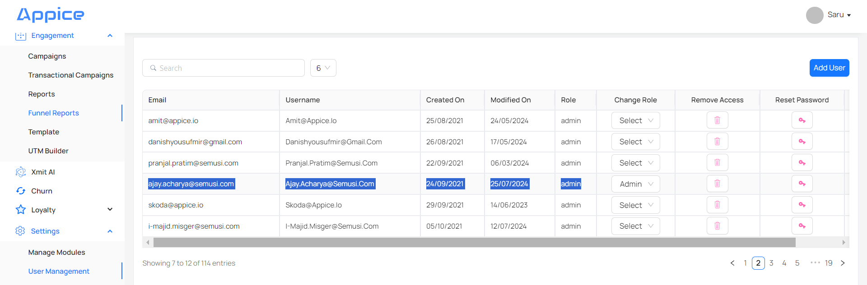

ii. Revoke Role
User Access can be removed from accessing the panel by revoking the role of the Users.
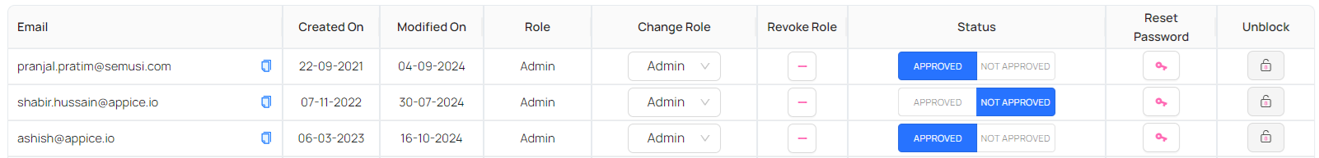

iii. Status
User Access can be temporarily disabled from the panel by marking the user as NOT APPROVED.
User Access can be enabled again by clicking on APPROVED.
Read only access can be provided to Bank’s officials like Contact center agents and customer quality team (anytime) to address customer inquiries related to the notifications sent through the platform.
NOTE - Reset Password in User Management is not applicable as Users will login using AD.

v. Unblock
If a user tries to login with wrong credentials or is blocked from Login from Panel, that user can be unblocked by clicking on Unblock for that user.
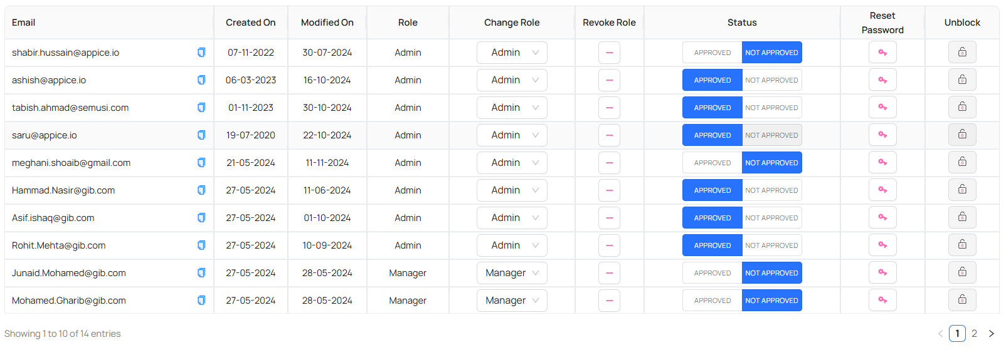

18. Role Management
There are 5 roles in AppICE panel with following module access:
Roles | User Management | Campaign Creation | Campaign Updation | Campaign Deletion | Campaign Review/Give Comments | Campaign Activation | Audit Logs | Features seen on Login
Admin | Yes | Yes | Yes | Yes | Yes | Yes | Yes | - User Management  - Campaign Create/Edit/Review/Delete/Activate  - Audience Segment  - Funnels  - Audit Logs
Marketer | No | Yes | Yes | No | No | No | No | - Campaign Create/Edit  - Audience Segment  - Funnels
Reviewer | No | No | No | No | Yes | No | No | - Campaign Review  - Audience Segment  - Funnels
Manager | No | Yes | Yes | Yes | No | Yes | No | - Campaign Create/Edit/Delete/Activate  - Audience Segment  - Funnels
Infosec | Yes | No | No | No | No | No | Yes | - User Management  - Audit Logs

19. Other Integrations
- The AppICE platform should be integrated with the GIB LDAP system to allow login with their unique ADID. Refer to section 19.7 of Appendix section for more details.
- The AppICE onprem systems should be integrated with various security agents like Splunk, FIM etc to follow GIB security standards.

20. Event List
Documentation if implemented events ( events list) to be stored by GIB for all future references against change in App UI by GIB

21. Requirement Traceability Matrix (RTM)
Please refer to 22.8 for the final BRD.

S.No. | BRD | FSD
1 | 1 → 11.1 → Table 3 | 1
2 | 2 | 2
3 | 3.1 | 2.1
4 | BR-1 | 9
5 | BR-2 | 9
6 | BR-3 | 14.2
7 | BR-4 | 11
8 | BR-5 | 11
9 | BR-6 | 11
10 | BR-7 | 11.3
11 | BR-8 | 11.4
12 | BR-9 | 11.5
13 | BR-10 | 11.1  11.3  14
14 | BR-11 | 11.1  11.3  14
15 | BR-12 | 11.1  11.3  14
16 | BR-13 | 11.5
17 | BR-14 | 11.5
18 | BR-15 | 11.3  11.6
19 | BR-16 | 11.3
20 | BR-17 | 11  14
21 | BR-18 | 11  14
22 | BR-19 | 11  14.6
23 | BR-20 | 11
24 | BR-21 | 15
25 | BR-22 | 15
26 | BR-23 | 17
27 | BR-24 | 16
28 | BR-25 | 11.3
29 | BR-26 | 11.3
30 | BR-27 | NA
31 | BR-28 | 9
32 | BR-29 | 9
33 | BR-30 | 14.2
34 | BR-31 | 11.3
35 | BR-32 | 14.4  11.3
36 | BR-33 | NA  This is from Meem Channel
37 | BR-34 | NA  This is for Meem Team
38 | BR-35 | 5
39 | BR-36 | NA  This is for Meem Team
40 | BR-37 → SR1 | 13
41 | BR-37 → SR2 | 2
42 | BR-37 → SR3 | 9
43 | BR-37 → SR4 | 18
44 | BR-37 → SR5 | 2
45 | BR-37 → SR6 | 13
46 | BR-37 → SR7 | 15
47 | BR-37 → SR8 | 19 → b
48 | BR-37 → SR9 | 7

22. Appendix

22.1 Use Cases
Examples:
UC3
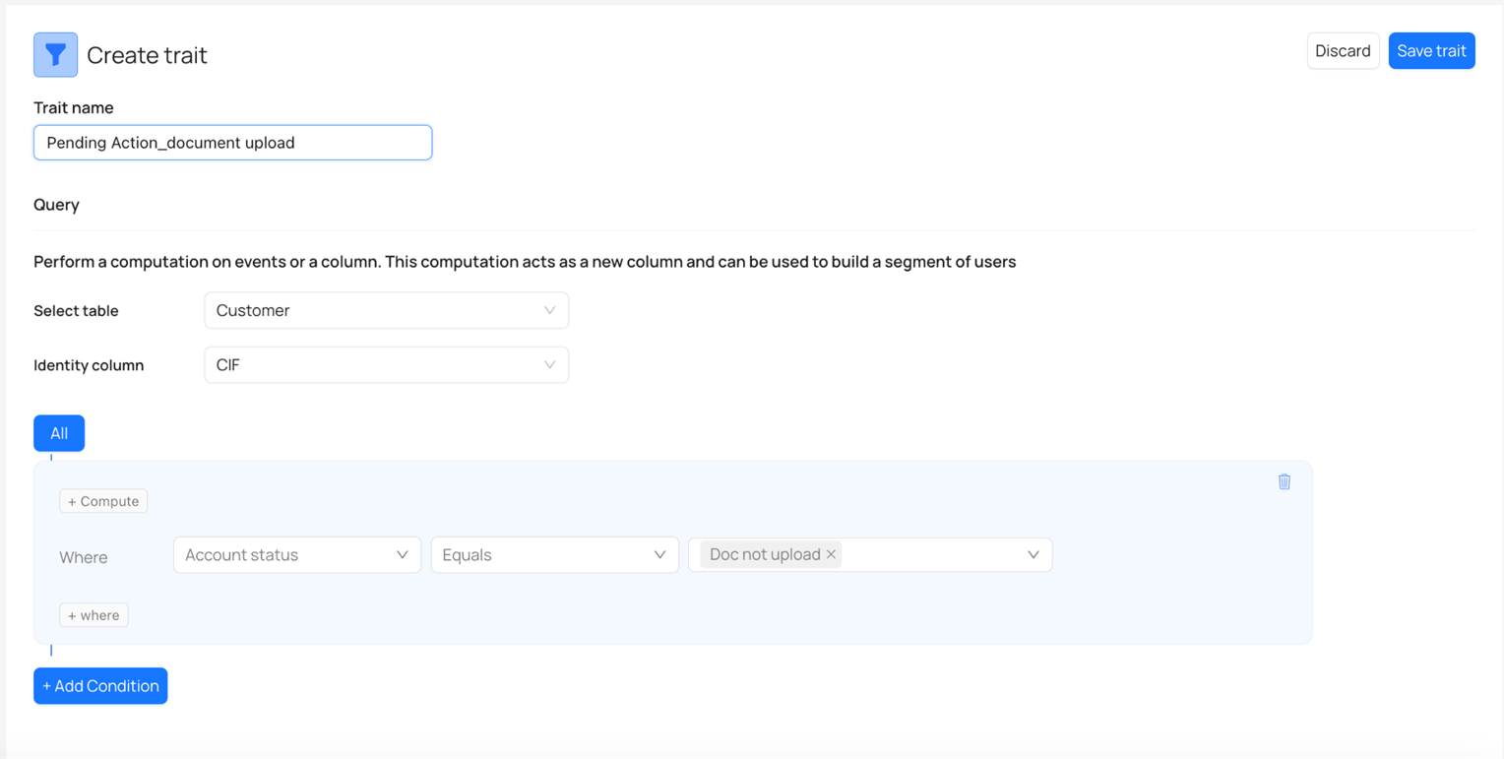
UC19
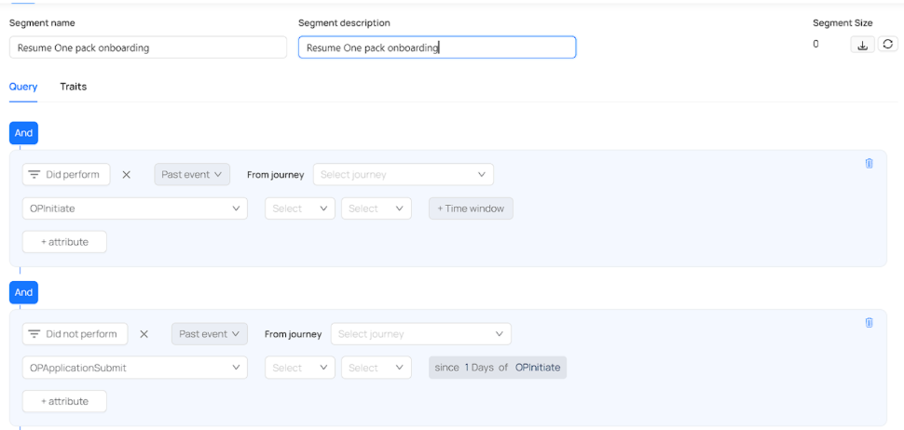
UC20
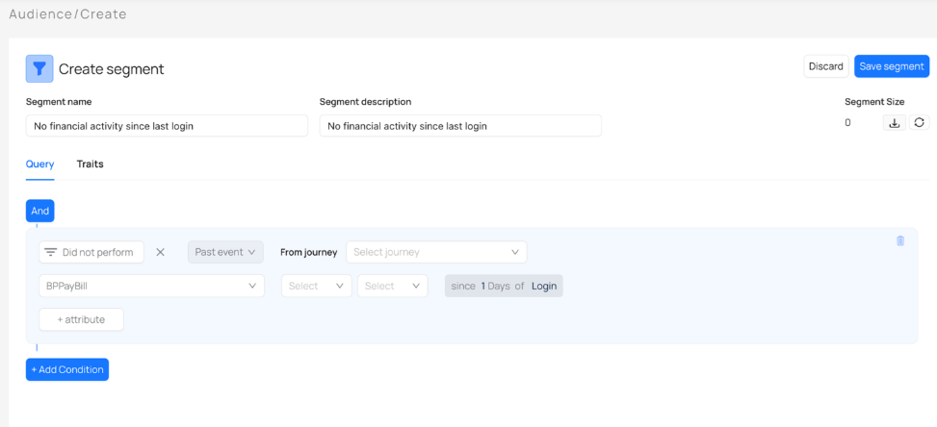

22.2 Data Taxonomy

22.3 Events List

22.4 SMS Integration

22.5 Email Integration
Following is the gateway details:
Source IP/Subnet | Destination IP/Subnet | Port Number
GIB-SIT | 10.8.15.212 | smtpprd.gib.com: 10.194.100.120 | SMTP/25

This can be accessible and can be used without any user.

Example:
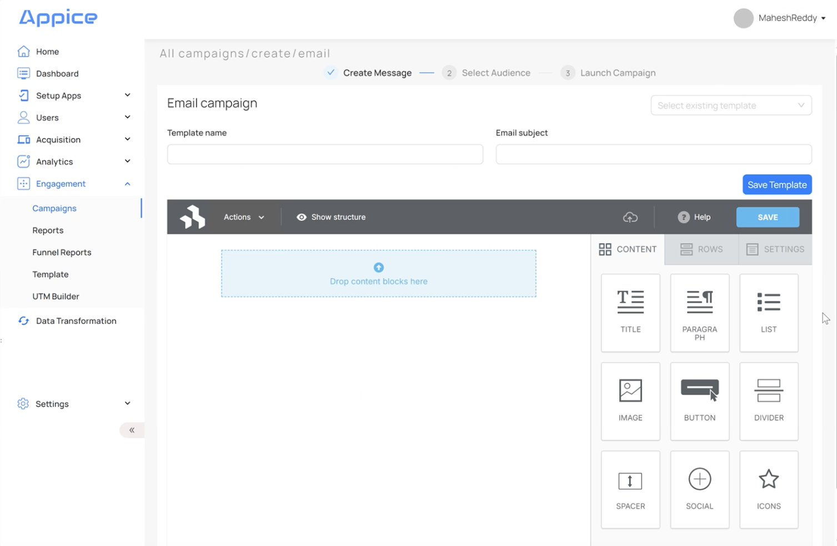

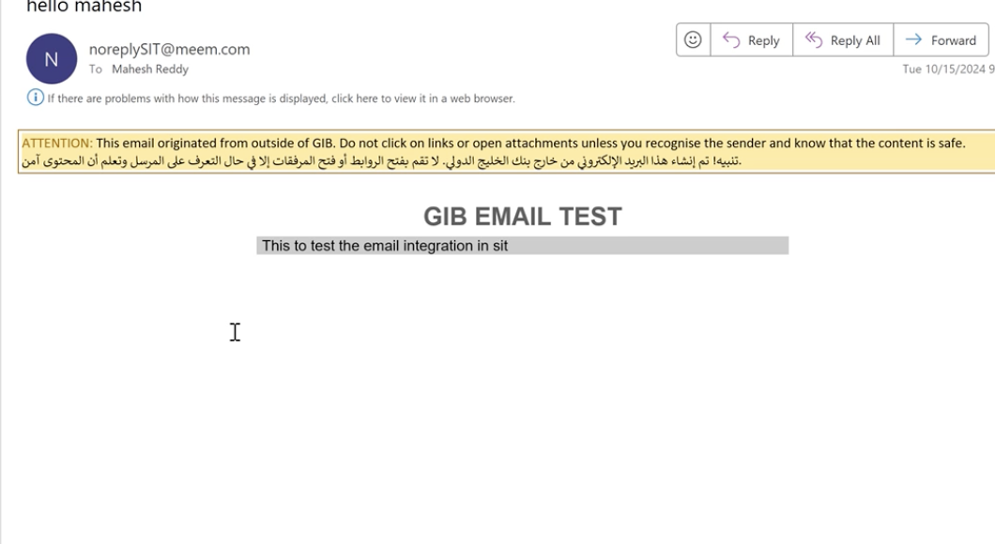

22.6 LDAP Integration

22.7 Sample data

22.8 Final BRD

22.9 MMP Integration

23. Audit Logs
Audit logs contain information about users who are doing activities on the AppICE Panel like logging in/logging out/creating campaigns/updating campaigns/creating audience segments etc.
This feature is only applicable to Admin & Infosec Users.
Here is how it is shown on Panel:
